What caused WWI?
Objectives: Explain how the causes of WWI led to the start of the conflict.

Introduction
Directions: Read through the scenario below and answer the questions that follow.

Gary is a new kid in school. He is very proud and has been trying to get as many friends as he can, partly to have friends, but also so he has someone to help him out if he gets into a fight (which he often does). Gary is also taking steroids and has been lifting weights in the gym every day. Gary’s closest friends are Adrian Hartford and Ian.
Frank is a guy in school that has been there for years, he is popular and well known throughout the school. Frank is on the football team, so he is just a strong as Gary, but he isn’t on steroids so he’s not as aggressive. Frank is close friends with Russell, Sebastian, and Gabe Brians.
Gary is trying out for the football team and wants Frank’s position as quarterback. Although they do not show it, both Gary and Frank want each other out of the school. To hurt each other socially, Frank is trying to become friends with Gary’s friends and Gary has been doing the same. Both are spreading rumors about the other.

One day after practice, Adrian Hartford made fun of Sebastian’s family. Sebastian, being very proud of his family took a swing at Adrian Hartford and gave him a bloody nose…

1. How is Gary a threat to Frank’s status in the school?
2. What actions are putting Gary and Frank against each other?
3. How do you think the incident between Adrian Hartford and Sebastian is going to effect Frank,Gary, Ian, and Russell?
What was World War I?
Watch this Discovery Channel Video on WWI then answer the questions below about WWI.
1. When was WWI? | 2. Where did WWI take place? | 3. Who (which countries) were involved in WWI?
Causes of WWI
Directions: Use the information on the following pages to fill in the graphic organizer below.
Cause of WWI | Definition | How did this cause contribute to the start of World War I?
M  Militarism | What is militarism?
A  Alliances | What is an alliance?
N  Nationalism | What is nationalism?
I  Imperialism | What is imperialism?
A  Assassination | What does assassination mean?
Militarism
Militarism is the belief that a country should have a strong military capability and be prepared to use it aggressively to defend or promote its interests. Leading up to World War I, imperial countries in Europe were strong proponents of militarism. They spent more and more money on military technology, employing more troops, and training their soldiers. They found that to gain colonies it helped to be militarily superior to the people they colonized and the other industrialized countries they were competing with. As tensions in Europe increased leading up to 1914, European countries raised and prepared large armies, navies, and airforces to protect their homelands.
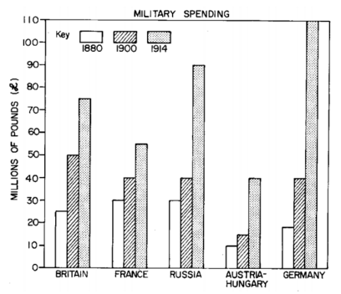 | 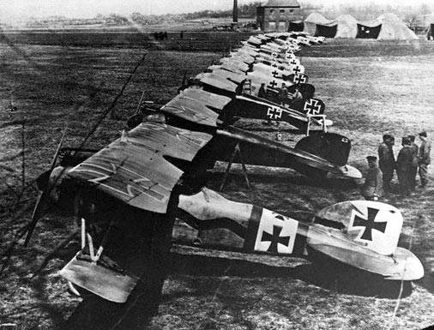  German planes used in WWI.  Source: https://commons.wikimedia.org/wiki/File:AlbatDIII.jpg
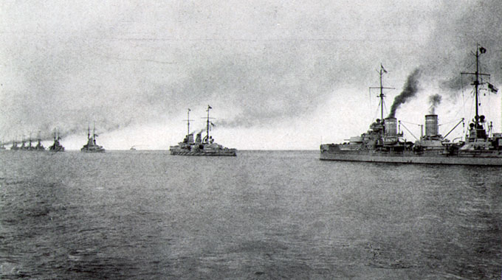
A battleship squadron of the German High Seas Fleet; the far right vessel is a member of the Kaiser class.1917. Source: https://en.wikipedia.org/wiki/File:Hochseeflotte_2.jpg

Imperialism
European countries competed with each other all over the world in the 1800s and early 1900s. They fought one another at sea and used treaty negotiations to claim colonies and spheres of influence in Africa and Asia. The search for raw materials to fuel industry and markets to buy goods in far-flung corners of the world led to increased tension in Europe.  Image to the right:  A French political cartoon from 1898. "China -- the cake of kings and... of emperors" (a French pun on king cake and kings and emperors wishing to "consume" China). A pastry represents "Chine" (French for China) and is being divided between caricatures of Queen Victoria of the United Kingdom, William II of Germany (who is squabbling with Queen Victoria over a borderland piece, while thrusting a knife into the pie to signify aggressive German intentions), Nicholas II of Russia, who is eyeing a particular piece, the French Marianne (who is diplomatically shown as not participating in the carving, and is depicted as close to Nicholas II, as a reminder of the Franco-Russian Alliance), and a samurai representing Japan, carefully contemplating which pieces to take. A stereotypical Qing official throws up his hands to try and stop them, but is powerless. It is meant to be a figurative representation of the Imperialist tendencies of these nations towards China during the 1890s.  Source: https://commons.wikimedia.org/wiki/File:China_imperialism_cartoon.jpg | 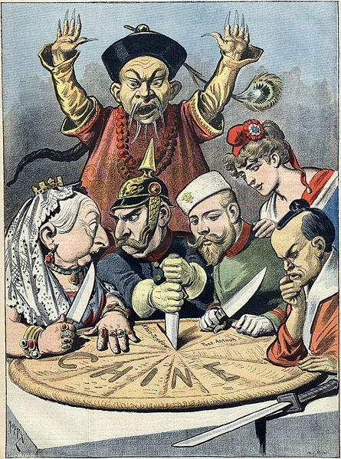
Colonial Holdings in 1914
Source: https://upload.wikimedia.org/wikipedia/commons/8/89/Colonisation2.gif

Alliances
To increase their own nations’ security, European powers signed treaties with one another forming alliances. Alliances are agreements between nations stating that each country will assist the other if they are attacked. On the verge of World War I, there were two large alliances. One alliance was called the Triple Entente (French for alliance), sometimes called the “Allied Powers” and it consisted of the United Kingdom (Great Britain), France, and Russia. In addition, Russia was allied with some Slavic countries in the area of Europe known as the Balkans including Serbia. The other was called the Triple Alliance and is sometimes referred to as the “Central Powers” these included Germany, Austria-Hungary, and Italy. As the war continued, the Ottoman Empire joined this group and Italy left this alliance to join the other Triple Entente.
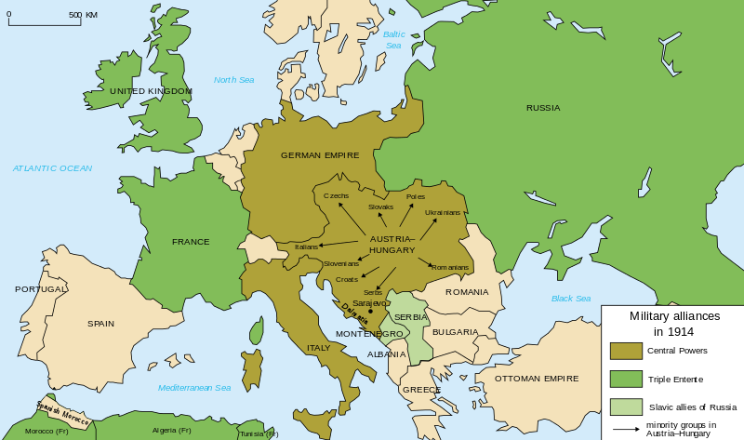
Map of military alliances of Europe in 1914. (English).
Source: https://commons.wikimedia.org/wiki/File:Map_Europe_alliances_1914-en.svg
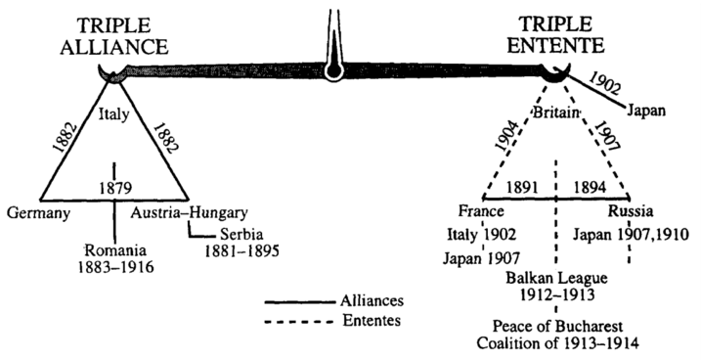
Nationalism
In the 1700s and 1800s, nationalism brought revolution and unification to Europe. Groups of people with common languages, histories, and cultures like the Italians and Germans fought to create their own countries out of older empires. Leading up to the World War I, people in Europe started to define themselves based on their nation and in opposition to others. Pride in one’s country was at an all time high. Some ethnic groups that wanted to unify but were a part of the few empires left in Europe, like the Austrian Hungarian Empire and the Ottoman Empire, created tension by declaring their desire to rule themselves. | 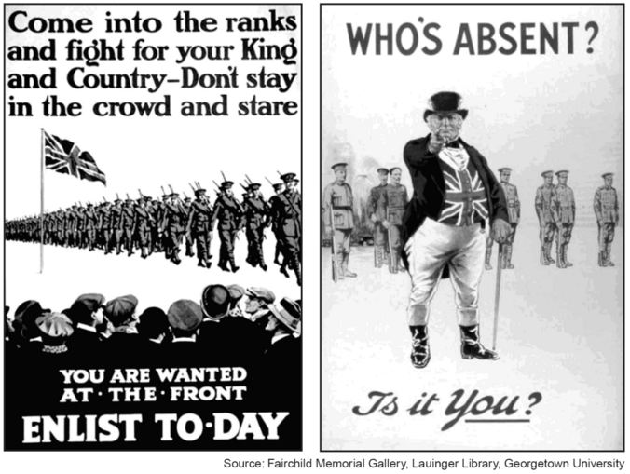  British poster encouraging young men to enlist in the army to defend their country.  Source: Fairchild Memorial Gallery, Lauinger Library, Georgetown University. NYS Global History Regents Exam.
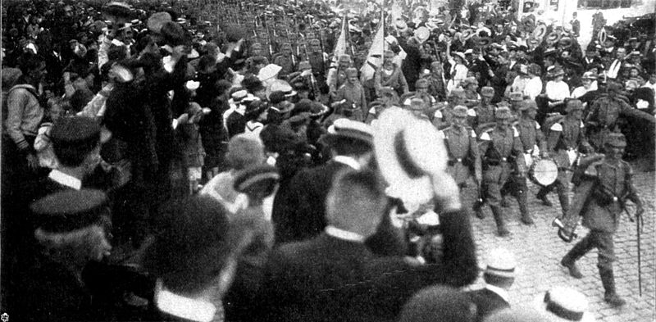
German soldiers being cheered in Lubeck during their advance to the front lines in 1914 during World War I. The concept of the "Spirit of 1914"by Johann Plenge identified the outbreak of war as forging national solidarity of Germans.
Source: https://en.wikipedia.org/wiki/File:IR_L%C3%BCbeck_033_-_EB.jpg

Assassination in the Balkans
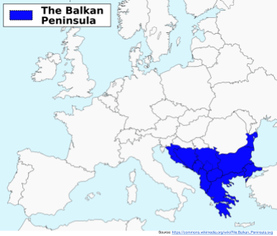
The Balkans- the Powder Keg of Europe
In 1914, the Balkan Peninsula, in southeastern Europe, was a particularly tumultuous region: Formerly under the control of the Ottoman Empire which was declining in Europe, the area was under the influence of two competing powers, Russia and Austria-Hungary. Austria-Hungary, a large and diverse empire, was starting to lose control of its most nationalistic regions (Germans in Austria, Magyars in Hungary). In the Balkans, one of the most active ethnic groups were the Serbians who were ethnically similar to many Russians and referred to themselves as Slavs, or Slavic people. In 1908, Austria-Hungary annexed the twin Balkan provinces of Bosnia-Herzegovina. This grab for territory and control angered the independent Balkan nation of Serbia – who considered Bosnia a Serb homeland – as well as Slavic Russia.

Upstart Serbia then doubled its territory in back-to-back Balkan wars (1912 and 1913), further threatening Austro-Hungarian supremacy in the region. Meanwhile, Russia had entered into an alliance with France – who were angry over German annexation of their lands in the aftermath of the Franco-Prussian War in 1870-71 – and Great Britain, whose legendary naval dominance was threatened by Germany’s growing navy. This Triple Entente, which squared off against the German-Austro-Hungarian alliance, meant that any regional conflict had the potential to turn into a general European war. As a result, the Balkans were known as the “powder keg” of Europe. A powder keg is a container for gunpowder which can erupt if there is a spark.
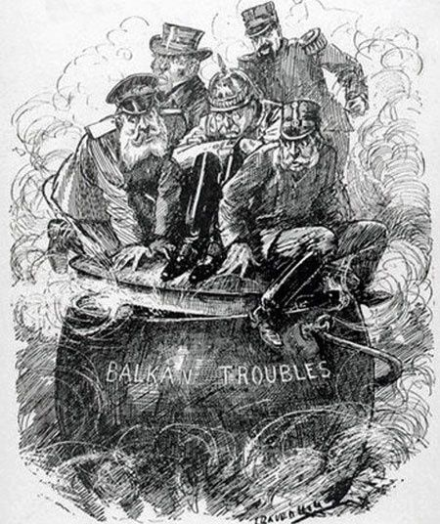  Political cartoon published before WWI.  Source: https://s-media-cache-ak0.pinimg.com/736x/c2/5a/72/c25a72db4ee575576aa6be7e7f9ef7e7.jpg | The Balkans in 1913  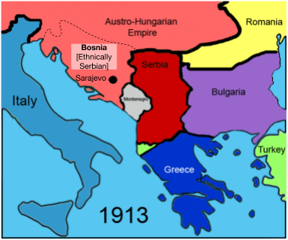  Source: https://en.wikipedia.org/wiki/File:Balkans_Animation_1800-2008.gif

The Assassination of Archduke Franz Ferdinand
Watch the History Channel’s Outbreak of WWI video and read the information on the BBC’s Bitesize History Assassination in Sarajevo web page before filling out your MANIA graphic organizer.
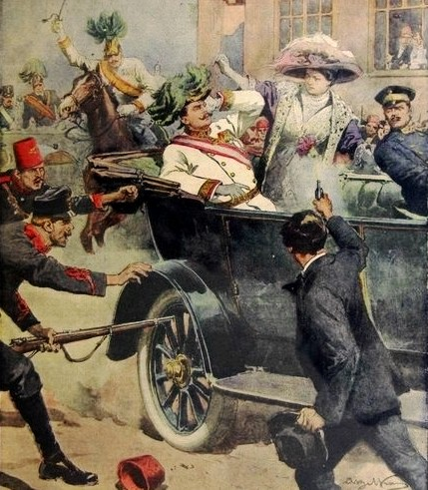  The first page of the edition of the Domenica del Corriere, an Italian paper, with a drawing of Achille Beltrame depicting Gavrilo Princip killing Archduke Francis Ferdinand of Austria in Sarajevo. July 12, 1914.  Source: https://en.wikipedia.org/wiki/File:DC-1914-27-d-Sarajevo-cropped.jpg | 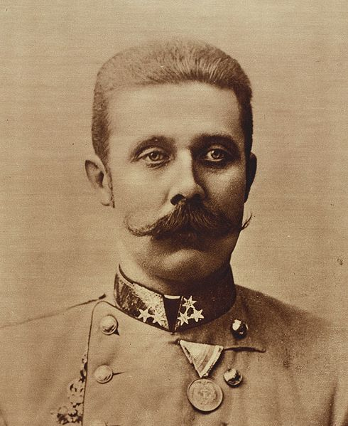  Archduke Franz Ferdinand of Austria.  Source: https://en.wikipedia.org/wiki/File:Franz_ferdinand.jpg
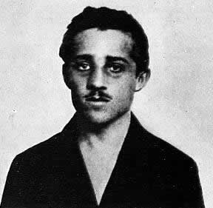
Gavrilo Princip.
Source: https://en.wikipedia.org/wiki/File:Gavrilloprincip.jpg
Declarations of War in Europe After The Assassination of Archduke Franz Ferdinand
Date | Declarer | On
1914
July 28 | Austria-Hungary | Serbia
August 1 | Germany | Russia
August 3 | Germany | France
August 4 | United Kingdom | Germany
August 6 | Austria-Hungary | Russia
 | Serbia | Germany
August 11 | France | Austria-Hungary
August 12 | United Kingdom | Austria-Hungary
November 1 | Russia | Ottoman Empire
November 2 | Serbia | Ottoman Empire
November 5 | United Kingdom, France | Ottoman Empire
1915
May 23 | Italy | Austria-Hungary
August 21 | Italy | Ottoman Empire
August 27 | Italy | Germany
Source: https://en.wikipedia.org/wiki/Participants_in_World_War_I

