What was the geographic and historical context for the founding of the Ming Dynasty?
- Describe the geographic context for founding of the Ming Dynasty.

A Changing Map and Protection to the North
Directions: Examine the images below, and then complete the questions that follow.
 | When the Yuan dynasty ruled China, the Mongols controlled land that included their homeland to the north. Through trade routes they were connected to the rest of the Mongol empires that lay to the west and to the Middle East and Europe. Since the Mongols and their allies ruled most of central Asia, they had little need to reinforce their defenses and did little to maintain the Great Wall.  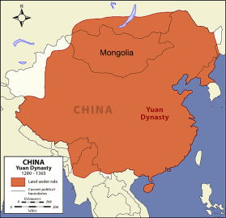  Source: http://archive.artsmia.org/art-of-asia/history/images/maps/china-yuan-large.gif | The early Ming emperors pushed the Mongols and other nomadic tribes north and secured their borders. They reinforced and expanded the Great Wall of China (Watch this video: https://goo.gl/Hu2QlQ) ) continuously throughout their dynasty’s reign. Much of the Great Wall as we know it today was built during the Ming dynasty.  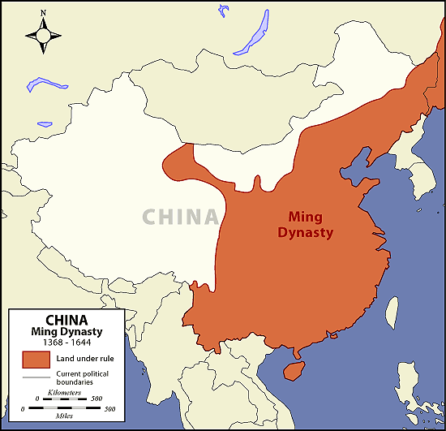  Source: http://archive.artsmia.org/art-of-asia/history/images/maps/china-ming-large.gif
1. What is the difference between these two maps?

2a. What advantages did the Yuan Dynasty gain from the land it controlled? What disadvantage came from controlling this land? |  | 2b. What advantages did the Ming Dynasty gain from the land it controlled? What disadvantage came from controlling this land?

The Rise of the Ming Dynasty
Directions: Examine the timeline and images below, then respond to the questions.
1. Who ran the Yuan dynasty?  2. Why was the Yuan dynasty in decline?  3. Why did Zhu Yuanzhang rebel in 1368?  4. What was the major impact of this rebellion? | By the middle of the 14th century, the Yuan dynasty, run by the Mongols was in decline. Like all Chinese dynasties, it was coming to an end and the evidence that the rulers had lost the Mandate of Heaven was everywhere. The government was corrupt, spent too much money on wars, and they could not collect enough taxes from the population to provide them with the services to keep them content. In addition, many Chinese leaders grew tired of being ruled by the foreign Mongols. They wanted a return to China run by Chinese. In 1368, a rebel leader named Zhu Yuanzhang (1328-1398) who led a group of bandits against the Yuan military and other rivals who wanted power, captured the capital city and declared the start of the Ming dynasty (1369-1644).

What was the geographic and historical context for the founding of the Ming Dynasty?
Directions: Using evidence from the documents above, respond to the task below in the space provided.
Think Like a Geographer  Contextualize | How did the Ming Dynasty secure its borders?  Which dynasty ruled this region before the Ming Dynasty?  Who founded the Ming Dynasty? How did he found the Ming Dynasty?

