Name: Date: Global 9/Period: Mongol Webquest

The Mongols

By the end of this you should be able to answer the following Essential Questions:
- What areas did the Mongols conquer?
- What was the impact of the Mongols in the areas they conquered?
Your task:
With a partner you must complete two (2) activities using the links provided along with your textbook and any other resources you may find.
- Map of Mongolian conquests which includes:
  - Location of the Mongolian homeland
  - The four khanates
  - Invasion routes
  - Marco Polo’s route to and from China
  - Labels on major geographic features (ie, bodies of water, mountains, etc)
Don’t forget a key, title and compass and to color the water blue.

- Complete answers to the Key Questions listed in this packet.

INTERNET LINKS TO USE:
- The Mongols in World History http://afe.easia.columbia.edu/mongols/index.html
  - A great site with lots of links to various topics
    - The Pastorial Nomadic Life-For descriptions on how Mongols lived
    - The Mongols’ Mark on Global History-For descriptions on contributions and Pax Mongolica
    - The Mongol Conquests-For descriptions of why and how the Mongols conquered neighboring areas
    - The Mongols in China-For descriptions on Kublai Khan, the Yuan Dynasty and military failures
    - Key Figures in Mongol History-For biographies of key figures including Genghis (Chinggis) Khan, Kublai Khan and Marco Polo
    - Maps-Links to various thematic maps for use in studying the Mongols
- Genghis Khan http://www.history.com/topics/genghis-khan
  - Biography of Genghis Khan
- Kublai Khan http://www.history.com/topics/kublai-khan
  - Biography on Kublai Khan
- Marco Polo http://www.history.com/topics/exploration/marco-polo
  - Biography on Marco Polo
- Encyclopedia Britannica-Genghis Khan http://www.britannica.com/biography/Genghis-Khan
  - Article on Genghis Khan and the unification of the Mongols
- Pax Mongolica http://www.silk-road.com/artl/paxmongolica.shtml
  - An excellent overview of the effect of the Mongols on the Chinese history

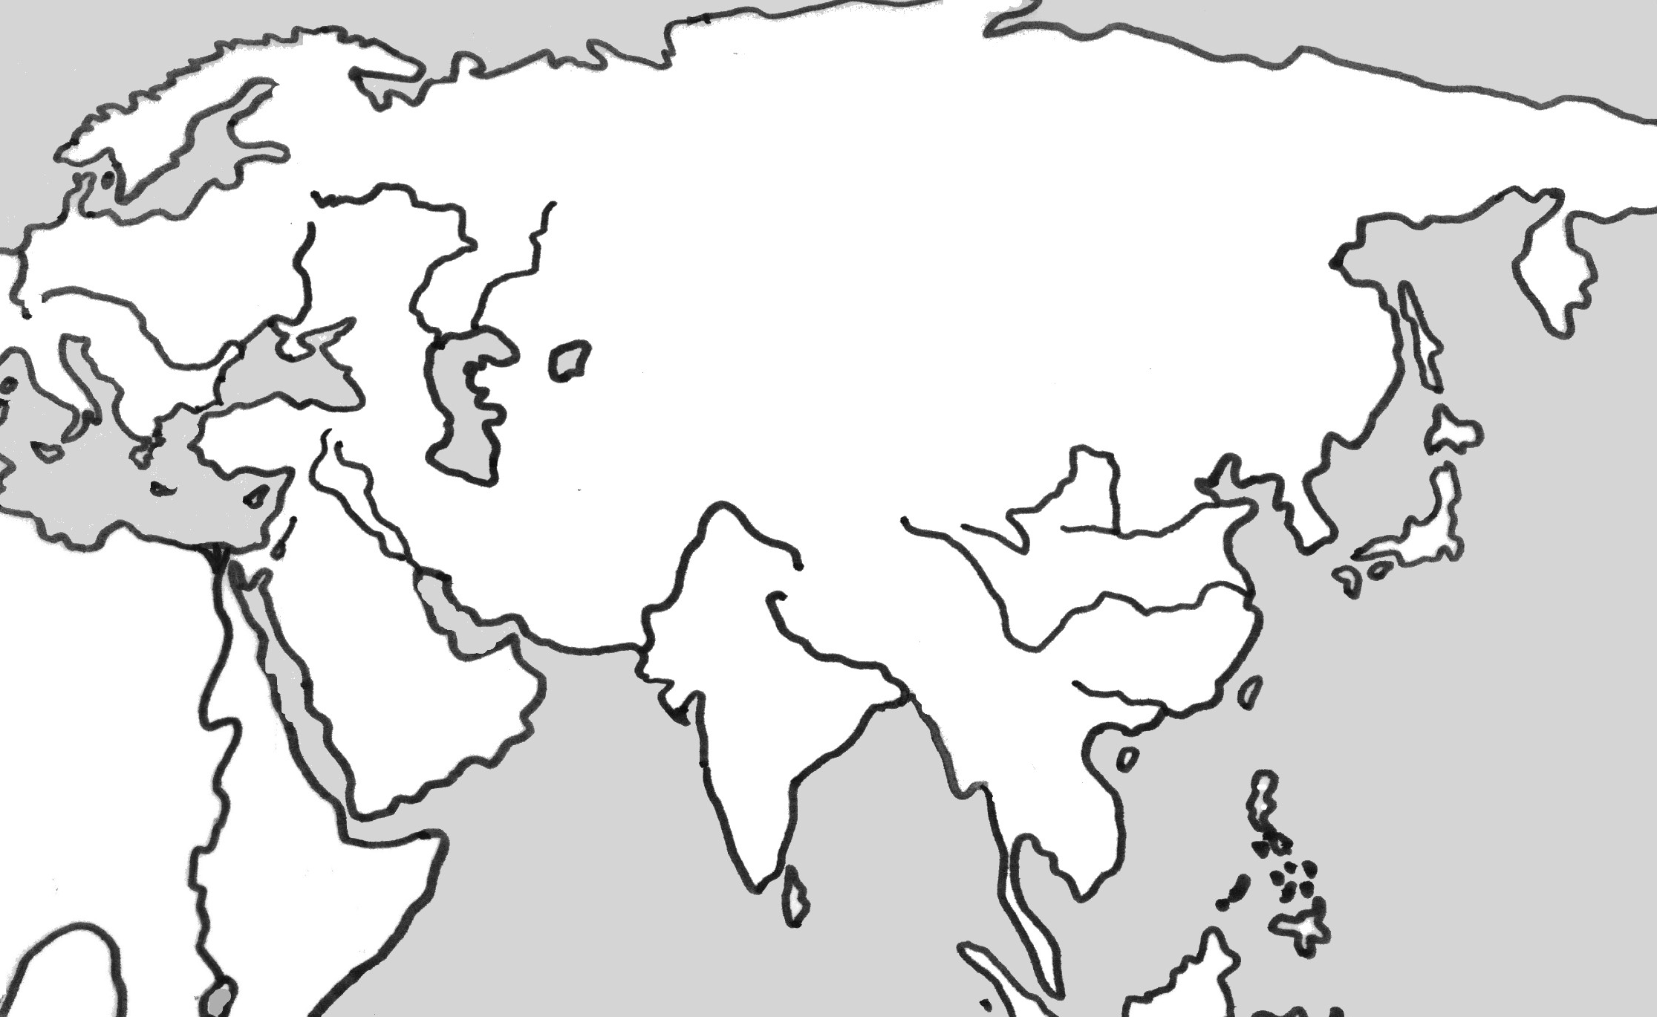

Completely answer the following Key Questions.
- Where was the homeland of the Mongols? Describe the way the Mongols lived.
- What tactics did Genghis Khan use to unite the Mongols and take over neighboring areas?
- How did the Mongols rule?
- What was Pax Mongolica and how did it affect trade and interaction?
- What was the impact of the Mongol conquest on Chinese society and political structure?

- Who is Marco Polo and how did Europeans view his stories?
- Why were the Mongols unable to take over Japan?
- What forces led to the fall of the Mongols?

