How did the Mongols gain, consolidate, and maintain power?

Directions: Examine the documents below, then complete the questions that follow.

What is a Khan?

Khan was the name given to male rulers of the Mongols, Tartars, or Turkic/Altaic peoples of Central Asia, with female rulers called khatun or khanum. Though the term seems to have originated with the Turkic peoples of the high inner steppes, it spread to Pakistan, India, Afghanistan and Persia through the expansion of the Mongols and other tribes.

Many of the great Silk Road oasis towns were ruled by khans during their heyday, but so were great city-states of the Mongol and Turkic empires of their age, and the rise and fall of khans subsequently have greatly shaped the history of Central, Southeast and Eastern Asia — from the brief and violent Mongol khans to the modern rulers of Turkey.
Adapted from https://www.thoughtco.com/what-is-a-khan-195348

Who were the Mongols?

The traditional homeland of the Central Asian people known as the Mongols is a vast highland region in what are now Mongolia and northern China. The Mongols share a common language and a tradition of following a nomadic way of life herding livestock. Their origin is unknown. By the 13th century a confederation of nomadic Mongol tribes had become a powerful military force. Under the leadership of Genghis Khan and his successors, they established an empire that reached from what are now China and Korea in the east to eastern Europe and the shores of the Persian Gulf in the west. At the height of their power, they overthrew the rulers of northern and southern China and reunited China under Mongol rule, as the Yuan (or Mongol) Dynasty. The Mongols were the first foreigners to rule all of China. The western part of their empire, in Russia and eastern Europe, was known as the Golden Horde. The power of the Mongol Empire declined greatly in the 14th century.

"Mongol Empire." Britannica LaunchPacks, Encyclopædia Britannica, 6 Feb. 2018. packs.eb.com/social-studies/208784/article/275900. Accessed 14 Feb. 2018.

Document 1: The battle of Liegnitz, 1241

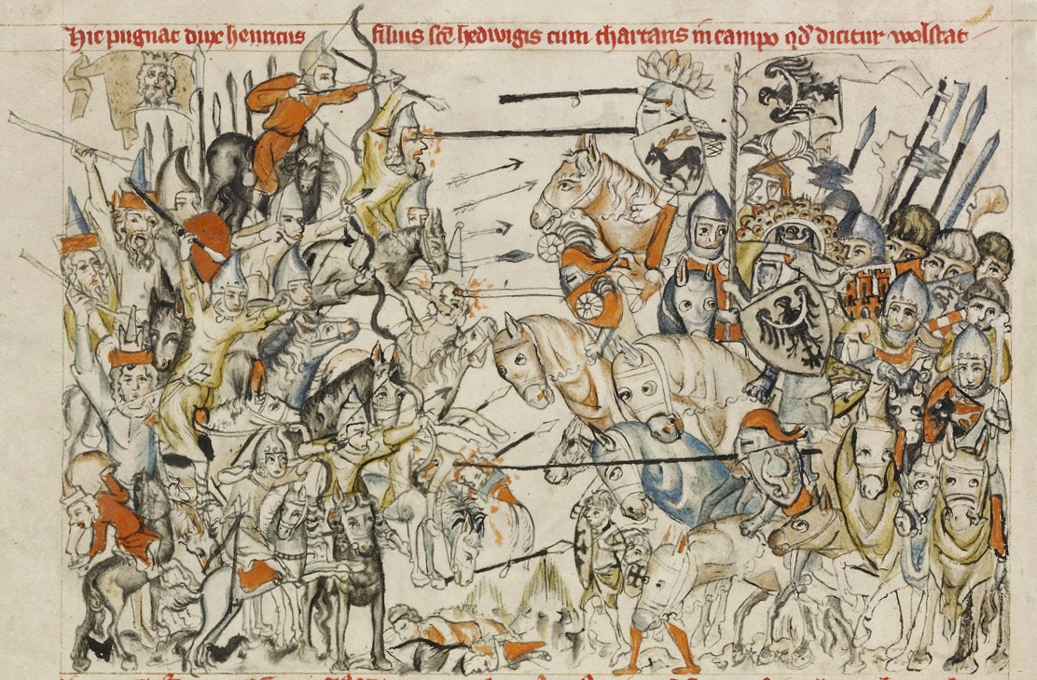
What does this image reveal about how the Mongols gain, consolidated, and/or maintained power?
Circle one or more:
This document illustrates how the Islamic Caliphates:
GAINED POWER
CONSOLIDATED POWER
MAINTAINED POWER

Document 2A: Bow and Horse

… The Mongols had developed a composite bow made out of sinew and horn and were skilled at shooting it while riding, which gave them the upper hand against ordinary foot soldiers. With a range of more than 350 yards, the bow was superior to the contemporaneous [around during the same time] English longbow, whose range was only 250 yards. A wood-and-leather saddle, which was rubbed with sheep’s fat to prevent cracking and shrinkage, allowed the horses to bear the weight of their riders for long periods and also permitted the riders to retain a firm seat. Their saddlebags contained cooking pots, dried meat, yogurt, water bottles, and other essentials for lengthy expeditions. Finally, a sturdy stirrup enabled horsemen to be steadier and thus more accurate in shooting when mounted. A Chinese chronicler recognized the horse’s value to the Mongols, observing that “by nature they [the Mongols] are good at riding and shooting. Therefore they took possession of the world through this advantage of bow and horse.”…
Adapted from the New York State Education Department. June 2013. Global History Exam. Internet. Available here; accessed July 12, 2017.
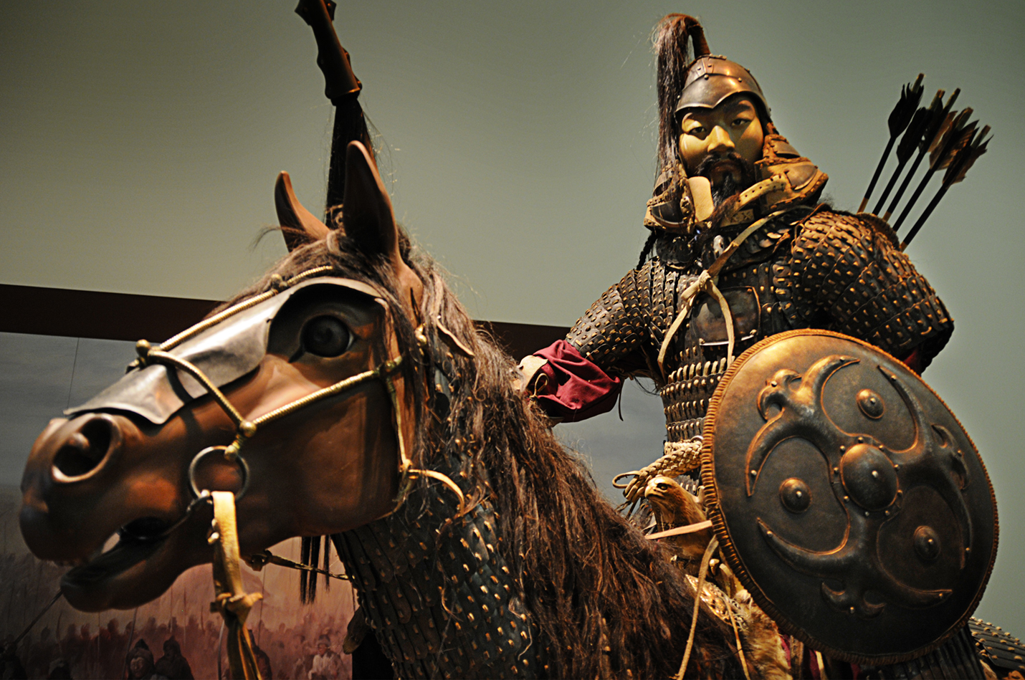
Document 2B: Bow and Horse - Reconstruction of a Mongol warrior
What do these reveal about how the Mongols gain, consolidated, and/or maintained power?
Circle one or more:
This document illustrates how the Mongol Khanates
GAINED POWER
CONSOLIDATED POWER
MAINTAINED POWER

Image is courtesy of Wikimedia Commons and is public domain.

Document 3:
All Mongols were fighters, but Chinggis [Genghis] made a reorganized army the core of the society and the carrier of many of his reforms. Under him and his successors, the Mongol army had the following characteristics:
- All males 15-70 served in the army, all as cavalry.
- The army’s 95 units of 10,000 soldiers were subdivided into units of 1,000, 100, and 10.
- Soldiers were promoted based on merit [their ability] not based on their family’s status in society.
- Members of different tribes were mixed together in units of every size to ensure loyalty to the army above loyalty to the tribe.
- Allies and levies [military men] from conquered territories were also integrated into the fighting force, the latter usually being placed in the front ranks.
- Absolute obedience to orders from superiors was enforced.
- Officers had tight control over their troops’ actions (plunder only with permission, no one allowed to transfer out of their unit).
- No one in the army was paid, though all shared to varying degrees in the booty (items that were plundered/stolen).
Adapted from “Mongol Empire Builders: Fiends from Hell or Culture Brokers? (1200-1400 CE).” (n.d.). In san Diego State University’s World History for All. Retrieved July 21, 2017, from here.

What does this document reveal about how the Mongols gain, consolidated, and/or maintained power?
Circle one or more:
This document illustrates how the Mongol Khanates
GAINED POWER
CONSOLIDATED POWER
MAINTAINED POWER

Document 4:
. . .Kublai Khan [ruler of the Yuan Dynasty, the Mongol run empire in China] was a vigorous and capable ruler. He carried on large warlike hunts to show that he kept Mongol tradition, but he also showed some appreciation for Chinese culture. He acted to restore some of the devastation in North China. He began a vast renovation of the Grand Canal, which was so important to the wealth and unity of the country. He directed the building of water-control projects, such as dams and dikes, along the Yellow River. . . .
Adapted from the New York State Education Department. June 2013. Global History Exam. Internet. Available here; accessed July 12, 2017.

Circle one or more:
This document illustrates how Mongol Khanates
GAINED POWER
CONSOLIDATED POWER
MAINTAINED POWER

What does this text reveal about how the Mongols gain, consolidated, and/or maintained power?
Document 5: An Excerpt from The Travels of Marco Polo
Now you must know that from this city of Cambaluc [Mongol capital in China, now Beijing] proceed many roads and highways leading to a variety of provinces...the messengers of the Emperor in travelling from Cambaluc...will, find at every twenty-five miles of the journey a station which they call Yamb, or, as we should say, the “Horse-Post-House.”

….You must know that by the Great Kaan’s orders there has been established between those post houses, at every interval of three miles, a little fort with some forty houses round about it, in which dwell the people who act as the Emperor’s foot-runners. Everyone of those runners wears a great wide belt, set all over with bells, so that as they run the three miles from post to post their bells are heard jingling a long way off. And thus on reaching the post the runner finds another man similarly equipt, and all ready to take his place, who instantly takes over whatsoever he has in charge...so the new man sets off and runs his three miles. At the next station he finds his relief ready in like manner; and so the post proceeds, with a change at every three miles. And in this way the Emperor...receives despatches with news from places ten days’ journey off in one day and night; or, if need be, news from a hundred days off in ten days and nights; and that is no small matter!

Moreover, there are also at those stations other men...who are employed for expresses when there is a call for great haste in sending despatches to any governor of a province...and these men travel a good two hundred or two hundred and fifty miles in the day, and as much in the night..... They take a horse from those at the station which are standing ready saddled, all fresh and in wind, and mount and go at full speed, as hard as they can ride in fact. And when those at the next post hear the bells they get ready another horse and a man equipt in the same way, and he takes over the letter or whatever it be, and is off full-speed to the third station, where again a fresh horse is found all ready, and so the despatch speeds along from post to post, always at full gallop, with regular change of horses. And the speed at which they go is marvellous.

Yule, Henry. Excerpt from The Book of Ser Marco Polo: The Venetian Concerning Kingdoms and MArvels of the East. (n.d.). In Columbia University’s Asian Topics in World History. Retrieved
20:26., July 12, 2017, from here.

Circle one or more:
This document illustrates how the Mongol Khanates
GAINED POWER
CONSOLIDATED POWER
MAINTAINED POWER

What does this text reveal about how the Mongols gain, consolidated, and/or maintained power?

