Name: Date:
Global 10/Period: The Rise and Fall of Napoleon

Who was Napoleon Bonaparte?
Objective: Describe important events in the life of Napoleon Bonaparte..
Directions: Each of the paintings below are of Napoleon. Examine the images and information presented, and then answer the question that follows.

Image A  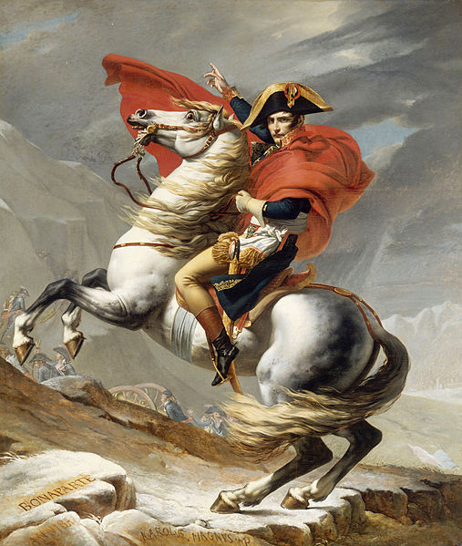  Bonaparte Crossing the Grand Saint-Bernard Pass by Jérôme-Martin Langlois and Jacques-Louis David, 1802.  Source: https://en.wikipedia.org/wiki/File:Jacques_Louis_David_-_Bonaparte_franchissant_le_Grand_Saint-Bernard,_20_mai_1800_-_Google_Art_Project.jpg | Image B  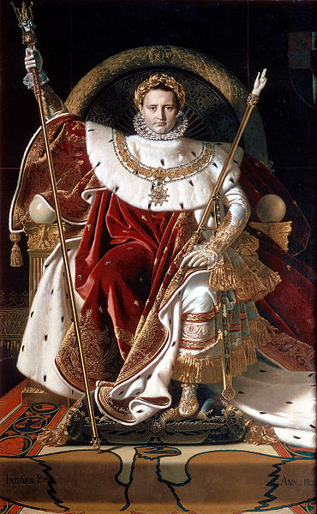  Napoleon on his Imperial throne. by Jean-Auguste-Dominique Ingres, 1806.  Source: https://commons.wikimedia.org/wiki/File:Ingres,_Napoleon_on_his_Imperial_throne.jpg | Image C  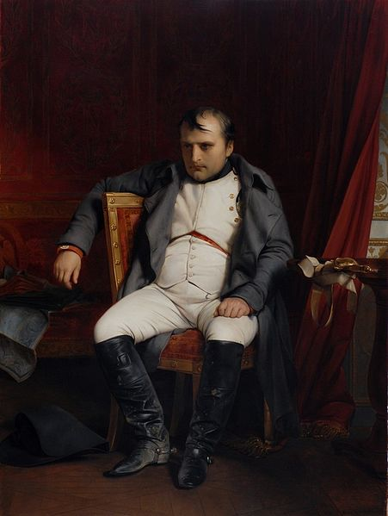  Napoléon Bonaparte abdicated in Fontainebleau by Paul Delaroche, 1845  Source: https://commons.wikimedia.org/wiki/File:DelarocheNapoleon.jpg
Describe how Napoleon is depicted in Image A. | Describe how Napoleon is depicted in Image B. | Describe how Napoleon is depicted in Image C.
Based on the images above, how did Napoleon’s role in France and people’s perception of him change over time?
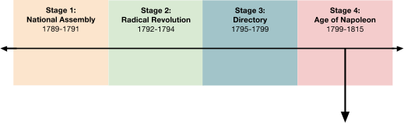
STAGE 4 | 1799-1815: Age of Napoleon
 |  |  |  |  | 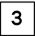
 | 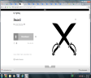 |  | 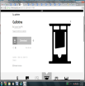
 | Nov. 1799 |  | March, 1804 |  | Dec. 1804 |  | 1803- 1815 |  | June 1815
 | Napoleon overthrows the Directory and declares himself First Consul of France |  | The Code Napoleon is issued |  | Napoleon declares himself Emperor of France and reinstitutes hereditary rule |  | Napoleonic Wars  Conquers and controls most of Europe by 1812  Fails to invade Russia in Dec. 1812 and is defeated in wars against allied European powers  Napoleon is exiled for life |  | At Congress of Vienna European powers redraw map to pre-Napoleon lines  Louis XVIII installed as the king of France

The Life of Napoleon
Watch each of the clips linked below from Biography.com about Napoleon Bonaparte and answer the questions that accompany each section. Scan the QR code or visit my website.
Military Beginnings (2:43) | French Dictator (2:29) | Strategic Genius (3:45) | The Fall (3:50) | Final Exile (2:45)
What characteristics made Napoleon a good military leader? | According to the video, why did “the French people” want Napoleon to take control of the government? | Why was Napoleon able to defeat the Austria, Russia, and England in the Napoleonic Wars? | What mistakes did Napoleon make as a leader? | What was Napoleon’s punishment after losing the Battle of Waterloo?
 | What beneficial changes did Napoleon make in France? |  | Why did Napoleon’s invasion of Russia fail?
November, 1799: Napoleon overthrows the Directory and declares himself First Consul of France

Directions: Read through each of the historical documents below and answer the questions that accompany them.

Document 1: Napoleon Bonaparte, personal account, Napoleon’s Account of His Coup d’Etat (excerpt), November 10, 1799
Note: This document was released publically during Napoleon’s reign.
Historical Context  From 1788-1789, Napoleon commanded French troops in Egypt to seize the land from the Ottoman Empire.  While in Egypt, Bonaparte tried to keep a close eye on European affairs, relying largely on newspapers and dispatches that arrived only irregularly. He was ordered back to Paris by the Directory who feared an invasion.  By the time he returned to Paris in October, the military situation had improved due to several French victories. The Republic was bankrupt, however, and the corrupt and inefficient Directory was more unpopular with the French public than ever.  Bonaparte was approached by one of the Directors, Emmanuel Joseph Sieyès, seeking his support for a coup to overthrow the French Constitution of 1795. On November 9th and 10th, troops led by Bonaparte seized control and dispersed the legislative councils, leaving a small number of representatives to name Bonaparte, Sieyès, and Ducos as provisional Consuls to administer the government. Although Sieyès expected to dominate the new regime, he was outmaneuvered by Bonaparte, who drafted the Constitution of the Year VIII and secured his own election as first consul. This made him the most powerful person in France, a power that was increased by the Constitution of the Year X, which made him first consul for life.  Adapted from “Napoleon Bonaparte.” New World Encyclopedia. http://www.newworldencyclopedia.org/entry/Napoleon_Bonaparte | Vocabulary  coup d’etat- also known as coup, is a sudden, usually violent, overthrow of a government  The Council of Elders- also known as the Council of Ancients, this was half of the elected officials that were a part of The Directory
Pre-Reading Questions
1. Who wrote this document?

2. When was it written?

3. What is the author’s perspective?

4. Who was the intended audience?

5. Consider the author and his perspective, what biases should the reader remember as they read this document?

1  2  3  4  5  6  7  8  9  10  11  12  13  14  15  16  17  18  19  20  21  22  23  24  25  26  27  28  29  30  31  32  33  34  35  36  37  38  39  40  41  42  43  44  45  46  47  48  49  50  51 | On my return to Paris [from Egypt] I found division among all authorities, and agreement upon only one point, namely, that the Constitution was half destroyed and was unable to save liberty.  All parties came to me, confided to me their designs, disclosed their secrets, and requested my support; I refused to be the man of a party.  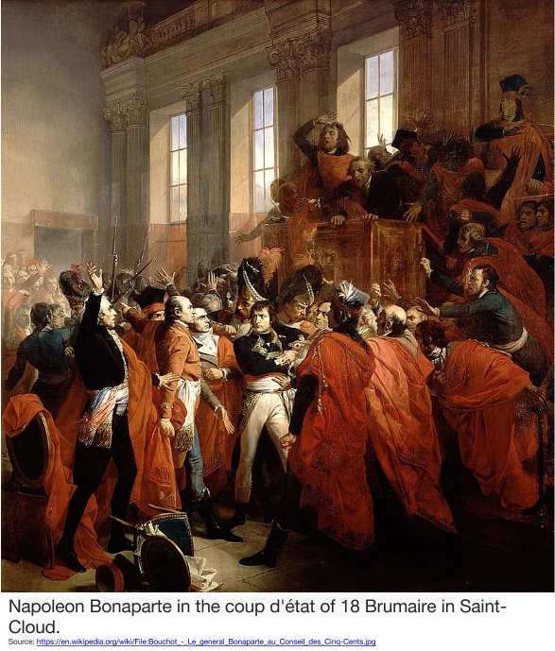  The Council of Elders summoned me; I answered its appeal. A plan of general restoration had been devised by men whom the nation has been accustomed to regard as the defenders of liberty, equality, and property; this plan required an examination, calm, free, exempt from all influence and all fear. Accordingly, the Council of Elders resolved upon the removal of the legislative Body to Saint-Cloud; it gave me the responsibility of disposing the force necessary for its independence. I believe it my duty to my fellow citizens, to the soldiers perishing in our armies, to the national glory acquired at the cost of their blood, to accept the command….  I presented myself at the Council of Five Hundred, alone, unarmed, my head uncovered, just as the Elders had received and applauded me; I came to remind the majority of its wishes, and to assure it of its power.  The stilettos [daggers] which menaced the deputies were instantly raised against their liberator; twenty assassins threw themselves upon me and aimed at my breast. The grenadiers of the Legislative Body whom I had left at the door of the hall ran forward, placed themselves between the assassins and myself. One of these brave grenadiers had his clothes pierced by a stiletto. They bore me out.  At the same moment cries of “Outlaw” were raised against the defender of the law. It was the fierce cry of assassins against the power destined to repress them.  They crowded around the president, uttering threats, arms in their hands they commanded him to outlaw me; I was informed of this: I ordered him to be rescued from their fury, and six grenadiers [soldiers] of the Legislative Body secured him. Immediately afterwards some grenadiers of the  legislative body charged into the hall and cleared it.  The factions, intimidated, dispersed and fled. The majority, freed from their attacks, returned freely and peaceably into the meeting hall, listened to the proposals on behalf of public safety, deliberated, and prepared the salutary [beneficial] resolution which is to become the new and provisional law of the Republic.  Frenchmen, you will doubtless recognize in this conduct the zeal of a soldier of liberty, a citizen devoted to the Republic. Conservative, tutelary [serving as a protector], and liberal ideas have been restored to their rights through the dispersal of the rebels who oppressed the Councils.  STEWART, JOHN HALL, DOCUMENTARY SURVEY OF THE FRENCH REVOLUTION, 1st, © 1951. Printed and electronically reproduced by permission of Pearson Education, Inc., Upper Saddle River, New Jersey. from the NYS Social Studies ToolKit. http://www.c3teachers.org/inquiries/frenchrev/ | 6. How does Napoleon describe the government when he returns to Paris?  7. Napoleon wrote in lines 7-10 that many people wanted him to take action to fix the government. He responds “I refused to be the man of a party.” What do you think he meant by that? Why would he write that in this document?  8. According to Napoleon, who came up with the plan for the coup d’etat? How does he describe them? Why do you think he described them in that way?  9. Based on lines 26-47, in your own words, describe what happened when Napoleon attempted his coup d’etat.  10. In lines 30-31, what word does Napoleon use to refer to himself? Why do you think he uses this word?  11. Why do you think that Napoleon describes himself as a "soldier of liberty" (lines 49-50)?  12. According to lines 50- 51, what does Napoleon claim to have done by completing the coup?  13. How would a French citizen who took Napoleon at his word (believed him) see him after reading this?  14. What was the purpose of this document?

March, 1804: The Code Napoleon is issued

Document 2: The Code Napoleon [also known as the Napoleonic Code and the French Civil Code], March,1804
Historical Context  Bonaparte instituted several lasting reforms including centralized administration of the départements, higher education, a tax system, a central bank, law codes, and road and sewer systems. The Code was prepared by committees of legal experts under the supervision of Jean Jacques Régis de Cambacérès, who held the office of second consul from 1799 to 1804; Bonaparte, however, participated actively in the sessions of the Conseil d'État (Council of State) that revised the drafts. His set of civil laws, the Napoleonic Code or Civil Code, has importance to this day in many countries.  Adapted from “Napoleon Bonaparte.” New World Encyclopedia. http://www.newworldencyclopedia.org/entry/Napoleon_Bonaparte |  | Pre-Reading Questions  1. Who wrote this document?  2. When was it written?  3. What is the purpose of this document?
1  2  3  4  5  6  7  8  9  10  11  12  13  14  15  16  17  18 | ARTICLE 1.  1. The laws are executory throughout the whole French territory, by virtue of the promulgation [formal declaration] thereof made by the First Consul. They shall be executed in every part of the republic, from the moment at which their promulgation can have been known.  BOOK I: OF PERSONS.  CHAPTER I: Of the Enjoyment of Civil Rights.  7. The exercise of civil rights is independent of the quality of citizen, which is only acquired and preserved conformably to the constitutional law.  8. Every Frenchman shall enjoy civil rights.  TITLE II: OF PROPERTY.  544. Property is the right of enjoying and disposing of things in the most absolute manner, provided they are not used in a way prohibited by the laws or statutes.  545. No one can be compelled to give up his property, except for the public good, and for a just and previous indemnity [guarantee that they will not suffer a financial loss as a result].  Source: Code Napoleon, the French Civil Code. Translated from the original and official edition, Published at Paris, 1804 by a barrister of the Inner Temple. https://archive.org/stream/codenapoleonorf00spengoog/codenapoleonorf00spengoog_djvu.txt | 4. Who is the “First Consul” referred to in line 3?  5. What does the phrase “quality of citizen” mean in line 9?  6. Which of the laws in the Code Napoleon represent a continuation of revolutionary ideals?  7. Does the act of creating a law code represent a continuation of or end to revolutionary ideals? Explain.

December, 1804: Napoleon declared himself Emperor of France and reinstituted hereditary rule

Document 3: Jacques-Louis David, painting, Consecration of the Emperor Napoleon I and Coronation of the Empress Josephine,1804
Historical Context In January 1804, Napoleon’s police uncovered an assassination plot against him, sponsored by the House of Bourbon (Louis XVI’s family). Bonaparte then used this incident to justify the re-creation of a hereditary monarchy and divine right in France, with himself as emperor, hoping that a House of Bourbon restoration would be impossible once the Bonapartist succession was declared in the constitution. He crowned himself emperor on December 2, 1804, at Notre Dame de Paris. After the Imperial regalia had been blessed by the Pope, Napoleon crowned himself before crowning his wife Joséphine as Empress.
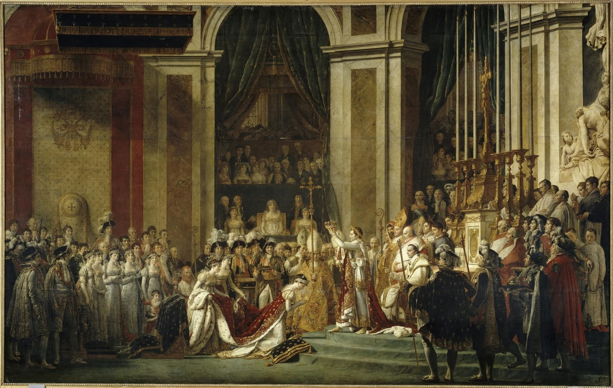  Source: © RMN-Grand Palais/Art Resource, NY. from the NYS Social Studies ToolKit. http://www.c3teachers.org/inquiries/frenchrev/ | 1. List the objects or people you see in the painting.
 | 2. Describe the action in the painting
 | 3. Explain the message that the painting conveys.

Document 4: Napoleon Bonaparte, personal account delivered to the Legislative Body, Napoleon’s Account of the Internal Situation of France, December 31, 1804
Pre-Reading Questions  1. Who wrote this document?  2. When was it written? |  | 3. Who was the intended audience?
1  2  3  4  5  6  7  8  9  10  11  12  13  14  15  16  17  18  19  20  21  22  23  24  25  26  27 | The internal situation of France is today as calm as it has ever been in the most peaceful periods. There is no agitation to disturb the public tranquility, no suggestion of those crimes which recall the Revolution. Everywhere useful enterprises are in progress, and the general improvements, both public and private, attest the universal confidence and sense of security. …  It was clearly seen that for a great nation the only salvation lies in hereditary power [power based on family relation], which can alone assure a continuous political life which may endure for generations, even for centuries. …  After prolonged consideration, repeated conferences with the members of the Senate, discussion in the councils, and the suggestions of the most prudent [wise] advisers, a series of provisions [rules] was drawn up which regulate the succession to the imperial throne… The French people, by a free and independent expression, then manifested its desire that the imperial dignity should pass down in a direct line through the legitimate or adopted descendants of Napoleon Bonaparte, or through the legitimate descendants of Joseph Bonaparte, or of Louis Bonaparte.  From this moment Napoleon [speaking in third person] was, by the most unquestionable of titles, emperor of the French. No other act was necessary to sanction his right and consecrate [make official by a religious figure] his authority. But he wished to restore in France the ancient forms and recall those institutions which divinity itself seems to have inspired. He wished to impress the seal of religion itself upon the opening of his reign. The head of the Church [the Pope], in order to give the French a striking proof of his paternal affection, consented to officiate at this august [distinguished] ceremony. What deep and enduring impressions did this leave on the mind of Napoleon and in the memory of the nation! What thoughts for future races! What a subject of wonder for all Europe!  Copyright © Hanover Historical Texts Collection. Used by permission of Hanover College, Hanover, IN from the NYS Social Studies ToolKit. http://www.c3teachers.org/inquiries/frenchrev/ | 4. According to Napoleon, describe what life was like in France in 1804.  5. What change in the French government has Napoleon announced in lines 14-17? Does this represent a continuation of the ideals of the French revolution, or an end to them?  6. In line 14, Napoleon uses the phrase, “The French people, by a free and independent expression..” Why do you think he uses this language?  7. What “ancient form,” that was abolished earlier in the French Revolution does Napoleon refer to in line 22?  8. If you were a French citizen who supported the ideals of the revolution, how would you view Napoleon after reading this?  9. If you were a French citizen who suffered from the chaos caused by the revolution up to this point, how would you view Napoleon after reading this?

How did the French Revolution conclude?
Objective: Describe the state of the French government and Europe after Napoleon.

1803-1815: Napoleonic Wars and the Fall of Napoleon
Between 1803 and 1812, Napoleon expanded the borders of France to include most of Europe during his most successful period as commander during what are called the Napoleonic Wars.

In 1812 Napoleon, who had conquered most of Europe, heard that the Russians were raising a large army and preparing for war. In response, Napoleon increased his troops to a massive force of 450,000-600,000 men. Despite advisors who warned against it, Napoleon invaded Russia.

Instead of fighting the French, the Russians, led by Czar Alexander I retreated north into Russia. As they did so, they burned all of the crops and killed the livestock they passed, a policy known as the scorched-earth policy so Napoleon’s troops would have nothing to eat as they marched in pursuit. At the same time, the cold and long Russian winter set in. Russia was too big and too far north (causing the harsh winter) for Napoleon to conquer. After four months of marching Napoleon turned back towards France in defeat with only 40,000 soldiers.

After his defeat in Russia, a coalition formed between Russia, Prussia, the United Kingdom (England), Spain, and Portugal. They defeated the French army at the Battle of Nations in October of 1813, then advanced through France occupying Paris in March of 1814. Napoleon was forced into exile on an island called Elba. He escaped after less than a year on the island and raised another army but that too was defeated.

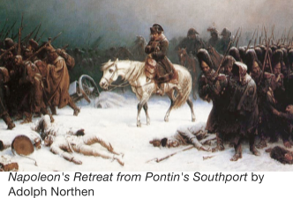
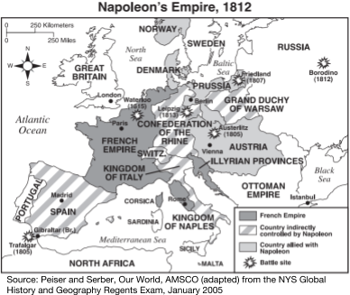
In 1815, Napoleon was sentenced to exile for life on the remote island of Saint Helena
in the Atlantic Ocean.
Adapted from “Napoleon Bonaparte.” New World Encyclopedia.
http://www.newworldencyclopedia.org/entry/Napoleon_Bonaparte

Regents Multiple Choice Check for Understanding
1. Which factors protected Russia from control by Napoleon’s army?
(1) religious & cultural similarities
(2) industrialization & modernization
(3) geographic size & location
(4) political & economic instability

June, 1815: At Congress of Vienna European powers redraw map to pre-Napoleon lines,
Louis XVIII installed as the king of France

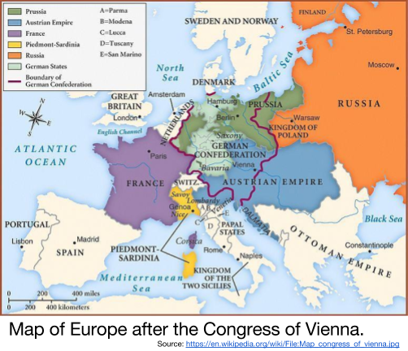
After the troops of the coalition of countries that defeated Napoleon in 1814 arrived in Paris and forced surrender, the French Senate invited Louis XVI’s relative, Louis XVIII to take the throne. Louis XVIII had made several declarations while in exile from France stating that if he were to be the king of France that he would abide by the rules of constitution and not persecute those who followed Napoleon. France was a Constitutional Monarchy as it was for a brief period before Louis XVI’s death in first years of the French Revolution with less and less power for the monarch.

After Napoleon was defeated and exiled from Europe, representatives from the major countries in Europe (Britain, Austria, Prussia, France, Russia)led by Austrian Prime Minister, Klemens von Metternich met in Vienna to settle land ownership issues caused by Napoleon's brief empire and to redraw Europe’s political map.

The goal of the Congress of Vienna was to restore the power of families that were in power before the French Revolution and to create balance of power in Europe that would prevent one country from gaining too much control and causing war.

Adapted from “Louis XVII” and “Congress and Treaty of Vienna.” New World Encyclopedia. https://en.wikipedia.org/wiki/Louis_XVIII_of_France#Restoration_I http://www.newworldencyclopedia.org/entry/Congress_and_Treaty_of_Vienna
Regents Multiple Choice Check for Understanding
1. One of the main purposes of the Congress of Vienna (1814–1815) was to
(1) promote the unification of Italy
(2) preserve the German territories gained by Otto von Bismarck
(3) restore the power of the Holy Roman Empire
(4) establish a balance of power in Europe after the defeat of Napoleon

