Name: Date:
Global 10R/Period: Post-Revolutionary France PPT Notes
Post-Revolutionary France
The Rise & Fall of Napoleon
https://youtu.be/ehi_oG7TWEQ

The Rise of Napoleon
The End of the Terror & the Rise of the Directory
- 1794-
- Too radical; violent
- 1795-
- Two-house legislature
- Executive body of 5 men
- Period of peace
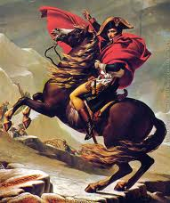
Napoleon Bonaparte to the Rescue
- October 1795-
- “Savior of the French Republic”
- 1796-
- Crossed the Alps & won
The End of the Directory
- 1799-
- Nov 1799-Napoleon’s troops surrounded the legislature & drove out its members

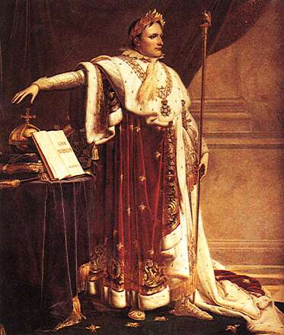
- Est. group of 3 consuls
- Napoleon is 1st consul
- “Blow to the state”
Napoleon Rules France
- 1800-Plebiscite held to approve a new constitution
- Plebiscite-
- 1804-
- Dec. 12- crowned @ Notre Dame Cathedral
Changes Under Napoleon
Social
Political
Economic
Napoleon’s New World Empire
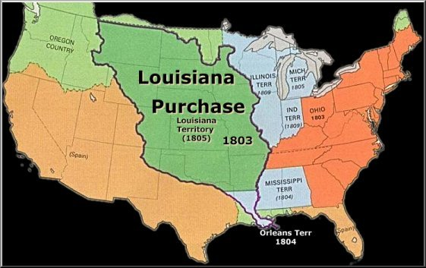
- 1789-Colony of Saint Domingue (Haiti) demand same rights as ppl of France under Nat’l Assembly

- 1801-
- 1803-
Napoleon’s European Empire
- Annexed Austrian Netherlands & parts of Italy
- Set up “puppet govt” in Switzerland
- GB, Russia, Austria & Sweden joined forces vs France
- Crushed by Napoleon

Battle of Trafalgar

- Nelson split Fr. Navy & captured their ship
- Effects of the Battle:

The French Empire
- By 1812-

- NOT under Fr. Control
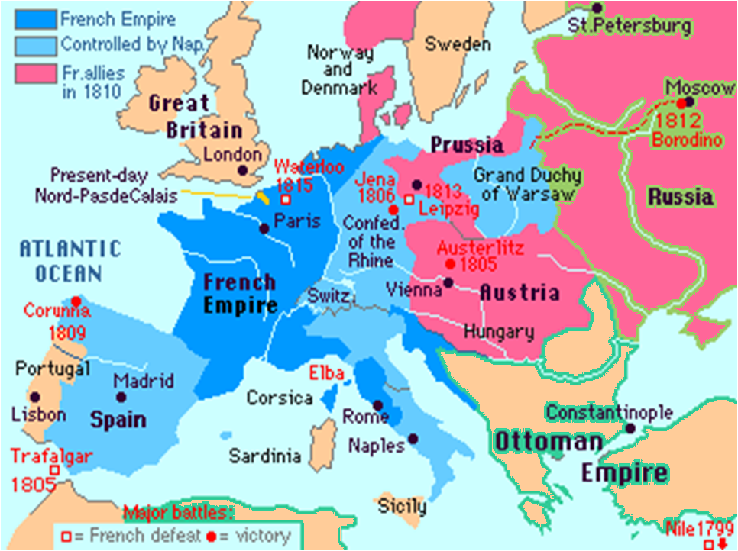

- Alliances

- “Puppet Govts”

The Fall of Napoleon
Napoleon’s First Mistake
- Nov. 1806-
- Blockade-

- Purpose was to make continental Europe more self-sufficient & destroys GB’s econ.
- Did not work

Napoleon’s Second Mistake
- 1808-
- Portugal refused to accept the Continental Sys.

- Spanish used guerillas
- Guerillas-
- Aided by GB
- France lost 300,000 men
Napoleon’s Third & Most Costly Mistake
- Alexander I of Russia refused to stop selling grain to GB
- June 1812-
- Alex pulls back his troops
- Scorched-Earth Policy-
- Sept 14, 1812-
- Stayed in Moscow until mid-October
- Heads back to France in the middle of the Russian winter!!
- Only ~10,000 of original 420,000 were left when they reached France
Napoleon’s Downfall

- Oct. 1813-Weak Fr. army faces army of Euro. Powers at Leizig

- 1814-Prussian and Russian forces reach Paris
- April 1814-Nap. surrenders and gives up throne

The Hundred Days War

- March 1, 1815-
- Within days, Nap. is emperor again
- Euro. Powers join together against Nap.
- June 18, 1815-

- Prussia arrives to aid GB
- GB & Prussia defeat Nap.
Napoleon Gets the Boot

- Wrote his memoirs
- Lived alone until his death of a stomach ailment in 1821

DIRECTIONS: Using Ch 23 Sect 5 (pgs 672-673), complete the chart.

Metternich’s Plan
Problem | Solution

