How did the end of World War I impact Germany?
Objectives: Describe how the end of World War I impacted Germany.

1919-1929: The Weimar Republic
The Birth of the Weimar Republic  In November of 1918, Germany surrendered in World War I. In 1919, the Treaty of Versailles was signed and deprived Germany of various territories, demilitarized the country, and forced Germany to pay heavy reparations. With the ending of World War I and Germany’s defeat, the imperial government came to an end and German leaders created a democratic government known as the Weimar Republic. In this new democratic government, there was a chancellor or prime minister. Under this new democratic government, women were allowed to vote, there was a bill of rights and political parties were able to form.  Problems in the Weimar Republic  Despite the hopes of a new democracy, Germany suffered from a range of early political and economic problems.  Political Problems  Politically, the Weimar Republic had many small political parties so it was nearly impossible to form a coalition. The Weimar Republic was criticized by both conservatives and leftists. Conservatives thought the Weimar Republic was too weak. Leftists and communists demanded the changes they’d heard Lenin brought to Russia. In addition to the critiques of the Weimar Republic, many Germans were still angered by the terms of the Treaty of Versailles. Having to pay such large reparations negatively impacted the economy. Not only did the Treaty of Versailles impact the economy, it also impacted German nationalism and the sense of pride they had for their country. Germans of all classes began to believe the Weimar Republic was weak and not doing enough to protect German pride.  Economic Problems  The political problems were compounded by economic problems. In 1922 and 1923, Germany experienced rampant inflation. Inflation is the rise in prices and the fall in the value of money. Many Germans who lived on fixed government incomes found their money to be worthless. In addition to inflation, Germany began to fall behind on reparation payments as mandated in the Treaty of Versailles. When the Weimar Republic was unable to make payments, France occupied the Ruhr Valley. The German workers in Ruhr Valley refused to work, but were still paid by the government with newly printed money. The newly printed money only created more inflation and soon the German currency (marks) were worthless.  Angered, bittered and humiliated, Germans began to look for scapegoats [people who are unfairly blamed for all problems] to explain their political and economic problems. Many Germans looked to German Jews as the reason for Germany’s problems. These political and economic problems caused many people to lose faith in the Weimar Republic and they began to look to extremist leaders to solve the problems it seemed the Weimar Republic was unable to solve.  To help the economy recover, the United States loaned Germany money and a new plan was developed by Western nations to reduce reparation payments. Between 1924 and 1929, Germany was able to experience a period of prosperity. | Directions: Read the excerpt. Respond to the questions.  1. What did the Treaty of Versailles require Germany to do?  2. What form of government emerged after Germany’s defeat in World War I?  3. In this new government, what three new freedoms were Germans granted?  4. Identify three political problems in the Weimar Republic.  5. Identify two (2) economic problems in the Weimar Republic.  6. Why did the scapegoating of Jewish people happen during these times of political and economic trouble in Germany?  7. Why did Germans begin to look to extremist leaders during these times of political and economic trouble?  8. How was Germany able to experience a period of prosperity between 1924 and 1929?

How did Hitler gain, consolidate and maintain power in Germany before the Great Depression?
Objectives: Describe how Hitler gained, consolidated and maintained power in Germany prior to the Great Depression.

1919-1929: The Rise of the Adolf Hitler
Hitler’s rise to power cannot be attributed to one event. There were multiple causes for Hitler’s rise to power including events happening throughout the world and events happening within Germany. Hitler was able to exploit these events and in 1933 he legitimately gained power to become chancellor through the support of conservative politicians.

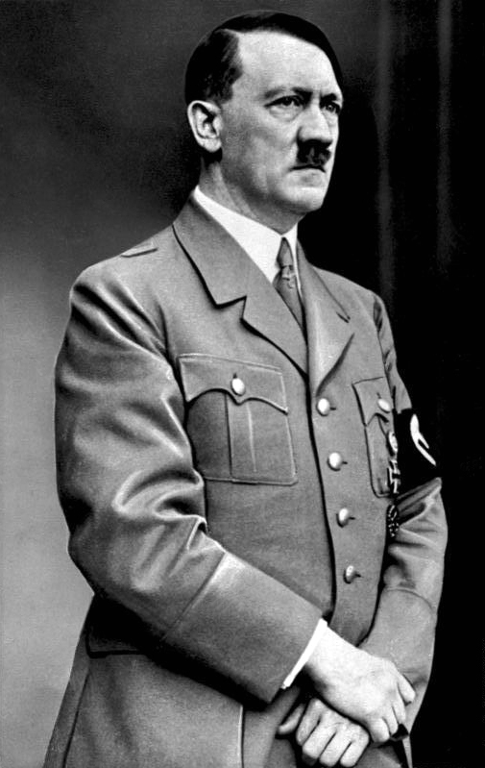  Source: https://commons.wikimedia.org/wiki/Adolf_Hitler#/media/File:Bundesarchiv_Bild_183-S33882,_Adolf_Hitler_retouched.jpg  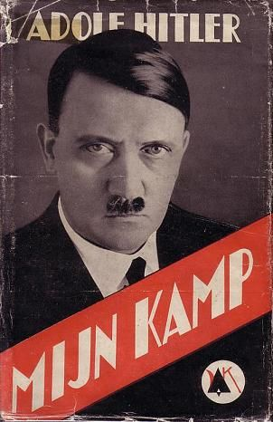  Dutch edition of Adolf Hitler's Mein Kampf. Mijn kamp, translated by Steven Barends. Publ. by De Amsterdamsche Keurkamer, 1939  Source: https://commons.wikimedia.org/wiki/File:Mijn_kamp_-_Adolf_Hitler_-_Steven_Barends_-_De_Amsterdamsche_Keurkamer_1939_(1e_druk).jpg  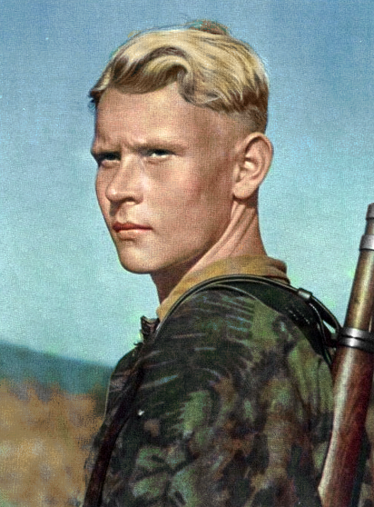  A German soldier from WW2 featuring blonde hair, blue eyes, long head, a smooth straight nose, and presumably tall stature - the stereotyped physical appearance of the Nordic race, which was said to be the most pure sub-race of the Aryan race.  Source: https://en.wikipedia.org/wiki/Nazism_and_race#/media/File:German_soldier_from_ww2.png | Directions: Read the excerpt below. Respond to the questions.  Hitler’s Early Life  In 1919, Hitler joined a the German Worker’s Party, a right-wing extreme nationalist party in Munich. This party focused on creating a scapegoat for the outbreak of the war and Germany's defeat. The scapegoats were found in "international Jewry," communists and politicians across the party spectrum. He quickly moved up the ranks in this organization and grew into an effective speaker and delivered speeches in front of large crowds in Munich. His speeches spoke against the Treaty of Versailles, Marxists and Jewish people. His speeches brought large crowds because of the economic crisis and the continued anger over the World War I defeat and the terms of the Treaty of Versailles. In July 1921, Hitler was introduced as Führer and Hitler changed the name of the party to the National Socialist German Workers Party, or Nazi party for short.  What type of political group did Hitler join when the war ended? Why?  Hitler began delivering speeches with his political organization. What was the topic of his speeches? Why did this draw in crowds?  The Beer Hall Putsch and Hitler’s Incarceration  By 1923, the Nazi party had 55,000 members and was stronger than ever. Still angered by the economic and political problems of inflation and poor leadership, Hitler decided to take matters into his own hands. From November 8 to November 9, 1923, Hitler and his followers staged the Beer Hall Putsch in Munich, a failed takeover of the government in Bavaria, a state in southern Germany. The Nazi party was banned, and Hitler was prevented from speaking in public until 1927 because his speeches were considered too inflammatory and agitating. In April 1924, he was sentenced to 5 years in jail for treason. While the takeover was unsuccessful, the attempt brought Hitler and the Nazis national attention.  What was the Beer Hall Putsch? Why did Hitler do this?  What was the impact of the Beer Hall Putsch?  Why was Hitler banned from public speeches until 1927?  While incarcerated, Hitler wrote a manifesto [a public declaration of policy and ideas] entitled Mein Kampf (“My Struggle”). This text outlined the ideas that inspired his millions of followers. The manifesto illustrates his strong and extreme German nationalism, his violent anti-semitism [hostility to or prejudice against Jews] and his anticommunism.  What did Hitler write during his incarceration?  Some of the ideas discussed in Mein Kampf include:  Anti-Semitism Racial Purity “Undesirables”  - Hitler blamed Germany's problems on the parliament of the Weimar Republic, the Jews, and Social Democrats, as well as Marxists. He believed that all of these people were all working for Jewish interests. He wrote about the Jews as corrupters of the nation that should be subjected to poison gas. • Hitler believed that racial purity was an absolute necessity for a renewed Germany • Hitler divided humans into categories. At the top, is the Germanic man with his fair skin, blond hair and blue eyes. Hitler refers to this type of person as an Aryan. Hitler believed that Aryans were the supreme form of humans, or master race and that everyone else was inferior. • Hitler stated that the destruction of the weak and sick is far more humane than their protection. Hitler believed in destroying "the weak" in order to provide the proper space and purity for the "strong".  According to Mein Kampf, what were Hitler’s views on Jewish people?  According to Mein Kampf, what were Hitler’s views on “racial purity”?  According to Mein Kampf, what were Hitler’s views on “undesirables”?  How did Hitler imagine the future of Germany?  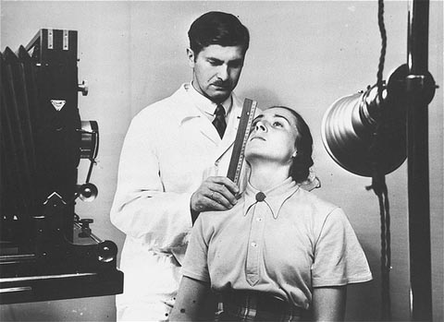 At the Kaiser Wilhelm Institute for Anthropology, Human Genetics, and Eugenics, a racial hygienist measures a woman's features in an attempt to determine her racial ancestry. Berlin, Germany, date uncertain. — National Archives and Records Administration, College Park, Md. Source: http://www.ushmm.org/outreach/en/media_ph.php?ModuleId=10007679&MediaId=7007  Hitler only served nine months of his five year sentence. During his incarceration, he decided that the success of the Nazis lie not in a violent overthrow of the Weimar Republic, but by winning power through constitutional means. Once he legally gained power, he could transform Germany into a nation that aligned with his doctrine. Upon his release, Hitler reorganized the Nazi party into a proper political organization and sought to compete for votes with other political parties. By 1929, the Nazi party had become an official national political party.  How did Hitler’s incarceration impact his decision about how he would gain power in Germany?  Adapted from: http://www.newworldencyclopedia.org/entry/Adolf_Hitler, http://www.bbc.co.uk/schools/gcsebitesize/history/mwh/germany/munichputschrev_print.shtml

What caused the Great Depression? How did the Great Depression impact the rise of totalitarian dictators?
Objectives: Describe the causes of the Great Depression and the impact on the rise of totalitarian dictators.

1930: The Great Depression
Directions: Read the excerpt below. Respond to the questions.

One major cause of the global Great Depression was the American Wall Street Crash of October 1929. America had given the Weimar Republic huge loans in 1924 to help with reparation payments. However, now America needed those loans back to assist its troubled economy. Because Germany lost its loans from America, it was unable to make reparation payments. Germany’s failure to make reparation payments meant that France and Britain were unable to make their loan payments. Throughout the world, trade began to slow down and production decreased. The Wall Street Crash had a ripple effect throughout the world that resulted in high unemployment throughout Europe. Unemployment forced many Europeans, especially in Germany, to rely on soup kitchens and other government support.

What caused the Great Depression? | How did the Great Depression impact European nations?

European governments seemed unable to handle the crisis. The traditional approaches to handling economic crises seemed to only cause more problems. With the current governments unable to ease the pain and suffering of unemployment and inflation, Europeans began to be drawn to totalitarian leaders who made promises about economic recovery. Totalitarianism is a political system in which all authority is in the hands of the state. In a totalitarian society, all control of public and private life are government run. In Stalin’s totalitarian communist government there was no ownership of private property. In totalitarian fascist there is private property and free enterprise with often severe restrictions. Although fascist governments differed, they had many characteristics in common such as extreme militaristic nationalism, a rejection of democracy, a belief in natural social hierarchy, and the limitation of individual rights. Fascist governments used violence, propaganda and intimidation to promote their ideas and to justify their control of every aspect of life. In a fascist government Europe’s first fascist leader was Benito Mussolini of Italy.

Question on following page
How did the Great Depression lead to the rise of totalitarian leaders?

Fascism is a term that was originally referred to the fascists of Italy under Mussolini. Nazism on the other hand, referred as National Socialism, is in an ideological concept of the Nazi Party or the National Socialist German Workers’ Party of Adolf Hitler.

Fascism believes in the ‘corporatism’ [the control of a state or organization by large interest groups] of all elements in society to form an ‘Organic State’. They were not racial and had no strong opinion of any race. For Fascists, the state was the most important element. The Doctrine of Fascism, which is the authoritative document of the fascism, emphasis on nationalism, corporatism, totalitarianism and militarism. According to this Doctrine the State is all embracing and no human or spiritual value exists beyond it.

But Nazism emphasized on racism. While fascism considered state as important, Nazism considered ‘Aryanism’ as more important. The Nazism doctrine believed in the superiority of the Aryan race.

While fascism was based on certain political ideology, Nazism was blindly based on racial hatred. Nazism considered class based society as enemy and stood for unifying the racial element. But fascism wanted to preserve the class system. The fascists almost accepted the concept of social mobility, while Nazism was against it.

Nazism considered state as a means for the advancement of the master race. But fascism considered state to be a form of nationalism. Fascists considered nationalism as something related to national culture as opposed to other cultures.
Source: http://www.differencebetween.net/miscellaneous/difference-between-fascism-and-nazism/
Nazism | Both | Fascism

