Name: Date:
Global 9/Period: Effects of the Neolithic
Effects of the Neolithic
Directions: Watch the video entitled “Human Prehistory 101 (Part 3 of 3): Agriculture Rocks Our World” from 23andMe, which can be found on my website or by scanning the QR code, and read through the infographic below and complete the activity and questions that follow.

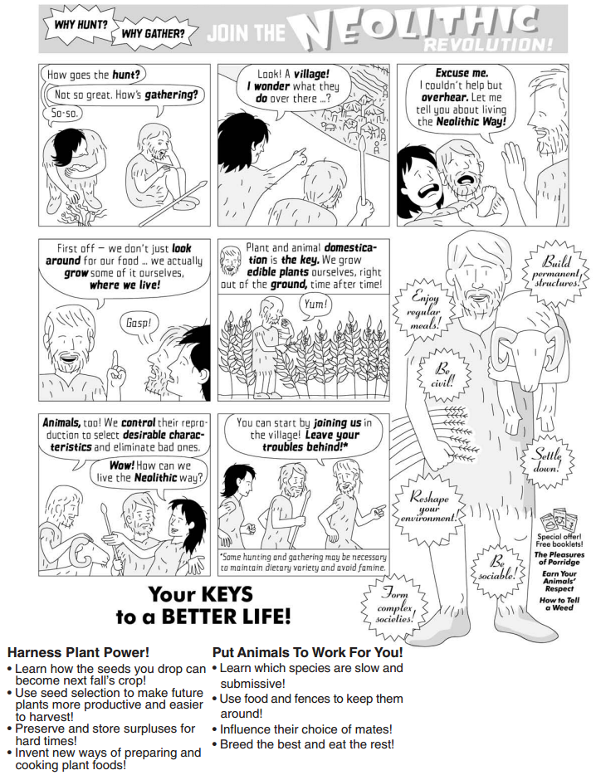
Hunting and Gathering |  | Agriculture
+  advantages | -  disadvantages | +  advantages | -  disadvantages

What was the Neolithic Revolution? What effects did it have?

Directions: Based on what you have learned about the Neolithic Revolution, complete the prompts below.

1. Explain what the Neolithic Revolution was.

2. Identify at least three effects of the Neolithic Revolution in the graphic organizer below.
