The Opium War

1.

Great Britain
2.
China
3.

4.

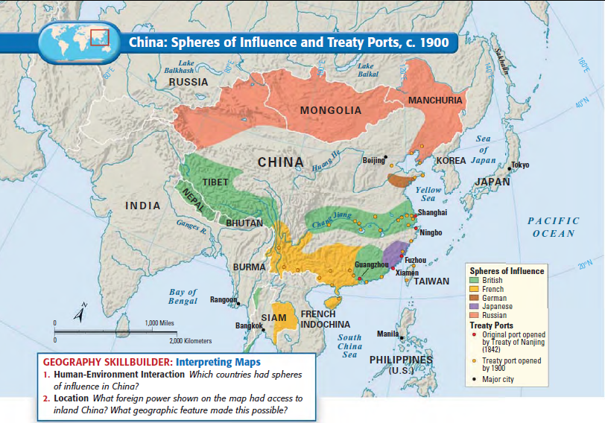
IMPERIALISM IN CHINA

China’s Problems

INTERNAL PROBLEMS | EXTERNAL PROBLEMS

IMPERIALISM IN CHINA VOCABULARY

