What was the geographic and historical context
for the founding of the Ottoman Empire?
- Describe the geographic context for founding of the Ottoman Empire.
➡ Directions: Examine the images below, then complete the questions that follow.
Think Like a Geographer | 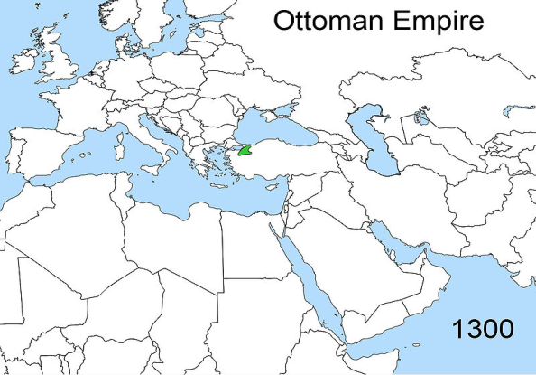 | 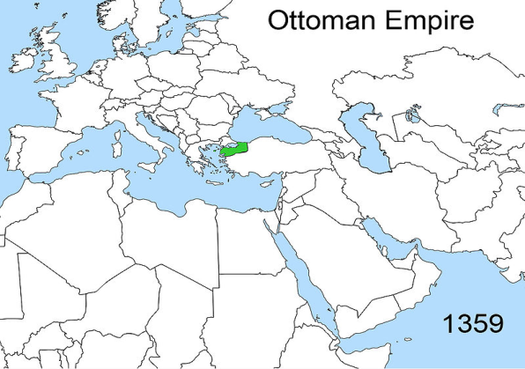 | 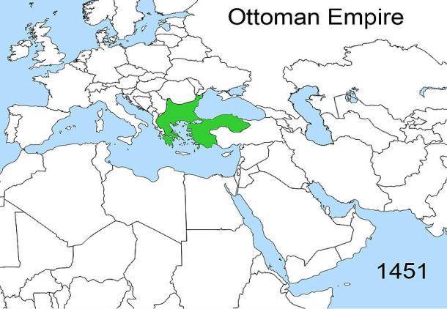
 | 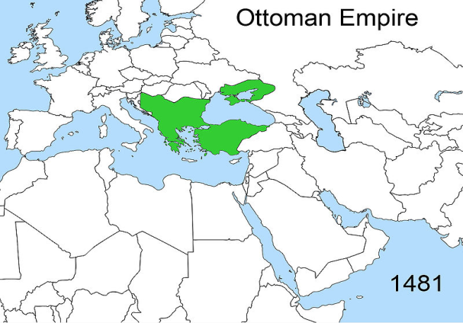 | 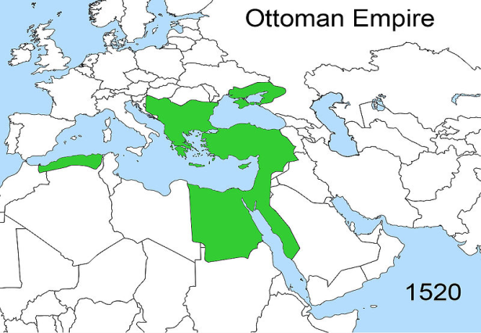 | 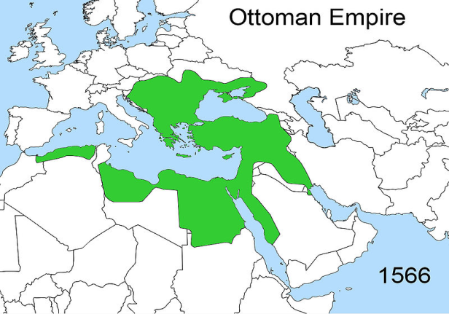
Source: http://en.wikipedia.org/wiki/Ottoman_Greece#/media/File:Territorial_changes_of_the_Ottoman_Empire_1566.jpg
Know  List three things you know in maps above. | Think  Based on your observations, what do you think caused the changes in the maps above. | Wonder  Write two questions you have about the maps above.

At the height of its power, the Ottoman Empire under Suleiman (1520-1566) controlled large territory in three continents:

_________________________________, _______________________________, and _______________________________.

As the Ottoman Empire grew, new people, particularly non-Muslims, became part of the empire. The Ottoman Empire was diverse and composed of three major religious and ethnic groups:

Muslims | Christians | Jews
Flashback: What is one similarity between Muslims, Christians and Jews?_________________________________________________.
Although conversion to Islam was not demanded of the conquered, many Christians and a few Jews voluntarily converted to have full rights in the empire. Those who did not convert continued to practice their old religions without restriction.

For centuries, the Ottoman Empire was the refuge of the Jewish people of Europe, who did not have the freedom of religion in Europe that the citizens of the Ottoman Empire did. Jews expelled from Spain in 1492 found refuge in the Balkans and elsewhere in Ottoman territory, where the sultan decreed they should be welcomed.
Source: http://www.newworldencyclopedia.org/entry/Ottoman_Empire
How were non-Muslims treated in the Ottoman Empire?

For centuries, why did Jewish people migrate to the Ottoman Empire?

The Rise of the Ottoman Empire
Directions: Examine the timeline and images below, then respond to the questions.
The Ottomans were a Muslim Turkish-speaking nomadic people who migrated from Central Asia in northwestern Asia Minor. They quickly conquered other societies and expanded their empire.

The Battle of Ager Sanguinis, medieval miniature  Source: https://en.wikipedia.org/wiki/Battle_of_Ager_Sanguinis#/media/File:Battle-of-Ager-Sanguinis.jpg | 1096-1290s: The Crusades were fought between Muslims and Christians.  - Using your prior knowledge, what sparked the Crusades?  - How did the Crusades affect the relationship between Christians and Muslims?
An imagined portrait of Osman I.  Source: https://en.wikipedia.org/wiki/Osman_I#/media/File:Osman_Gazi2.jpg | 1326: A leader named Osman and his Turkish warriors (Ottomans) took over areas of Asia Minor and the Balkan Peninsula in Eastern Europe near the Byzantine Empire.  - How might Christian leaders of the Byzantine Empire feel about the Muslim Ottomans taking over territory so close to the Byzantine Empire? Explain.
The entry of Sultan Mehmed II into Constantinople  Source: https://en.wikipedia.org/wiki/Mehmed_the_Conqueror#/media/File:Zonaro_GatesofConst.jpg | 1453: Under the leader, Mehmet II, the Ottomans continue to expand and capture the capital of the Byzantine Empire, Constantinople. Constantinople was renamed Istanbul and became the new capital of the Ottoman Empire. Hagia Sophia, a church, was turned into a mosque. After a 54 day siege and using a 27-foot cannon hauled by oxen and an advanced army with muskets [guns], Constantinople fell to the Ottomans.  - What message do you think the conquest of the Byzantine Empire sent to the rest of Europe?  - Why did the Ottomans convert the Hagia Sophia into a mosque?  - Why was this conquest a turning point in global history?
- Based on this map to your right, why was Constantinople so important to the Ottomans? | Source: Farah and Karls, World History, The Human Experience, Glencoe/McGraw-Hill (adapted) from the NYS Global History and Geography Regents Examination, August 2007.
Suleiman I  Source: https://en.wikipedia.org/wiki/Suleiman_the_Magnificent#/media/File:EmperorSuleiman.jpg | 1520-1566: The Ottoman Empire had a golden age under the sultan named Suleiman. The Ottomans called Suleiman “The Lawgiver” and Europeans called him “The Magnificent.” Suleiman also developed laws and enforced the Islamic law of sharia. Suleiman had several accomplishments:  - Took on bold military campaigns that increased the amount of territory controlled by the Ottomans  - Increased naval strength which allowed them to conquer parts of North Africa  - Oversaw achievements of Ottoman civilization in the fields of law, literature, art, and architecture  - Built strong fortresses to defend his territories  - Adorned and modernized the cities of the Islamic world (including Mecca, Damascus, and Baghdad) with mosques, bridges, aqueducts, and other public works  - What are common characteristics of golden ages?  - What were some of Suleiman’s achievements?  - Based on the information provided, could Suleiman’s rule of the Ottoman Empire be considered a Golden Age? Why or why not?
- How might the siege of Vienna affect how Europe viewed the Ottoman Empire? | 1529: Suleiman’s army attacked the city of Vienna, which at the time was located in the Holy Roman Empire and today is located in modern-day Austria . This sent fear throughout Europe because it demonstrated how strong the Ottoman Empire had become and showed that they were a threat to European states. The Ottomans were unsuccessful in conquering Vienna, but they continued to be seen as a threatening empire seeking to conquer Europe.  Source: https://upload.wikimedia.org/wikipedia/en/2/28/OttomanEmpire1683.png

What was the geographic and historical context
for the founding of the Ottoman Empire?

Directions: Using evidence from the documents above, respond to the task below in the space provided.
Think Like a Geographer  Contextualize | At the height of its power, the Ottoman Empire under Suleiman (1520-1566) controlled large territory in three continents:  _________________________________,  _________________________________, and  _________________________________.  Who founded the Ottoman Empire? How did he found the Ottoman Empire?  How did the Ottoman empire gain control over these territories?

