Compare and Contrast:
The Ottomans and the Mughals
DIRECTIONS: Answer the questions using the sources provided. Once you have completed the tasks, compare/contrast the Ottomans and Mughals on the last few pages.

How did the Mughal Empire govern a diverse empire?
Objective: Describe the actions taken by leaders of the Mughal Empire govern a religiously and ethnically diverse empire.
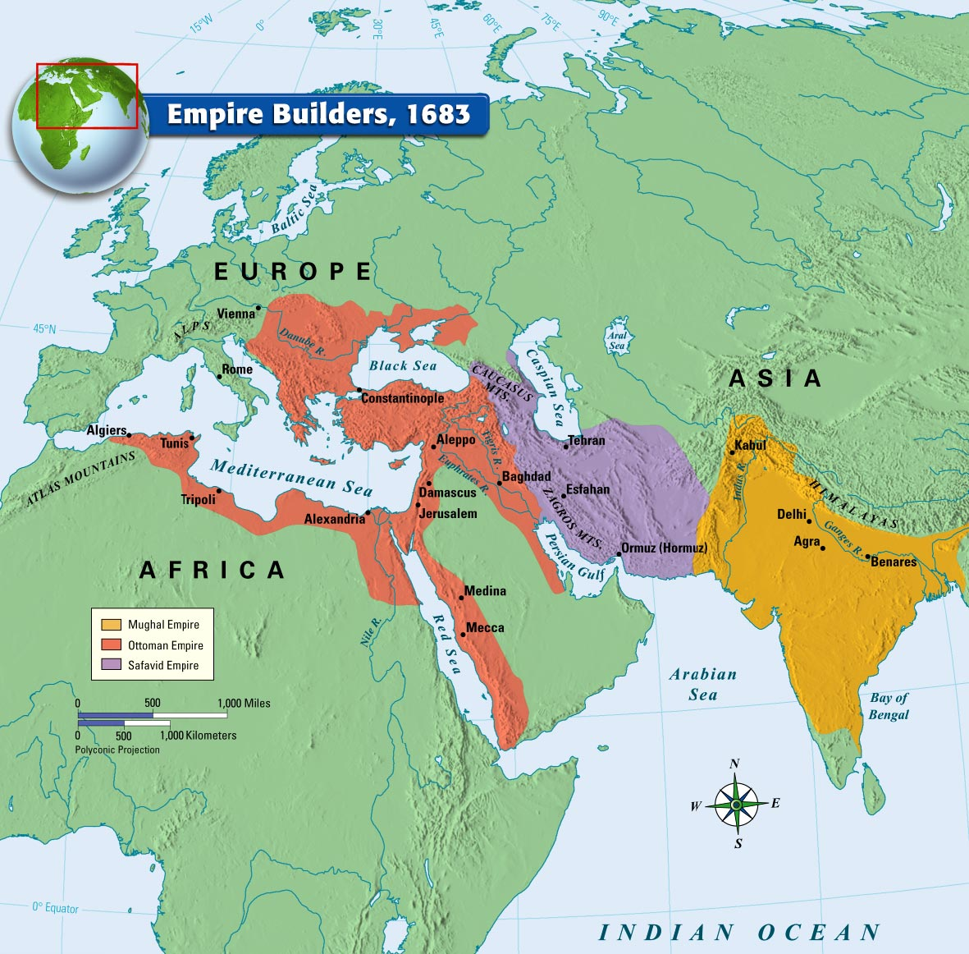
Building an Empire
The world in 1750 was marked by powerful Eurasian empires. The interactions of these empires disrupted regional trade networks and influenced the development of new global trade networks. The rulers of the Mughal Empire and Ottoman Empire were able to build strong and influential empires during this period.
urce:http://images.classwell.com/mcd_xhtml_ebooks/2005_world_history/images/mcd_mwh2005_0618377115_p71_f01.jpg
An Introduction to the Mughal Empire
Directions: Watch The Mughal Empire and Historical Reputation: Crash Course World History #217 (https://goo.gl/T4jwcr) and respond to the questions below. (Watch 0:40-3:45)
0:40 | What religion were the rulers of the Mughal Empire?__________________________________________________________
1:28 | Why was Babur [the founder of the Mughal Empire] and his followers called “Mughals”?
2:00 | The blending of Indian and Persian culture in the Mughal Empire is an example of _________________________________.
2:08-2:22 | According to John Green, what are two reasons why the Mughal Empire is important to study?
2:24-3:22 | Muslims were a minority in the Mughal Empire. Most people in the empire were Hindu. How did the Muslim Mughal leaders establish control over non-Muslims?
Mughal Empire and Expansion
Directions: With a partner, use the map below to respond to the questions.
The Mughal Empire began in 1526 and lasted until 1857. The empire extended over large parts of the Indian subcontinent.
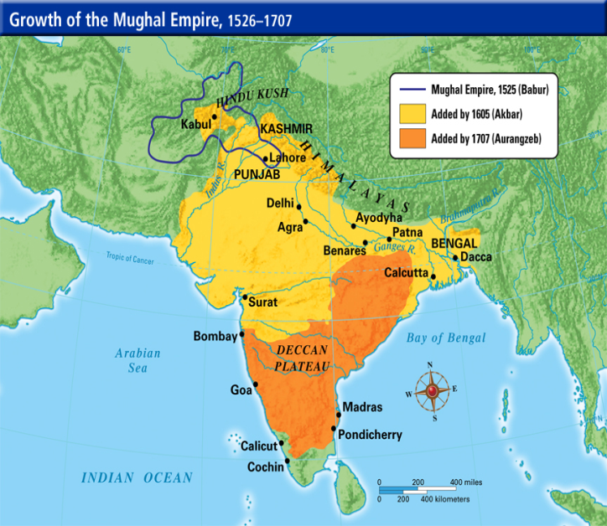 | Using the map to your left, describe how the extent of the Mughal empire changed from the reign of Babur to the reign of Aurangzeb.  What geographic feature prevented the Mughal Empire from expanding further to the north?

The Mughal Empire in Northern India 1500 - 1900
Directions: Watch the Electronic Cultural Atlas Initiative Projects and Affiliates (https://goo.gl/3VHxBa) and respond to the questions below.
What do the holes in the map to your right represent?  What did the animated video of the Mughal Empire’s territorial holdings reveal about the stability of the empire? | 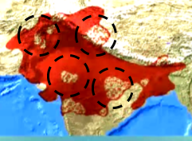
How did different Mughal emperors govern the Mughal empire?
Directions: Read the excerpt below and respond to the questions.
The Mughal Empire was an empire that at its greatest territorial extent ruled parts of modern day Pakistan and most of the Indian Subcontinent between 1526 and 1857. The empire was founded by the Mongol leader Babur in 1526, The word "Mughal" is the Indo-Aryan version of "Mongol." The Mughals retained aspects of Mongol culture well into the sixteenth century. The Mughal ruling class was Muslim, although many of the subjects of the empire were Hindu and also Sikh. When Babur first founded the empire, he did not emphasize his religion, but rather his Mongol heritage. The empire he founded was a sophisticated civilization based on religious toleration. Under Babur, Hinduism was tolerated and new Hindu temples were built with his permission.  The third Emperor, Abu Akbar also referred to as "Akbar the Great" is regarded as one of the great rulers of all time, regardless of country. He was an absolute ruler who was interested in all beliefs doctrines at a time when religious persecution was common throughout Europe and Asia. By the time of his death in 1605 he ruled over most of north, central, and western India. Akbar worked hard to win over the hearts and minds of the Hindu leaders. While this may well have been for political reasons - he married a Hindu princess. Akbar believed that all religions should be tolerated, and that a ruler's duty was to treat all people equally, whatever their belief. Therefore, he abolished the jizya, a tax paid by non-Muslims in return for religious liberty. Akbar's government included many Hindus who were allowed to reach senior government or military positions of responsibility - the governed were allowed to take a major part in the governing.  Akbar established the mansabdar system to generate land revenue and control the empire. The emperor would give the mansabdar (a military officer) the right to tax the people in the area they managed in exchange for promises of soldiers in wartime. The greater the size of the land the emperor granted, the greater the number of soldiers the mansabdar had to promise. Because the power of the mansabdar was not permanent and could not be permanent, the Emperor still maintained significant control over the large empire.  By 1707, when the last great Mughal Emperor died, the empire had begun to decline. Unfortunately, the religious tolerance that previously existed in the empire had been reversed. Because Aurangzeb was a very observant and religious Muslim he imposed Islamic law over the whole empire. As a result, all non-Muslims were no longer allowed to live under their own laws and customs. Thousands of Hindu temples and shrines were torn down and jizya, the tax which had been previously abolished by Abu Akbar, was re-imposed. The intolerance towards non-Muslims led to rebellion throughout the empire and the Mansabdar system was no longer effective in maintaining control.  Source: Adapted from http://www.newworldencyclopedia.org/entry/Mughal_Empire  http://www.bbc.co.uk/religion/religions/islam/history/mughalempire_1.shtml |  | 1. Where was the location of the Mughal Empire at its greatest territorial extent?  2. What religion was the ruling class in Mughal Empire? What religion were the majority of the people?  3. Identify at least two policies towards non-Muslims under the rule of Babur. Why do you think religious groups were treated this way?  4. Akbar the Great is “regarded as one of the great rulers of all time, regardless of country.” Why is he held in such high esteem?  5. Identify at least two policies towards non-Muslims under the rule of Akbar the Great. Why do you think religious groups were treated this way?  6. Describe the mansabdar system. How did this system allow Akbar the Great to have greater control and power?  7. Identify at least two of Aurangzeb's religious policies.  8. How were Aurangzeb’s policies different from Babur and Akbar the Great? Why was his approach to religious tolerance different?  9. What impact did Aurangzeb’s policies have on the empire?  10. Under which emperor(s) was the Mughal empire the most stable? Explain how religious tolerance impacted stability in the Mughal empire?

How did the Ottoman Empire govern a diverse empire?
Objective: Describe the actions taken by leaders of the Ottoman Empire to govern a religiously and ethnically diverse empire.
Some Reminders About the Ottoman Empire Empire
Years | Main Ruler | Ruling Religion | Region
1299-1922 | 1520-1566 Suleiman the Magnificent  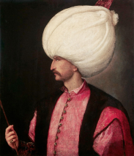 | ________________________ | Europe, Africa, Asia  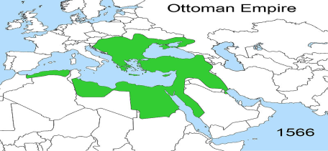
An Introduction to the Ottoman Empire
Directions: Watch Venice and the Ottoman Empire: Crash Course World History #19 (https://goo.gl/r2dQCh) and respond to the questions below. (Watch 04:44-08:20)
5:36 | Under which Sultan did the Ottoman Empire reach its greatest height? __________________________________
5:54-6:05 | The Ottoman Empire controlled about half of what the Roman Empire once controlled, but why was it much more valuable?
6:15-8:30 | What is the problem with hereditary nobles? How did the Ottoman Empire solve this problem? How did this help the Sultan maintain power?

Ottoman Empire and Expansion
Directions: Using the video (https://goo.gl/IR8G6h) and the images below, observe how the Ottoman Empire’s territory changed over time.
The Ottoman Empire began in 1299 and lasted until 1922.
The empire extended over large parts of the three continents: Africa, Asia and Europe.
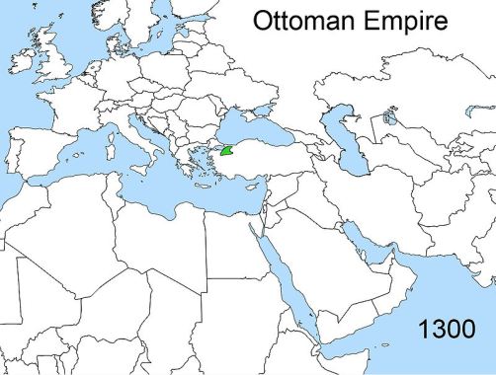 | 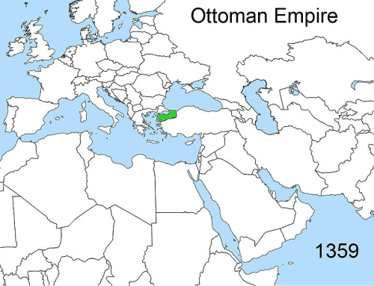 | 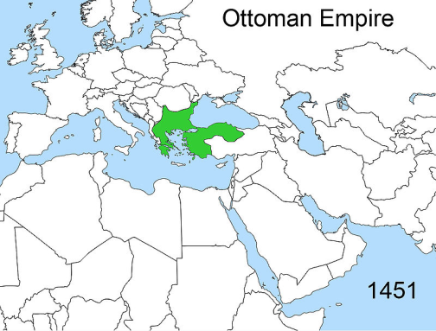 | 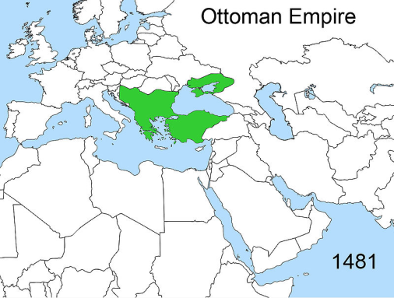
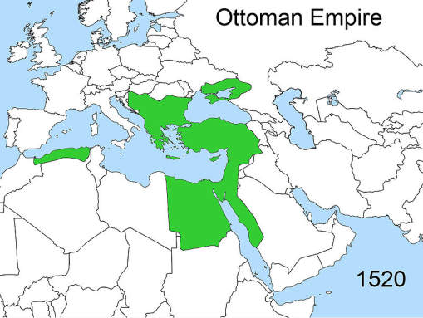 | 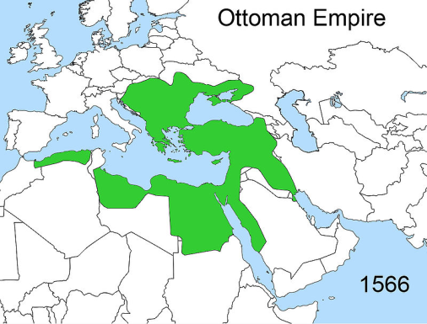 | 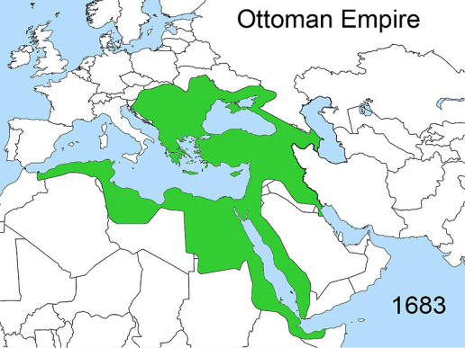 | 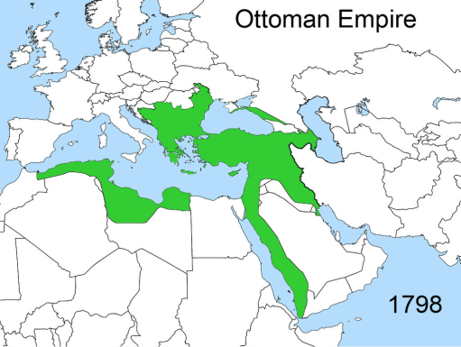
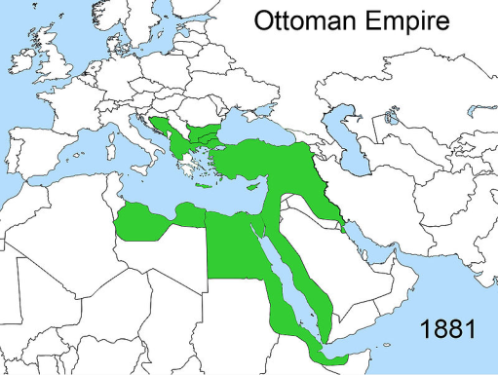 | 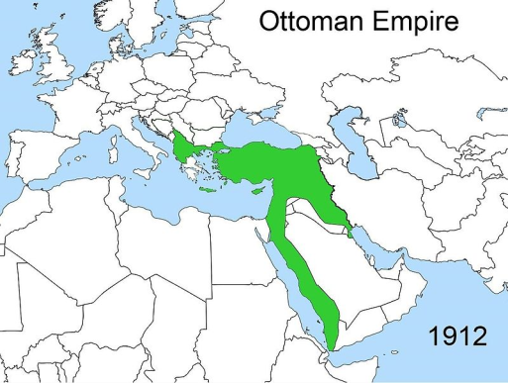 | 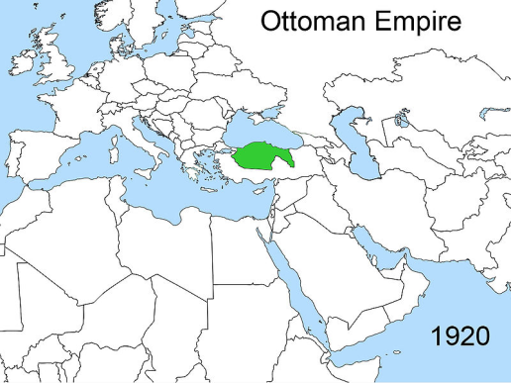 | What do the animated video and maps above of the Ottoman Empire’s territorial holdings reveal about the stability of the empire?
Source: http://en.wikipedia.org/wiki/Ottoman_Greece#/media/File:Territorial_changes_of_the_Ottoman_Empire_1566.jpg

How did different Ottoman emperors govern the Ottoman Empire?
Directions: Read the excerpt below and respond to the questions.
The Ottoman Empire was the one of the largest and longest lasting empires in history. It was an empire inspired and sustained by Islam and Islamic institutions. It replaced the Byzantine Empire as the major power in the Eastern Mediterranean. The Ottoman Empire reached its height under Suleiman the Magnificent (reigned 1520-66), when it expanded to parts of three continents-- Asia, Africa and Europe. The city of Constantinople, which was renamed to Istanbul after the conquest of the Byzantine Empire, became the center of the Ottoman Empire. At its peak it included: modern-day Turkey, Egypt, Greece, Bulgaria, Romania, Macedonia, Hungary, Palestine, Jordan, Lebanon, Syria, parts of Arabia, and much of the coastal strip of North Africa.  Istanbul became not only a political and military capital, but because of its position at the junction of Europe, Africa, and Asia, one of the great trade centres of the world. Another important city was Bursa, which was a centers of the silk trade. Some of the later Ottoman conquests were clearly intended to give them control of other trade routes. Among the goods traded were: silk and other cloth, musk, rhubarb, porcelain from China, spices such as pepper, and dyestuffs such as indigo. The economic strength of the empire also owed much to Sultan Mehmet's policy of increasing the number of traders and artisans in the empire. He first encouraged merchants to move to Istanbul, and later forcibly resettled merchants from captured territories.  Because the Ottoman Empire spanned three continents, the population of the empire included non-Muslims such as Jews and Christians. These non-Muslim communities were organized according to the millet system. The millet system gave non-Muslim groups a limited amount of power to regulate their own affairs. Some millet groups were required to pay a jizya tax in return for protection and the right to practice their religion. Each millet was under the supervision of a leader, most often a religious patriarch, who reported directly to the Ottoman Sultan. The millets had a great deal of power—they set their own laws and collected and distributed their own taxes. In return, the empire insisted that the millets remain loyal.  Ottoman state organization was based on a hierarchy with the sultan (ruler) who was a Caliph (Islamic leader) at the top. The primary responsibility of the sultan was to ensure that justice was served. A body called the Diwan advised the sultan. Public opinion was regarded as important and the Ottomans made some use of polls to ascertain the popular will. All laws and taxes were posted in public so that the people knew their content. Provinces were originally governed by designated local military leaders, who often acquired large landholdings and passed the position on to their offspring. Provinces were subdivided into smaller units. The leaders of the millets collected taxes and oversaw their community’s legal systems. At times, the millet leaders and the sultan's representatives worked closely together, but sometimes clashed.  Source: Adapted from http://www.bbc.co.uk/religion/religions/islam/history/ottomanempire_1.shtm  http://www.newworldencyclopedia.org/entry/Ottoman_Empire |  | 1.Where was the location of the Ottoman Empire at its greatest territorial extent?  2. Under which leader did the Ottoman Empire reach the height of its power?  3. What geographic situation allowed the Ottoman Empire to become one of the great trade centers of the world?  4. Why did the Ottoman Empire continue to conquer more land?  5. What were three religious groups in the Ottoman Empire?  6. How were non-Muslim communities organized? What effect could this system have on maintaining control?  7. What influence do you think religious tolerance and the structure of government had on maintaining control of the empire?  8. How was the "Ottoman state" organized?  9. Why was public opinion important to the Ottoman Empire? How did collecting polls create order and stability in the Ottoman Empire?  10. Why were laws publicly posted? What impact might this have on maintaining control and stability?

How were the Mughal Empire and Ottoman Empire similar? How were they different?
Objective: Compare and contrast the Mughal Empire and Ottoman Empire's views on religious and ethnic tolerance and political organization.

Directions: Using your notes from the questions above, complete the compare and contrast chart below and respond to the questions.

 | Mughal Empire | Ottoman Empire
Region
Years of Reign
Ruling Religion
Strategies for Governing of Diverse Empire
Structure of Government
Names of Important Leaders

Based on all of the information you have gathered from the Mughal Empire and Ottoman Empire, why do you think both empires became so powerful? | Based on all the information you have gathered from the Mughal Empire and Ottoman Empire, what are the differences in the ways both empires became powerful?

Regents Multiple Choice Check for Understanding
1. Which characteristic is associated with the rule of both Akbar the Great and Suleiman the Magnificent?  (1) promoting equal rights for women  (2) expanding the role of legislative bodies  (3) forcing the conversion of citizens to Christianity  (4) practicing religious tolerance toward members of society | 2. One similarity in the rule of Akbar the Great and the rule of Elizabeth I is that both leaders implemented policies that encouraged  (1) compulsory education  (2) military disarmament  (3) voter participation  (4) religious toleration | 3. Which form of government is associated with the reigns of Suleiman the Magnificent, Akbar the Great, and Peter the Great?  (1) constitutional monarchy  (2) direct democracy  (3) theocracy  (4) absolute monarchy
4. One way in which Akbar the Great, Suleiman the Magnificent, and Philip II are similar is that they  (1) attempted to colonize the Americas  (2) supported democratic reforms in their countries  (3) tried to make Christianity the dominant religion of Asia  (4) controlled large empires at the height of their power | 5. Akbar the Great, Suleiman the Magnificent, and Louis XIV are all rulers associated with  (1) natural rights  (2) filial piety  (3) religious toleration  (4) absolutism | 6. One way in which Suleiman the Magnificent and Akbar the Great are similar is that they both brought about periods of  (1) political stability and religious tolerance  (2) religious conquest and persecution  (3) isolationism and cultural stagnation  (4) modernization and political disunity

