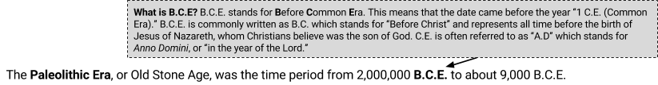
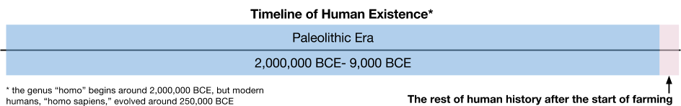

The Paleolithic Era, also known as the Stone Age/Era, is the time period from the evolution of the genus “homo,” that is human-like beings, to around 9,000 BCE when modern day humans started to farm. Modern-day humans evolved around 250,000 BCE, then spread across the world in search of food.

During this time, humans did not live in villages, towns, or cities. Instead, they lived in small groups of less than 100 people and lived a nomadic lifestyle. Nomads are people who frequently move from place to place in search of food, never living in one place for very long. Paleolithic nomads were hunter-gatherers, meaning that they got their food from foraging, the act of finding food, and through hunting or fishing.

Source: Adapted from “Paleolithic Age,” New World Encyclopedia. http://www.newworldencyclopedia.org/entry/Paleolithic_Age
1. When was the Paleolithic Era? | 2. Why did humans spread around the world? | What are nomads? | How did Paleolithic people get their food?

Migration of Humans from Africa to the Rest of the World
Directions: Examine the map below, then respond to the prompts that follow.
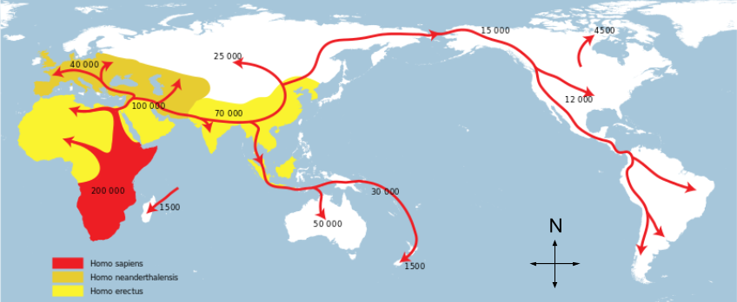
The red arrows on this map depict the spread of modern-day humans (homo sapiens) out of Africa during the Paleolithic Era. Humans followed migrating animal herds and moved into areas with more food to gather until they spread around the world. The numbers identify how many years ago (i.e.: 70,000 years ago) humans arrived in each area.
Source: http://commons.wikimedia.org/wiki/File:Spreading_homo_sapiens_la.svg
1. Label the following bodies of water, continents, and regions on the map above:  Atlantic Ocean Mediterranean Sea North America  Pacific Ocean Africa South America  Indian Ocean Asia Middle East  Southern Ocean Australia | 2. Place the following regions and continents in order from the first place where humans lived, to the last place where they settled.  1 Africa Europe  North America South Africa  Middle East South Asia  Europe | 3. Based on the map above, about how long did it take for humans to migrate to North America from Africa?
 |  | 4. What direction did humans have to travel to get from Asia to North America?
How do we know what we know about prehistory? How is our knowledge limited?

“Prehistory” refers to a time before humans had a written language. The Paleolithic Era took place during prehistory. Since there are no written records, historians rely on other evidence to construct what life was like.

Directions: For each of the sources below, identify what historians might be able to learn about the Paleolithic Era and what limitations each source has for historians.

Artifacts | 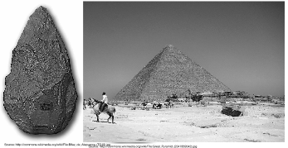 | Skeletons | 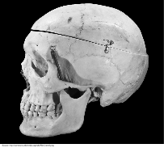
Artifacts are objects made by humans like tools, buildings, weapons, art, pottery, and clothing that are usually found and studied by archaeologists. Archaeology is the study of the past through what has been left by behind. |  | Anthropology is the study of the origins and development of people and their society. Some anthropologists study human skeletons to figure out how they lived, what they ate, and how they died.
1. What can historians learn from artifacts? |  | 3. What can historians learn from skeletons?
2. What limits do artifacts have as historical sources? |  | 4. What limits do skeletons have as historical sources?

Modern Day Societies | 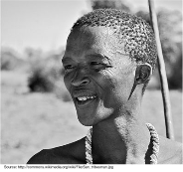 | Genomic Testing | 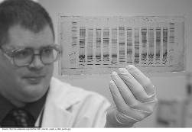
Anthropologists also study modern day societies in hopes that they will better understand how people lived in the past. There are still some people in the world that live like humans did in the Paleolithic Era. |  | Scientists can use genetic tests to determine where and when groups of humans migrated in the past. They can also figure out which groups of people came into contact with one another through genetic markers.
5. What can historians learn from studying modern societies? |  | 7. What can historians learn from genomic testing?
6. What limits do anthropological studies of modern societies have as historical sources? |  | 8. What limits does genomic testing have as a historical source?

