Name: Date:
Global 9/Period: Paleo. vs Neo.

Paleolithic versus Neolithic:
A Document Comparison

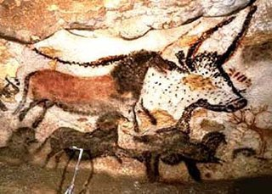

Directions: Annotate and source the documents. Using the information you gather from the documents, fill out the graphic organizer entitled “Paleolithic vs. Neolithic Life” (found at the end of the packet) with information that will help you compare and contrast the two eras.
Paleolithic Era Documents

Document 1

Paleolithic Era (Old Stone Age)
2,000,000 B.C.E. - 8,000 B.C.E.
Lifestyle | Nomadic; in groups of up to 50; tribal society; hunters and gatherers
Economy | There was no concept of private property
Art | Cave paintings, pottery
Technology | Fire; Rough stone tools
Food | Hunted and gathered for food; people followed animal herds that they hunted and moved locations when wild plants in other areas were ripe
Source: Dates from Bulliet, Crossley, Headrick, Hirsch, and Johnson. The Earth and Its Peoples, Cengage Learning, p. 20. Table adapted from http://www.diffen.com/difference/Neolithic_vs_Paleolithic

Document 2

“What Hunters Do for a Living”

A woman gathers on one day enough food to feed her family for three days, and spends the rest of her time resting in camp, doing embroidery, visiting other camps, or entertaining visitors from other camps. For each day at home, kitchen routines, such as cooking, nut cracking, collecting firewood, and fetching water, occupy one to three hours of her time. This rhythm of steady work and steady leisure is maintained throughout the year. The hunters tend to work more frequently than the women, but their schedule is uneven. It is not unusual for a man to hunt avidly for a week and then do no hunting at all for two or three weeks. Since hunting is an unpredictable business and subject to magical control, hunters sometimes experience a run of bad luck and stop hunting for a month or longer. During these periods, visiting, entertaining, and especially dancing are the primary activities of men.
Source: Richard Lee, “What Hunters Do for a Living,” in Man the Hunter, eds. R.B. Lee and I. DeVore (Chicago: Aldine, 1968) adapted from The Big History Project
Document 3
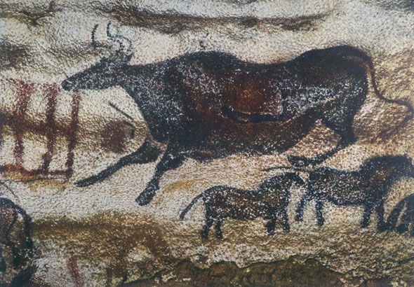
A Paleolithic cave painting in the Lascaux Cave in France depicting a bull and horses, animals that were important to the nomadic hunters that created the images.
Source: International Committee for Preservation of Lascaux. Photo credit: Has Hins. http://www.savelascaux.org/Gallery_photo18.php

Document 4

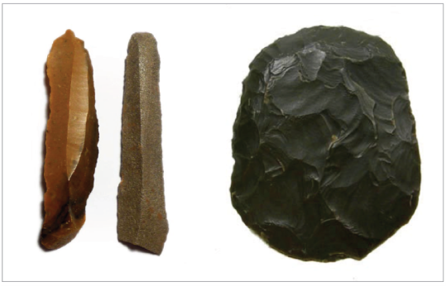
Tools from Hunter-Gatherer Societies

Hunter-gathering societies have used various types of stones, as well as bone and antler, to make a variety of tools such scrapers, blades, arrows, spearheads, needles, awls, fishhooks, and harpoons. The 6.5- to 6.7-cm (2.5- to 2.6-inch) flint blades on the left are from North Africa, dating from 5000–4500 BCE. The 5.7- x 4.6-cm (2.2- x 1.8-inch) scraper on the right is made of green jasper, dates from 5200 to 2500 BCE, and was found in the south-central Sahara Desert.
Source: http://www.worldmuseumofman.org/display.php?item=1167;
http://www.worldmuseumofman.org/display.php?item=434 adapted from The Big History Project.
Document 5
The images below are murals from the Lubbock Lake Landmark in Lubbock, Texas. Based on archaeological evidence, an artist created these images to show the Paleolithic lifestyle that humans living in this area of Texas engaged in from around thirteen thousand years ago to the 1500s.
Document 5a  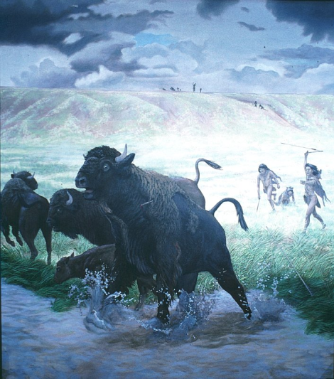 | Document 5b  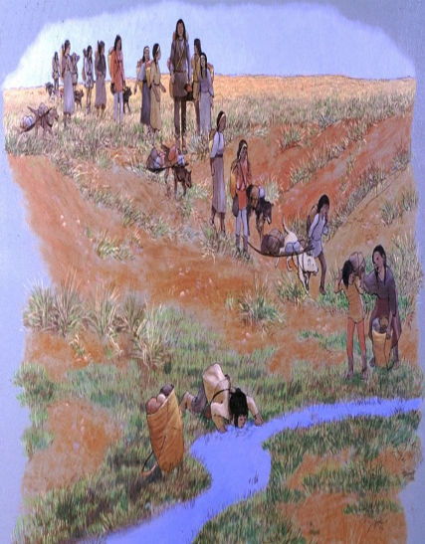l
Source: “Lubbock Lake Landmark” University of Texas at Austin. www.texasbeyondhistory.net/lubbock/images/lubbock-m23.html
Document 6

Should you be Eating like a Caveman?
…Dr. Eaton, a radiologist, and Cordain, an exercise physiologist… believes evolutionary forces dictate that we will live healthiest when we consume a diet similar to what early man ate 2.5 million years ago during the hunter-gatherer days of the Paleolithic Era. This diet included more (low-fat) proteins and (healthy) fats than most of us eat today, and fewer carbohydrates, mainly because Paleo man ate no wheat, rice, or corn whatsoever. These modern grains were not "invented" until 10,000 years ago. In other words, throughout 99.6 percent of our evolutionary history, we ate no bread, pancakes, pasta, or chow mein. As a result, they say, we aren't adapted to process them healthfully.
… Cordain first learned about Paleo nutrition in 1985 when the New England Journal of Medicine published a "Special Article" by Dr. Eaton and his colleague Melvin Konner. In that article, the authors concluded that the Paleo diet contained vastly more vitamin C, fiber, calcium, iron, folate, and essential fatty acids than our current supermarket-based fare. It also contained far less sugar, salt, and saturated fats. They concluded: "The diet of our remote ancestors may be a reference standard for modern human nutrition and a model for defense against certain 'diseases of civilization.'"

It’s easy to make fun of the Paleo diet. Right away, everyone says, “Sure, and how long did your basic caveman live?” About 20 to 25 years, it turns out. But primitive hunter-gatherers didn't die from heart disease, diabetes, and high blood pressure like we do. They died from germs, viruses, and traumas. We live longer today, in large part, because we have sewers, inoculations, and amazing (if expensive) health-care systems.
Source: Amby Burfoot, “Should you be Eating like a Caveman?” Runner's World (Dec 2005)

STOP HERE!

Neolithic Era Documents
Document 1
. . . The Neolithic Revolution also changed the way people lived. In place of scattered hunting communities, the farmers lived in villages. Near groups of villages, small towns grew up, and later cities too. Thus the Neolithic Revolution made civilization itself possible. (The Ancient Near East)

Within the villages, towns and cities, it was possible for people to specialize in the sort of work they could do best. Many stopped producing food at all, making instead tools and other goods that farmers needed, and for which they gave them food in exchange. This process of exchange led to trade and traders, and the growth of trade made it possible for people to specialize even more. . . .
Source: D. M. Knox, The Neolithic Revolution, Greenhaven Press from the NYS Global History and Geography Regents, Jan. 2004.
Document 2
Mesopotamia: Everyday Life
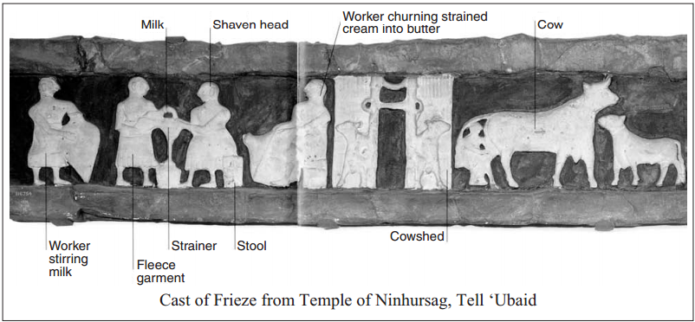
Source: The Visual Dictionary of Ancient Civilizations, Dorling Kindersley (adapted) from the NYS Global History and Geography Regents Exam, January 2010.

Document 3 |  | Document 4
.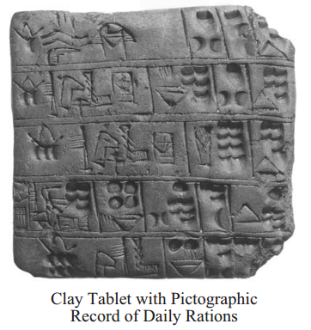 |  | 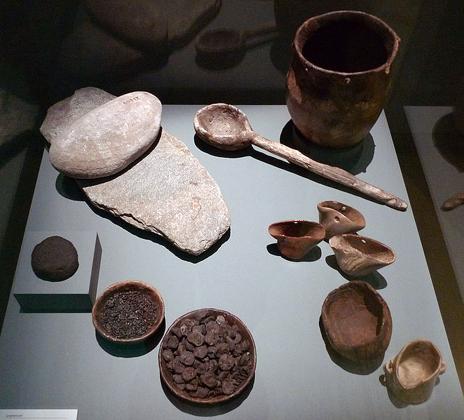  Neolithic cutlery and foodstuffs found at sites in Switzerland. The items include: millstones, charred bread, grains and small apples, a clay cooking pot, and containers made of antlers and wood.
Source: The Visual Dictionary of Ancient Civilizations, Dorling Kindersley (adapted) from the NYS Global History and Geography Regents Exam, January 2010. | Source:https://en.wikipedia.org/wiki/File:HMB_Essen_und_Kochger%C3%A4t_Jungsteinzeit.jpg

Document 5
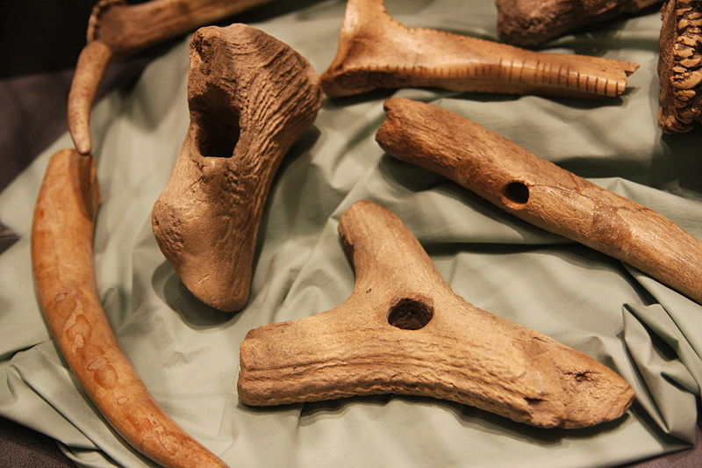
These tools were used by Neolithic farmers to plough fields, plant crops, and harvest the plants. The tools are made out of deer antler.
Source: https://en.wikipedia.org/wiki/File:CucuteniAgriculture.JPG

Document 6
This extract summarizes the findings of several archaeologists in the 1950s and 1960s.

. . . The first archaeological evidence for the domestication of cereals, and some of the earliest evidence for the domestication of animals, comes from a broad region stretching from Greece and Crete in the west to the foothills of the Hindu Kush south of the Caspian in the east. Here are found the wild plants from which wheat and barley were domesticated, whilst it is only in this zone that the wild progenitors [ancestors] of sheep, goats, cattle and pigs were found together, for the latter two had a much broader distribution than wild sheep and goats. By the tenth millennium B.C. peoples who relied upon hunting and gathering were reaping wild barley and wild wheat with knives, grinding the grain and using storage pits. By the sixth millennium there is evidence of village communities growing wheat and barley, and keeping sheep and goats, in Greece and Crete in the west, in southern Turkey, the Galilean uplands of the eastern littoral [coastal region] of the Mediterranean, in the Zagros mountains of Iran and Iraq, the interior plateaux of Iran, and in the foothills southeast of the Caspian. Subsequently the number of domesticated plants grown was increased, including flax, for its oil rather than for fibre, peas, lentils and vetch [plants used for food]. By the fourth millennium the olive, vine and fig, the crops which give traditional Mediterranean agriculture much of its distinctiveness, had been domesticated in the eastern Mediterranean. Cattle and pigs are thought to have been domesticated after sheep and goats. Cattle were used as draught animals, and for meat; not until the late fourth millennium is there evidence of milking in South West Asia. . . .
Source: D. B. Grigg, The Agricultural Systems of the World, Cambridge University Press from the NYS Global History and Geography Regents Exam, January 2004.

Document 7
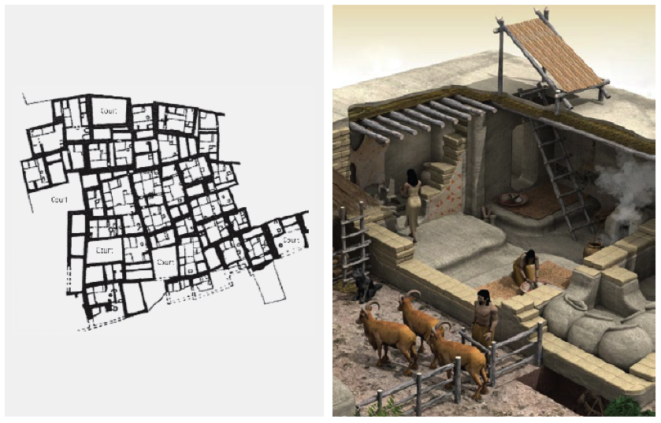
Catal Huyuk, in modern Turkey, was one of the first places in the world where humans lived in dense settlements. From about 7500 to 5700 BCE, an estimated average of between 5,000 and 8,000 people lived in mud-brick houses with rooftops serving as streets. James Mellaart, the British archaeologist who excavated Catal Huyuk in 1958, produced this drawing of the settlement’s layout. Alongside is an artist’s illustration of an individual dwelling.
Source:http://makingmaps.net/2008/10/13/cartocacoethes-why-the-worlds-oldest-map-isnt-a-map/;http://www.ediciona.com/portafolio/image/5/2/0/5/casa_catal_huyuk_5025.jpg adapted from The Big History Project.

Document 8
Specialization of Labor
Within the villages, towns and cities, it was possible for people to specialize in the sort of work they could do best. Many stopped producing food at all, making instead tools and other goods that farmers needed, and for which they gave them food in exchange. This process of exchange led to trade and traders, and the growth of trade made it possible for people to specialize even more…
Source: D.M. Knox, The Neolithic Revolution, Greenhaven Press, adapted from the January 2004, NYS Regents Exam.

Document 9
Kevin Reilly is a professor of humanities at Raritan Valley Community College and was the cofounder and first president of the World History Association.
Kevin Reilly, excerpt from The West and the World: A History of Civilization

The most obvious achievements of the first civilizations are the monuments — the pyramids, temples, palaces, statues, and treasures — that were created for the new ruling class of kings, nobles, priests, and their officials. But civilized life is much more than the capacity to create monuments.

Civilized life is secure life. At the most basic level this means security from the sudden destruction that village communities might suffer. Civilized life gives the feeling of permanence. It offers regularity, stability, order, even routine. Plans can be made. Expectations can be realized. People can be expected to act predictably, according to the rules.

The first cities were able to attain stability with walls that shielded the inhabitants from nomads and armies, with the first codes of law that defined human relationships, with police and officials that enforced the laws, and with institutions that functioned beyond the lives of their particular members. City life offered considerably more permanence and security than village life.
Source: Kevin Reilly, The West and the World: A History of Civilization (New York: Harper Collins, 1989) adapted from The Big History Project.

