Exhibit A: Roman Arches and Domes
Roman architecture continued the legacy left by the earlier architects of the Greek world. For example, the Romans used Greek column styles and built their grandest projects from marble. However, the Romans were also great innovators and they quickly adopted new construction techniques, used new materials, and uniquely combined existing techniques with creative design to produce a whole range of new architectural structures such as the dome and the arch. Many of these innovations were a response to the changing practical needs of Roman society, and these projects were all backed by the government which funded, organized, and spread them around the Roman world, guaranteeing their permanence so that many of these great edifices survive to the present day.
The Arch | The Pantheon
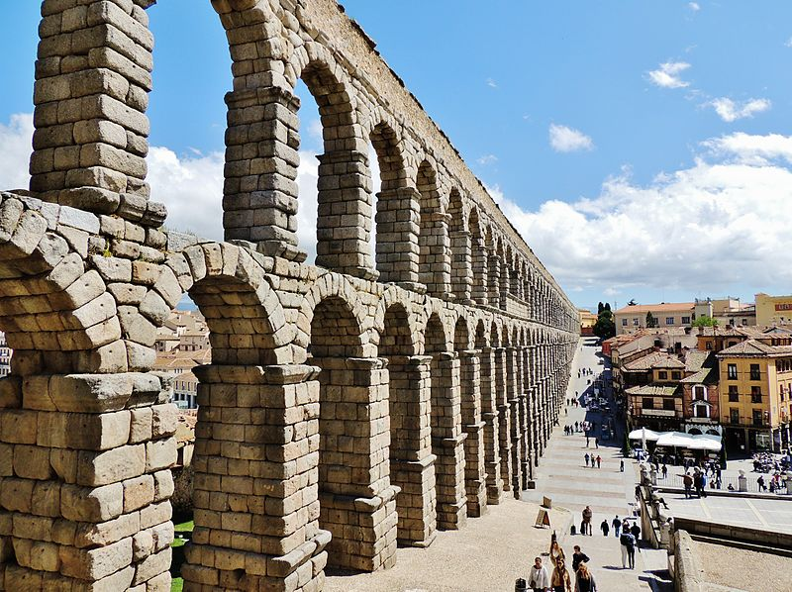  The Segovia Aqueduct in modern-day Spain is a well-preserved example of how Roman engineers used arches to span long distances and support a great amount of weight on a structure. | The Pantheon is the best preserved building from ancient Rome and was completed in c. 125 CE. Its magnificent dome is a lasting testimony to the genius of Roman architects and as the building stands virtually intact it offers a unique opportunity to step back 2,000 years and experience the glory that was Rome.  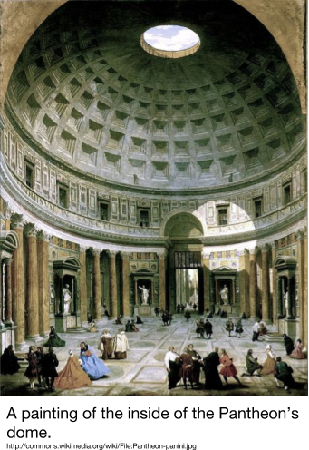  Source: http://www.ancient.eu/Pantheon/

Exhibit B: Roman Aqueducts
Watch an excerpt of History Channel's Mankind: The Story of All of Us about the Roman Aqueducts, read the text, and examine the image below.
These sometimes massive structures, with single, double, or triple tiers of arches, were designed to carry fresh water to urban centres from sources sometimes many kilometres away. The earliest in Rome was the Aqua Appia (312 BCE), but the most impressive example is undoubtedly the Pont du Gard near Nimes (c. 14 CE). Romans used the arch to span rivers and ravines.
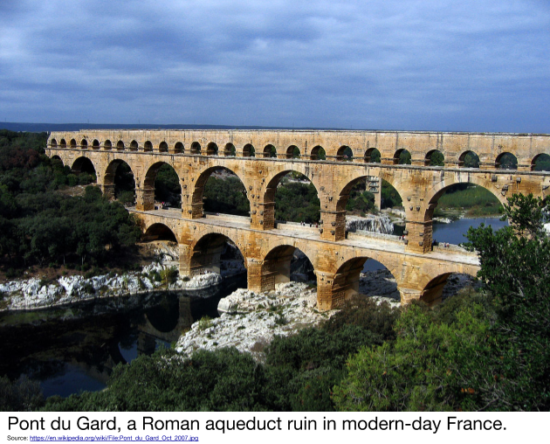
Source: Adapted from “Roman Architecture.” Ancient History Encyclopedia. http://www.ancient.eu/Roman_Architecture/

Exhibit C: The Colosseum
Watch Deconstructing the Colosseum and an excerpt of Where did it come from? Ancient Rome's Stadiums, read the text, and examine the image below.
Roman theatres and amphitheaters were inspired by the Greek versions. The Romans added a highly decorative stage building (scaenae frons) which incorporated different levels of columns, projections, pediments, and statues. Theatres also display the Roman passion for enclosing spaces, especially as they were often (partially or completely) roofed in wood or employed canvas awnings.

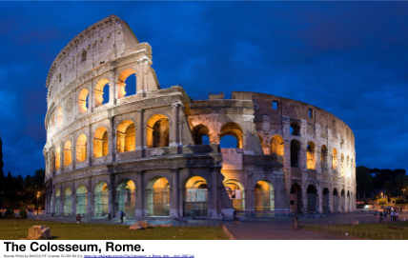
The fully enclosed amphitheatre was a particular favorite of the Romans. The Colosseum is the largest and most famous, and it is a typical example copied throughout the empire: a highly decorative exterior, seats set over a network of barrel vaults, and underground rooms below the arena floor to hide people, animals and props until they were needed in the spectacles.
Source: “Roman Architecture.” Ancient History Encyclopedia. http://www.ancient.eu/Roman_Architecture/
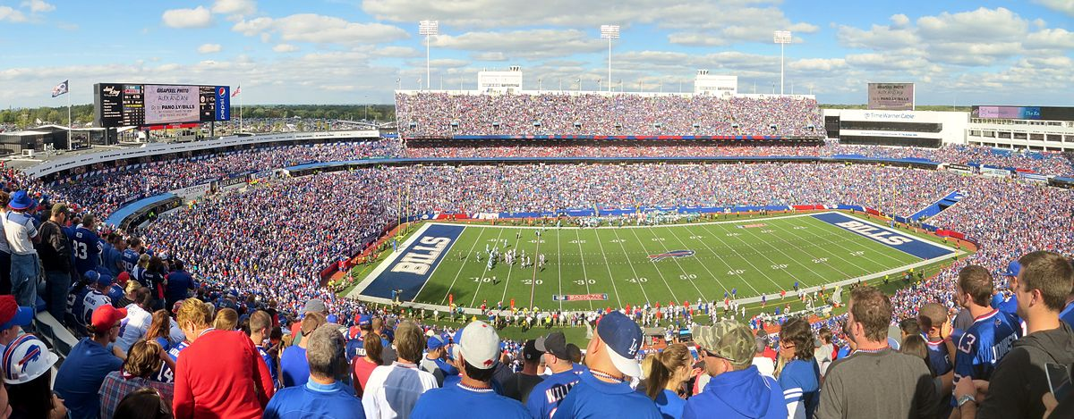
Many modern day stadiums use similar architecture techniques that were used during the construction of the Colesseum.

New Era Stadium, where the Buffalo Bills American football team plays.
Exhibit D: Roman Roads
Watch Ancient Roman Superhighway, an excerpt from Where did it Come From? Ancient Rome, and an excerpt of Mankind: The Story of All of Us about Roman roads and examine the images below.
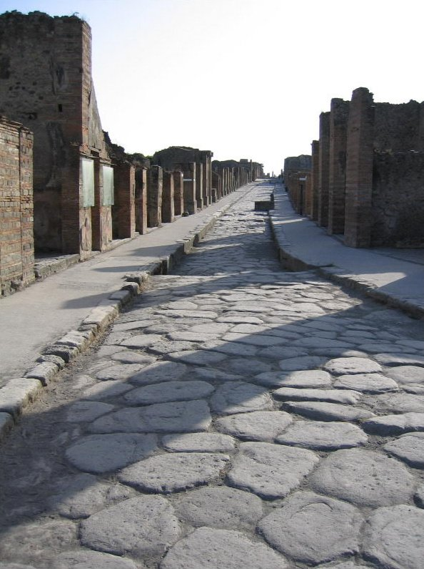  A street in Pompeii.  Source: https://commons.wikimedia.org/wiki/File:PompeiiStreet.jpg | 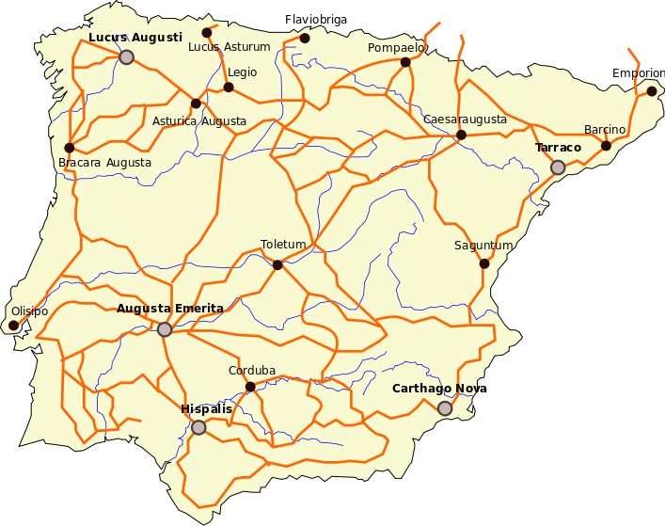  Map of major Roman roads in  modern-day Spain and Portugal.  Source: https://commons.wikimedia.org/wiki/File:Hispania_roads.svg

Exhibit E: Roman Sculpture
Roman sculpture, with artists from across a huge empire and changing public tastes over centuries, is above all else, remarkable for its sheer variety and eclectic mix. The art form blended the idealized perfection of earlier Classical Greek sculpture with a greater aspiration for realism and absorbed artistic preferences and styles from the East to create images in stone and bronze which rank among the finest works from antiquity [the Classical Era]. Aside from their own unique contribution, Roman sculptors have also, with their popular copies of earlier Greek masterpieces, preserved invaluable works for the future which would have otherwise been completely lost to world art.
Source: “Roman Sculpture.” Ancient History Encyclopedia. http://www.ancient.eu/Roman_Sculpture/
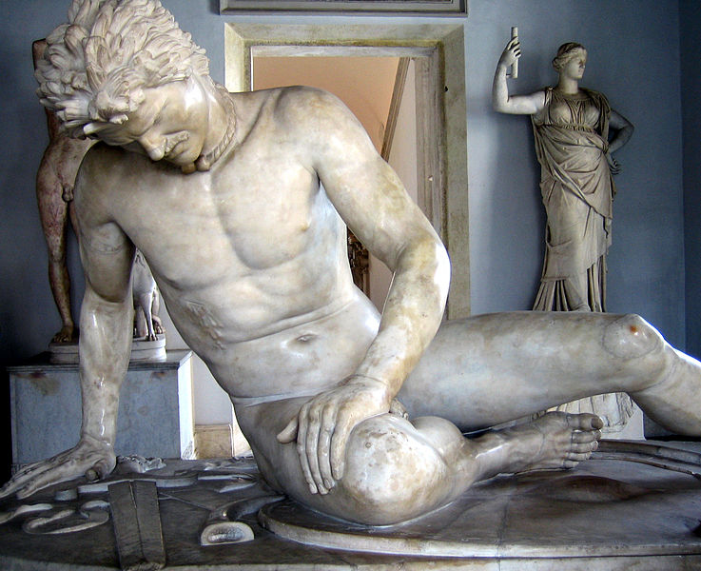  The Dying Gaul, sculpted from marble, is one of the best-known and most important works from Rome. The image above is a replica of one of the sculptures created to commemorate the victories over the Galatians in the 3rd and 2nd centuries BCE.  Source: https://commons.wikimedia.org/wiki/File:Dying_gaul.jpg |  |  | 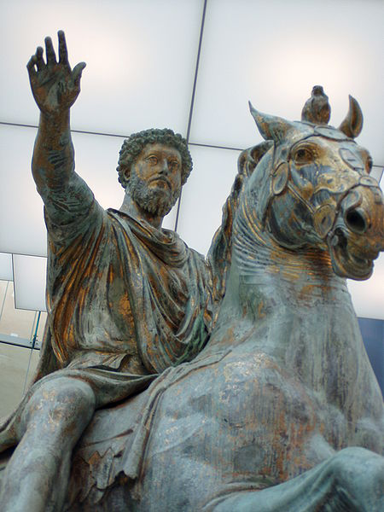  Bronze statue of Roman Emperor, Marcus Aurelius, erected ca. 175 CE.  Source: https://commons.wikimedia.org/wiki/File:Statua_Marco_Aurelio_Musei_Capitolini_Fronte2.JPG
Exhibit F: Roman Mosaics
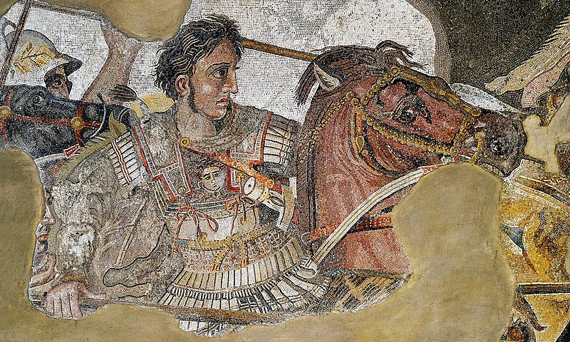  A section of the Alexander Mosaic, a much larger Roman work depicting a battle involving theGreek general Alexander the Great created in Pompeii around 100 BCE  Source: https://en.wikipedia.org/wiki/File:BattleofIssus333BC-mosaic-detail1.jpg |  | Mosaic is the art of creating images with an assemblage of small pieces of colored glass, stone, or other materials. Mosaics have been found in Roman dwellings from Britain to Dura-Europos. Splendid mosaic floors are found in Roman villas across north Africa, in places such as Carthage, and can still be seen in the extensive collection in Bardo Museum in Tunis, Tunisia. The most famous mosaics of the Roman world were created in  Africa and in Syria, the two richest provinces of the Roman Empire. Many Roman mosaics are found in Tunisian museums, most of which date from the second to the seventh century CE.  Source: “Mosaic.” Ancient History Encyclopedia. http://www.ancient.eu/Mosaic/
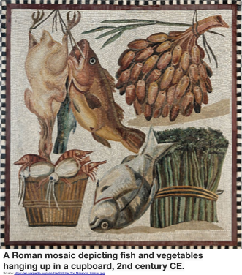 | 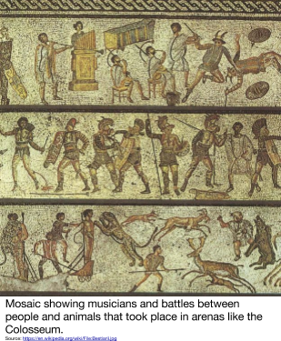
Exhibit G: Literature
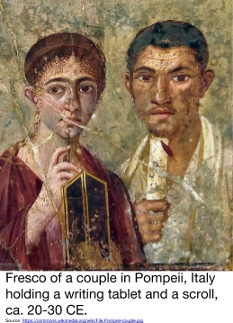
The two most well known Roman authors were Virgil and Cicero. Their works, though completed before Pax Romana, were widely read during the golden age.

Virgil (70 bce- 19 bce) was regarded by the Romans as their greatest poet, an estimation that subsequent generations have upheld. His fame rests chiefly upon the Aeneid, which tells the story of Rome’s legendary founder and proclaims the Roman mission to civilize the world under divine guidance. His reputation as a poet endures not only for the music and diction of his verse and for his skill in constructing an intricate work on the grand scale, but also because he embodied in his poetry aspects of experience and behavior that transcend history.

Marcus Tullius Cicero (106 bce- 43 bce) was a Roman statesman, lawyer, scholar, and writer who vainly tried to uphold republican principles in the final civil wars that destroyed the Roman Republic. His writings include books of rhetoric, speeches, philosophical and political treatises, and letters.

Source: Adapted from “Ancient Greek Literature.” New World Encyclopedia. http://www.newworldencyclopedia.org/entry/Ancient_Greek_literature

Exhibit F: Roman Medicine
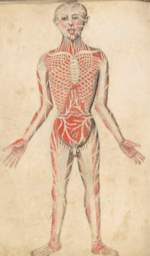
Roman medicine was greatly influenced by earlier Greek medical practice and literature but also made its own unique contribution to the history of medicine through the work of such famous experts like Galen. Whilst there were professional doctors attached to the Roman army, for the rest of the population medicine remained a private affair. Nevertheless, many large Roman households had their own medical specialist amongst their staff and with the spread of literature on the topic, access to medical knowledge became ever wider, treatments became more well known, and surgery became more sophisticated.

Galen (131-201) was a physician who learned about anatomy through the dissection of apes and pigs, clinical observation, and thorough examination of patient and symptoms. Galen was forbidden by Roman law to dissect human corpses, so his knowledge was limited to what he could learn from other animals and outward examinations of the bodies of dead gladiators and hanged criminals.

Sources: “Roman Medicine.” Ancient History Encyclopedia. http://www.ancient.eu/Roman_Medicine/; http://www.wdl.org/en/item/9712/#q=galen; http://www.bbc.co.uk/schools/gcsebitesize/history/shp/ancient/romanknowledgerev1.shtml

‘Muscles Man', A drawing based on Galen’s books about anatomy but drawn by someone else.
Source:http://commons.wikimedia.org/wiki/File:'Muscles_Man',_Pseudo-Galen,_Anathomia;_WMS_290_Wellcome_L0034577.jpg

