What and when was the post-classical era?
Identify characteristics that post-classical civilizations had in common.

Word | Image | Sentence
postgame conference |  | After the basketball finals, members of both teams and their coaches attended the postgame conference where they answered questions about the game.
postproduction |  | After a movie has been filmed, it is sent to postproduction where the video and audio are matched, and mistakes are re-recorded in a studio.
post-surgery |  | To recover after she had her appendix removed, Sara was sent to the section of the hospital called Post-Surgery where she was taken care of by doctors and nurses and taught how to take care of herself in the coming months.

1. Based on the information above, what do you think the prefix “post” means? How do you know? | 2. The time period you are going to learn about in Unit 4, 5, and 6 is called the post-classical era. Based on your response to question 1 and your understanding of Global History, what do you think “post-classical” means?

What is periodization? How are periods determined and named?
What and when was the post-classical era? What makes a civilization “classical”?

The time period you will study in upcoming unit is known the  “Post-Classical Age”  “Post-Ancient Era”  “Pre-Modern Era”  “The Middle Ages” | 1. Based on the names given to this era, what do you think you might learn about it?

2. Circle the words or phrases in the definition to the right that you do not know or are confused by. | Post-Classical Era/Period/Age (476-1500 CE)  Period of time when the first large empires that were established in the Classical Era lost their power to rising states which established land empires in a world that was more interconnected through trade than earlier civilizations. The increased interconnected led to greater cultural diffusion and conflict. These civilizations made great contributions to our collective learning as a result of golden ages marked by prosperity. During the post-classical era, major belief systems that still impact our world gained popularity and had a large influence on empires and those who lived in them.
3. Based on the definition to the right, why do you think we study the Post-Classical Era?

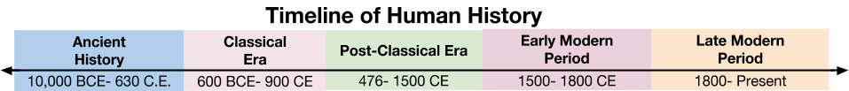

4. Based on the timeline above and your knowledge of Global History, during which time period were the first early river valley civilizations founded? | 5. Based on the timeline above and your knowledge of Global History, during which time period was the Roman Empire at its height? | 6. In Unit 4 you will study the Post-Classical Era, based on the timeline above, predict what period will you study in Unit 4.

