How did reform movements try to remedy problems brought on by the Industrial Revolution?
Objectives: Describe how reform movements tried to remedy problems during the Industrial Revolution.

What is a reform movement?
A reform movement is a type of social movement that aims to gradually change or improve certain aspects of society such as education or healthcare. A reform movement does not encourage rapid or fundamental changes. On the other hand, revolutionary movements seek to change the entire society.

1. What is the difference between a reform movement and a revolutionary movement?

2. Using your prior knowledge about the Industrial Revolution, make some predictions about what types of reform movements may have emerged as a result of the Industrial Revolution.

Reform Movements: Suffrage - Voting Rights for Women
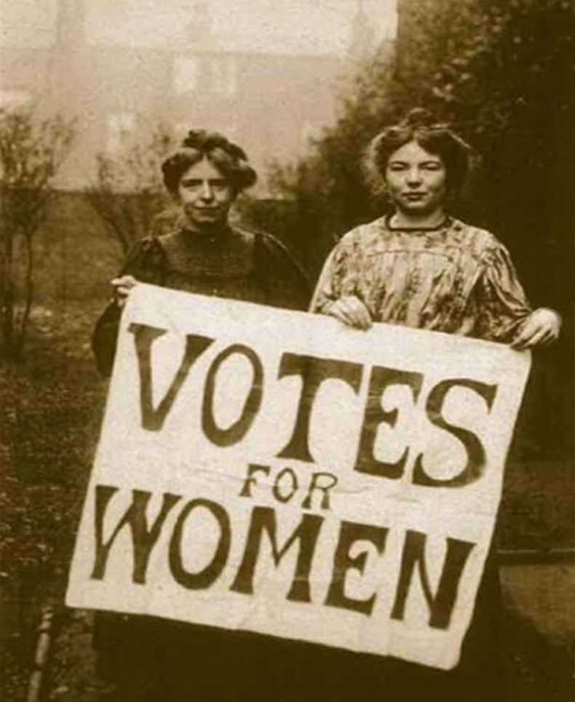  WSPU founders Annie Kenney & Christabel Pankhurst  The Women's Social and Political Union (WSPU) was the leading militant organization campaigning for women's suffrage in Great Britain, 1903–1917  Source: https://en.wikipedia.org/wiki/Women%27s_suffrage_in_the_United_Kingdom#/media/File:Annie_Kenney_and_Christabel_Pankhurst.jpg |  |  | During the 1800s, a cult of domesticity idealized the middle-class woman as a mother who stayed at home taking care of her kids and husband. She did not have a role outside the home. Many middle-class women disliked these expectations and protested the restrictions on their lives. Particularly, women wanted suffrage, or the right to vote.  In Great Britain women’s suffrage attracted attention when John Stuart Mill presented a petition in Parliament calling for inclusion of women's suffrage in the Reform Act of 1867, which was rejected. Later in the same year, Lydia Becker (1827 – 1890) founded the first women's suffrage committee, in Manchester. Other committees were quickly formed, and in 1897 they united as the National Union of Women's Suffrage Societies, with Millicent Garret Fawcett (1847 –1929) as president.  British suffragists faced opposition. Some opposers believed that women were too emotional to vote responsibly and others believed that women belonged at home, not in the government. Frustrated by this opposition, some women became more militant, or aggressive. Emmeline Pankhurst, assisted by her daughters Christabel and Sylvia, founded the Women's Social and Political Union (WSPU) in 1903. Her followers, called "suffragettes," heckled politicians, practiced civil disobedience, or refusal to obey certain laws, and were frequently arrested for causing riots. In February 1918, women over the age of 30 received the right to vote. Suffrage rights for men and women were equalized in 1928.  Adapted from: http://teacher.scholastic.com/activities/suffrage/history.htm
1. Why did this reform movement begin?

2. What were the goals of this reform movement?

3. What opposition did this reform movement face?

4. What were the tactics of this reform movement?

5. What impact did this reform movement have?

Reform Movements: Growth of Public Education
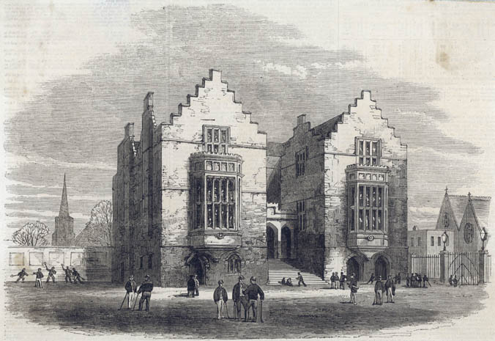  Harrow School in 1862. At public schools like Harrow, sport was an important part of the boys' education.  Source: http://www.bbc.co.uk/schools/primaryhistory/victorian_britain/children_at_school/ |  | Before the Industrial Revolution and reforms, education was scarce, expensive, and restricted to males. The only formal education provided to British children were religious schools. Reformers believed that they needed to have a literate workforce and that education should be available to even the poorest.  By the late 1800s, reformers fought to have the government set up public schools and require basic education for all children. In schools, students were taught discipline, patriotism, and work habits. In 1833, the government passed the Factory Act making two hours of education a day compulsory for children working in factories. The government also granted money to charities for schools for the first time. In 1844, the Ragged Schools Union was set up to give schooling to very poor children. In 1880, the Education Act made school attendance compulsory for children up to the age of 10. The 1902 Education Act established a system of secondary schools or high schools. Reforms also led to the opening of colleges and universities as well as libraries.  Adapted from: http://www.bbc.co.uk/bitesize/ks3/history/industrial_era/the_industrial_revolution/revision/5/  http://www.nationalarchives.gov.uk/education/resources/1833-factory-act/
1. Why did this reform movement begin?

2. What were the goals of this reform movement?

3. What impact did this reform movement have?

Reform Movements: Unions
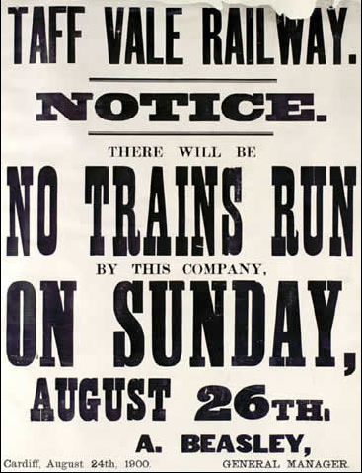  A poster announcing that no trains would be running on the Taff Vale Railway on 26 August, and a handwritten schedule giving details of resumed freight services after the strike. The union was made to pay the railway company £23,000 in damages for striking. This lack of immunity from having to pay for the loss of earning caused by the strike seriously hampered the activities of trade unions, until the Trade Disputes Act of 1906 removed the possibility that unions would have to pay for lost earnings.  Source: http://www.nationalarchives.gov.uk/pathways/citizenship/struggle_democracy/docs/taffvale.htm | A union is an organized association of workers formed to protect and further their rights and interests such as fair wages, working hours, and working conditions. During the Industrial Revolution, workers were subjected to long hours, poor wages, and dangerous conditions. Unionized workers striked, or refused to work. During the 18th century, when the Industrial Revolution prompted a wave of disputes between workers and factory owners, the government introduced measures to prevent unionization and striking. The Combination Acts, passed in 1799 and 1800, during the Napoleonic wars, made any sort of strike action illegal - and workmen could receive up to three months' imprisonment or two months' hard labor if they broke these new laws.  Despite the Combination Acts, workers continued to press for better pay and working conditions during the early part of the 19th century, and trade unions grew rapidly in London and elsewhere. Parliament repealed the Combination Acts in 1824 and 1825. Trade unions could now no longer be ignored as a political force, though employers remained reluctant to treat workers' representatives as their equals. During the 1830s, labor unrest and trade union activity reached new levels.  In the improved economic conditions of the 1850s and 1860s, the foundations of a powerful trade union movement were established and membership rose from approximately 100,000 in the early 1850s to around a million by 1874.  The economic slump of the 1870s and 1880s presented new challenges. Labor leaders such as Thomas Mann, one of the chief organizers of the successful London dock strike (1889), argued that the trade union movement needed to become far more open and inclusive. 'New unionism' reached out to the many unskilled workers in Britain who lacked union representation. The first women's 'trade societies' also began to emerge during this period. The strike by the female workers at the Bryant & May match factory, in the East End of London, in July 1888 highlighted the expanding boundaries of trade union activity in Britain.  Source: http://www.nationalarchives.gov.uk/pathways/citizenship/struggle_democracy/trade_unionism.htm
Why did this reform movement begin?

What were the goals of this reform movement?

What opposition did this reform movement face?

What were the tactics of this reform movement?

What impact did this reform movement have?

British Factory Legislation
1833 Parliament passed a Factory Act, which forbade nearly all textile mills from employing children under eleven years, and prohibited children between eleven and thirteen from working more than forty-eight hours a week, or nine in a single day. It also prohibited youths between the ages of thirteen and eighteen from working more than sixty-nine hours a week, or twelve in a single day. These work periods were to include an hour and a half for meals. Children under thirteen were required to have two hours of schooling per day.

1847 The Ten Hours Act limited the workday to ten hours for women and children who worked in factories.

1880 The first Employers’ Liability Act granted compensation to workers for on-the job injuries not their own fault.
Source: NYS Global History and Geography Regents Exam, January 2002.

Identify two actions taken by the government to change economic policy.

Describe how these reforms might have impacted the lives of workers.

