Name: Date:
Global 10/Period: Revolution in England

Revolution in England

DIRECTIONS: Using the Revolution in England reading, fill in the diagram describing any events that took place, important beliefs, etc for each English ruler listed.
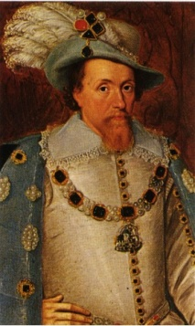
James I
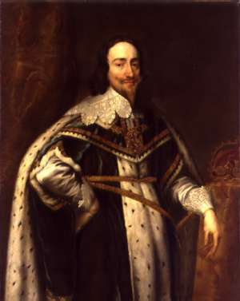Charles I
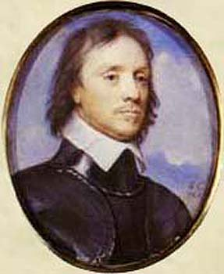Oliver Cromwell/ English Civil War
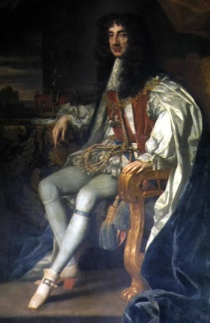Charles II
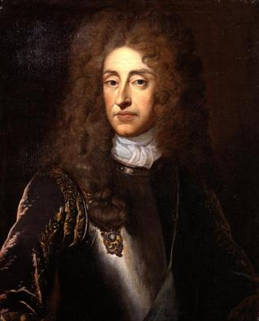James II
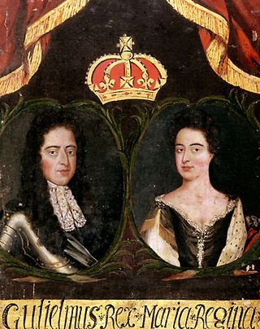William & Mary

Important Vocabulary
- Petition of Right
- Restoration-
- Glorious Revolution-
- Constitutional Monarchy-
Puritan-

