**Name: Date:**

**Global 10/Period: The Rise and Fall of the Guomindang**

**The Rise and Fall of the Guomindang**

**(The Nationalist Party)**

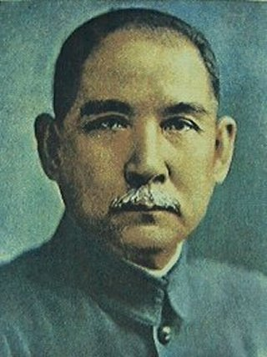**The Struggles of the New Republic**

* 1911 Revolution**-**
  + - Wanted to replace Qing
    - Forms Nationalist Party/Guomindang Party
* Qing falls
  + China 🡪

**WWI Leads to More Problems**

* 1917-China declares war against Germany
  + - Treaty of Versailles-gave territories to Japan
* **May 4th Movement (**1919)-
  + 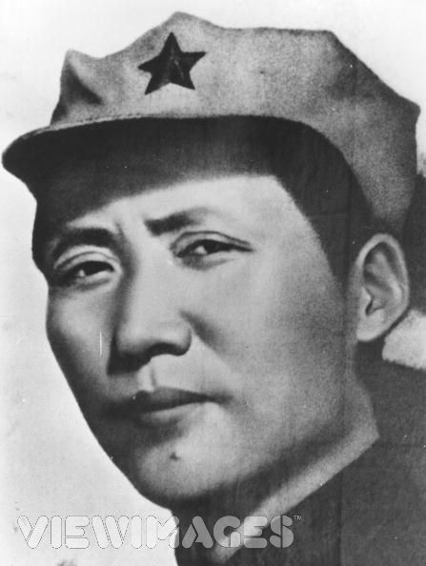Spread to other cities

**Formation of the Chinese Communist Party (CCP)**

* Young Chinese against w. democracy

  + 1921- Form Chinese Communist Party (CCP)

**The Guomindang   
(The Nationalist Party)**

* 1925-Sun dies
  + takes over Guomindang

**Guomindang and CCP-Allies & Enemies**

* March north together to conquer warlords that had taken over
* 1927-Nationalists into Shanghai
* 1928-Chiang becomes pres. of Nationalist Republic of China

**Civil War**

* 1930-
  + - Recruited for Red Army
  + Attacked by Nationalist army but never driven out
    - Realizing possible defeat, members of CCP fled

**The Long March**

* October 1934-100,000 set out from Jianxi
* Mao Zedong was elected Chairman of the party at the end of the march

**Japanese Invasion**

* 1931-Japanese invaded Manchuria
  + 1937-



* + December 1937-March 1938: >300,000 Chinese slaughtered
  + ~80,000 women/girls raped
    - Mutilated or murdered
* + 1945-Japanese defeated

**Unit 731**

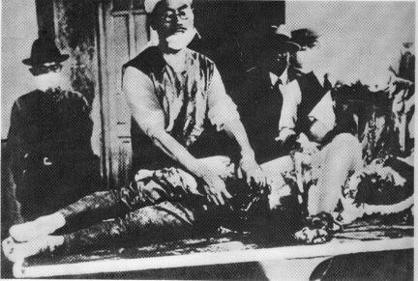

**Civil War Renewed**

* 1946-Civil war broke out again
  + - Controlled southwestern China
    - Did little to win support
  + - Controlled much of Northern China

**Victory for CCP**

* Cities fall to CCP one by one
  + 1949-CCP, led by Mao, wins control of China

**Important Info to Know**

* Guomindang
* SunYat-sen
* May 4th Movement
* CCP/Communist Party
* Mao Zedong
* Chiang Kai-shek
* Long March
* Rape of Nanjing
* PRC/People’s Republic of China