Name: Date:
Global 9/Period: River Valley Civilizations: Adaptations/Modifications

Early River Valley Civilizations: Adapting and Modifying

EXAMPLE #1: IRRIGATION
What is irrigation?
Irrigation is the process of bringing water from a natural source like a river to an area without water.

The environmental problem is that there is … | so | Early River Valley Civilizations modified their environments to create …
Unreliable access to water |  | IRRIGATION SYSTEMS
DIRECTIONS: Watch the “What is irrigation?” video found on my website or by scanning the QR code to see examples of irrigation across the world. Based on the video, identify advantages and disadvantages to using irrigation in the chart below.

Advantages to Using Irrigation | Disadvantages to Using Irrigation

Irrigation in Ancient Egypt and Mesopotamia

Directions: Watch this Discovery Education Video on irrigation in Ancient Egypt and the Irrigation in Ancient Mesopotamia video both found on my website or using the QR codes then complete the chart below.

Describe the techniques used by Ancient Egyptians and people living in Mesopotamia to meet their water and food needs. | Explain the effects of using these techniques on these  civilizations.

Example #2: Terrace Farming
The environmental problem is that there is … | so | Early River Valley Civilizations modified their environments to create …
Not enough flat land to farm because of mountains |  | TERRACE FARMING

Terrace Farming in Ancient China

Directions: Examine the image below and watch the video on the rice terraces in Yunnan, China found on my website or by scanning the QR code then complete the tasks the follow.

Terrace Farming  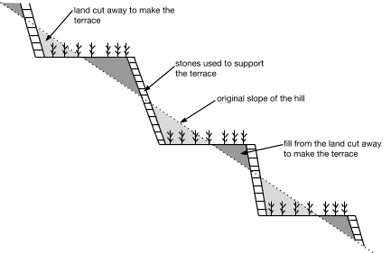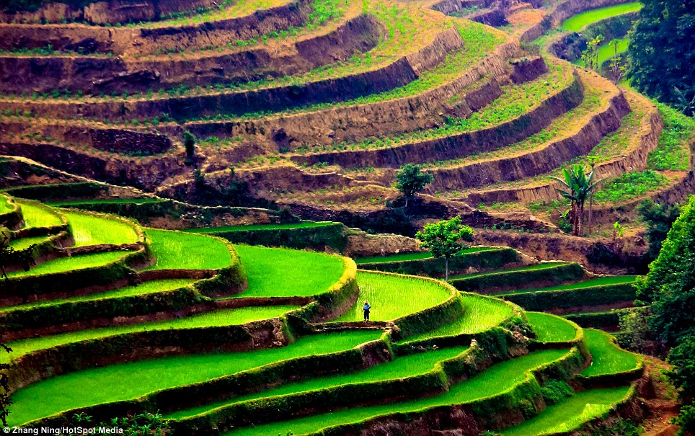 | In your own words, describe what terrace farming is and explain how terrace farming benefited the Ancient Chinese.

