The Sepoy Rebellion (1857-1858)

Watch this video entitled “Sepoy Mutiny- Revolt of 1857” (https://youtu.be/MV0fYMIvtyU), then read the information below and answer the accompanying questions.

The Sepoy Rebellion, also known as India’s First War of Independence, the Great Rebellion, the Indian Mutiny, the Revolt of 1857, and the Indian Rebellion of 1857, was a revolt of soldiers employed by the British East India Company against the Company. The rebellion was a major turning point in colonial India. As a result, the British government replaced the Company as the rulers of India and India became an official colony of Great Britain.

Since the 1600s, the British East India Company had operated trading posts in India and employed Indian soldiers, known as sepoys, to protect the Company's interests. The Company’s influence and power in India grew over the next two centuries. They took control of land through military conquest and by the 1700s could arguably have been considered a “nation” within India.

1. Who were the sepoys? | 2. What was the role of the British East India Company in India?

Long-Term Causes of the Sepoy Rebellion

Expansion of  British Power in India  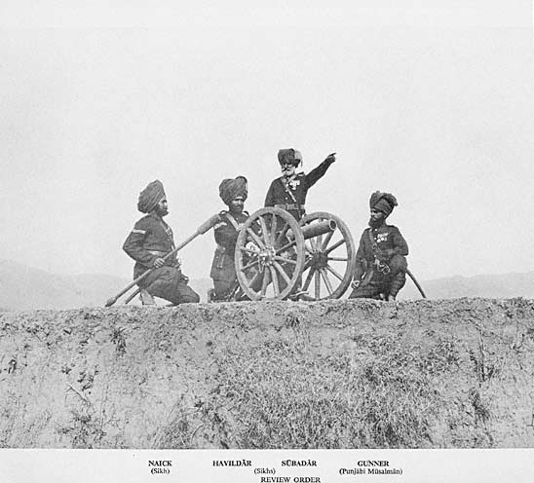  British Indian Army soldiers, 1895.  Source | Westernization  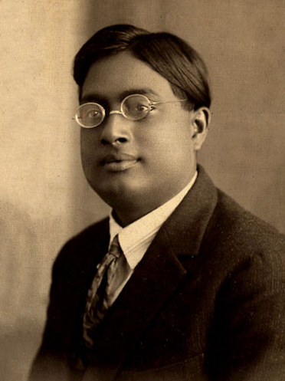  Photograph of Indian physicist, Satyendra Nath Bose, 1925.  Source: https://en.wikipedia.org/wiki/File:SatyenBose1925.jpg | Sepoys Outnumbered  British Troops  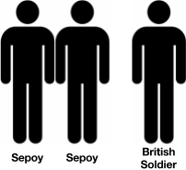
The British East India Company took control of a large amount of India through force and through treaties that Indian princes who had no choice but to sign. Whenever possible the British replaced India rulers with British officials. | Westernization, the process of changing a culture to be more “western” or European/American, was promoted by the British in India. They proposed changes to laws regarding Hinduism and the caste system, introduced a British education system, and British fashions became popular. | The British held all of the positions of power in the British East India Company, but they were not the majority of the Company’s soldiers. Two out of three soldiers working for the Company were Indian.

Short-Term Causes of the Sepoy Rebellion: The Spark
The immediate cause for the revolt was the introduction of the new Enfield rifle to the British Indian Army. To load it, the sepoys had to bite off the ends of lubricated cartridges that held the gunpowder for the rifle. A rumor spread among the sepoys that the grease used to lubricate the cartridges was a mixture of pigs’ and cows’ lard. This was a problem because it was a violation of Hindu and Muslim religious practices to have contact with pig (Muslims) and cow (Hindu) products. There is no conclusive evidence that either of these materials was actually used on any of the cartridges in question. However, the perception that the cartridges were tainted added to the larger suspicion that the British were trying to undermine Indian traditional society. For their part, the British did not pay enough attention to the growing level of sepoy discontent. Disrespected, the soldiers reacted by arming themselves against their commanders, killing many of them, and taking control of military compounds and weapons.

3. Explain what led to the start of the Sepoy Rebellion.
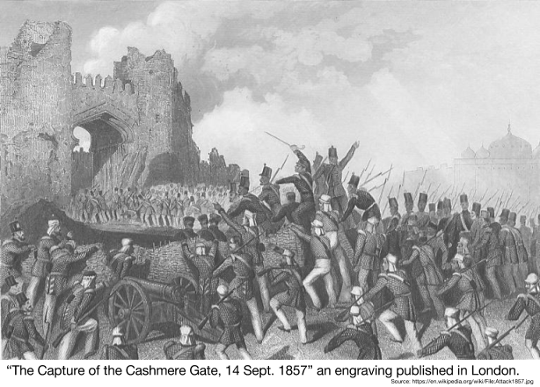
The Rebellion: Why were the sepoys unsuccessful?
At first, the sepoys successfully took control of a number of Indian cities including Delhi, but their lack of organization and lack of widespread support in the face of the British colonial system was not enough to retain control of India and drive out the colonizers. The sepoys did not have a clear leader or a command structure. Instead, they fought independently to defend the areas they controlled from the British. They also struggled to gain widespread support from Indians because of religious division. For example, when one of the leaders of the rebellion, a Muslim named Bahadur Shah Zafar declared himself Emperor of India, Sikhs from the Punjab region of India who had fought against Islamic rule under the Mughals refused to support him. In addition, the sepoys were only able to get support from some regional princes. Others, who had comfortable positions under British rule, supported the East India Company. Eventually, British reinforcements arrived with new supplies and weapons like siege guns needed to defeat the sepoys encamped in cities. The last rebels were defeated in Gwalior on June 20, 1858 and the warring parties signed a peace treaty on July 8, 1858 ending the war.

4. Identify and explain three reasons why the sepoys were unable to free India from the British.

Effects of the Sepoy Rebellion
British Government  Takes Control in India  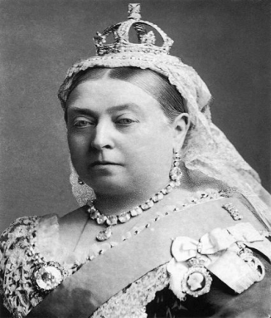  Queen Victoria of England became the official ruler of India. | Representation for Indians, but Little Power  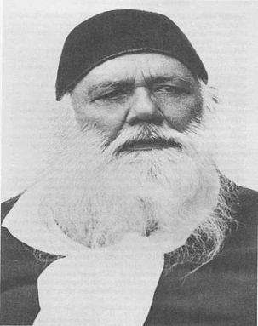  Photograph of Sir Syed Ahmed Khan, one of the Indian representatives on the Legislative Council. | Continued Modernization and Westernization of India  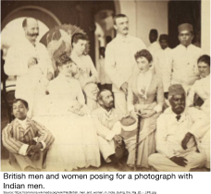
As a result of their inability to control India, the British East India Company was replaced by the British government. India became an official British colony and was known as the “jewel in the crown” of the British Empire. The British government continued to administer India as the Company had, with strict control. They also exiled the last Mughal ruler and executed his sons. | The British realized that one of the reasons for the rebellion was that they did not consult with Indians on the policies they enacted in India. After 1861, an Indian-nominated group or representatives held seats in the Legislative Council, though they were “non-official members” and had little power. | The British continued the process of expanding their education system in India and public works programs (roads, railways, telegraphs, and irrigation). The British built up a communications and transportation network to prevent another rebellion like the one let by the sepoys. In addition, westernization continued, threatening traditional Indian society and the caste system.

What were the positive effects of the Sepoy Rebellion? | What were the negative impacts of the Sepoy Rebellion?
Directions: Using what you have just learned, answer the following question. Start by choosing a claim. Support your claim by completing the chart with evidence and explanations. Use the claim, evidence and explanations to write a paragraph that thoroughly answers the question.

Did the Sepoy Rebellion moved Indians closer to independence?
Yes, it moved them closer to independence. | Yes and No | No, it did not move them closer to independence.
The Sepoy Rebellion moved India closer to independence because... | Even though the Sepoy Rebellion had positive impacts on Inida such as … , the Sepoy Rebellion made India worse because … | The Sepoy Rebellion did not move India closer to independence because...
CLAIM
Evidence to Support Your Claim | Reasoning: Explain how your evidence supports your claim.

Did the Sepoy Rebellion moved Indians closer to independence?

