Did Emperor Shi Huangdi
Improve China?

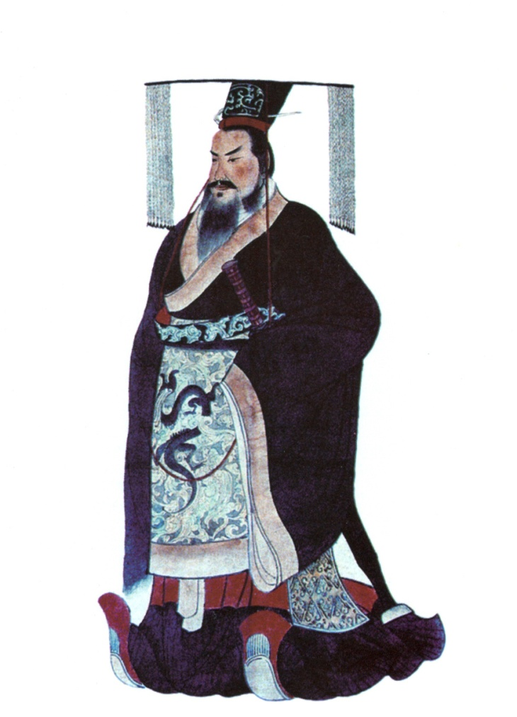
Unknown artist, Image of Emperor Shi Huangdi, ca. 1850. Public domain.

Name:
Date:
Global 9/Period:

DIRECTIONS: You will be investigating the rule of Emperor Shi Huangdi in order to answer the question: Did Shi Huangdi Improve China? The following supporting questions and the primary sources that accompany them will give you the basis for your answer.

What is a thesis?
Objective: Write appropriate thesis statements given a question and reasons.

Writing a Thesis
Your THESIS is a statement that identifies what you are trying to PROVE to your reader.

Claim | + | Reasons | = | THESIS
your opinion or answer to the question | conjunction to connect claim and reasons | why your opinion is right or truthful |  | a statement that identifies what you are trying to PROVE to your reader

In order to write a thesis, you must evaluate evidence.

Did Shi Huangdi improve China?
Objective: Evaluate whether Shi Huangdi improved China.

Yes, it was a success! | Yes and No | No, it was not a success.
Shi Huangdi improved China because... | Even though Shi Huangdi made some improvements such as … , he made China worse because … | Shi Huangdi did not improve China because...

Staging the Compelling Question:
Did Emperor Shi Huangdi improve China?
Objectives:
- Contextualize political, economic and social characteristics of China in 221 BC.
- Describe the Terra-cotta Army and the Great Wall of China reveal about Shi Huangdi.
- Describe what evidence will be needed to respond to the compelling question.
- Construct a working thesis in response to the compelling question.

Who was Shi Huangdi? | What area did he rule?
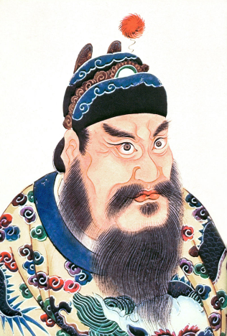  Shi Huangdi, (259 BCE - 210 BCE) was the emperor of the Qin dynasty dynasty. Rather than maintain the title of king, he ruled as the First Emperor of the Qin dynasty from 220 to 210 BC. During his reign, he supported the philosophy of Legalism. | Note: Ch’in = Qin  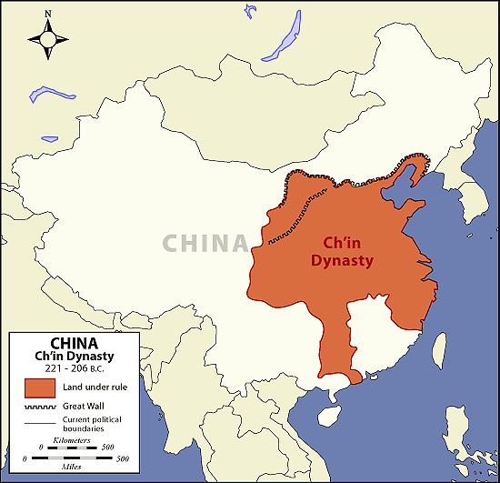  Source: http://archive.artsmia.org/art-of-asia/history/images/maps/china-ching-large.gif

What can we learn about Shi Huangdi from artifacts?
Artifact 1: Terracotta Army
Context: Workers digging a well outside the city of Xi'an, China, in 1974 struck upon one of the greatest archaeological discoveries in the world: the terracotta [clay] army. The terracotta army is part of an elaborate mausoleum created to accompany the first emperor of China, Shi Huangdi, into the afterlife. His mausoleum, or burial chamber is a 19-square-mile complex designed to mirror the plan of his capital, Xioanyan, and guarded by over 7,000 unique terracotta soldiers. Each clay-crafted figure weighs some 300 to 400 pounds and stands 6 feet high. The figures were buried in pits 15 to 20 feet deep and the largest of them stretched as far as two football fields laid end to end. According to the historian Sima Qian (c. 145-95 BCE), workers from every province of the Empire toiled unceasingly until the death of the Emperor in 210 in order to construct a subterranean [underground] city within a gigantic mound. It took 36 years, and hundreds of workers, to raise the terracotta warrior army. According to the National Geographic video clip, “China Terra-Cotta Warriors”, Shi Huangdi was so obsessed with nobody knowing the location of his tomb that his son had all the artisans and workers that constructed the tomb buried alive.
Source: “Terra-Cotta Army Protects First Emperor's Tomb”, John Roach, http://science.nationalgeographic.com/science/archaeology/emperor-qin/
“Mausoleum of the First Qin Emperor” http://whc.unesco.org/en/list/441/
“Mausoleum of the First Qin Emperor” http://travel.nationalgeographic.com/travel/world-heritage/mausoleum-first-qin-emperor/
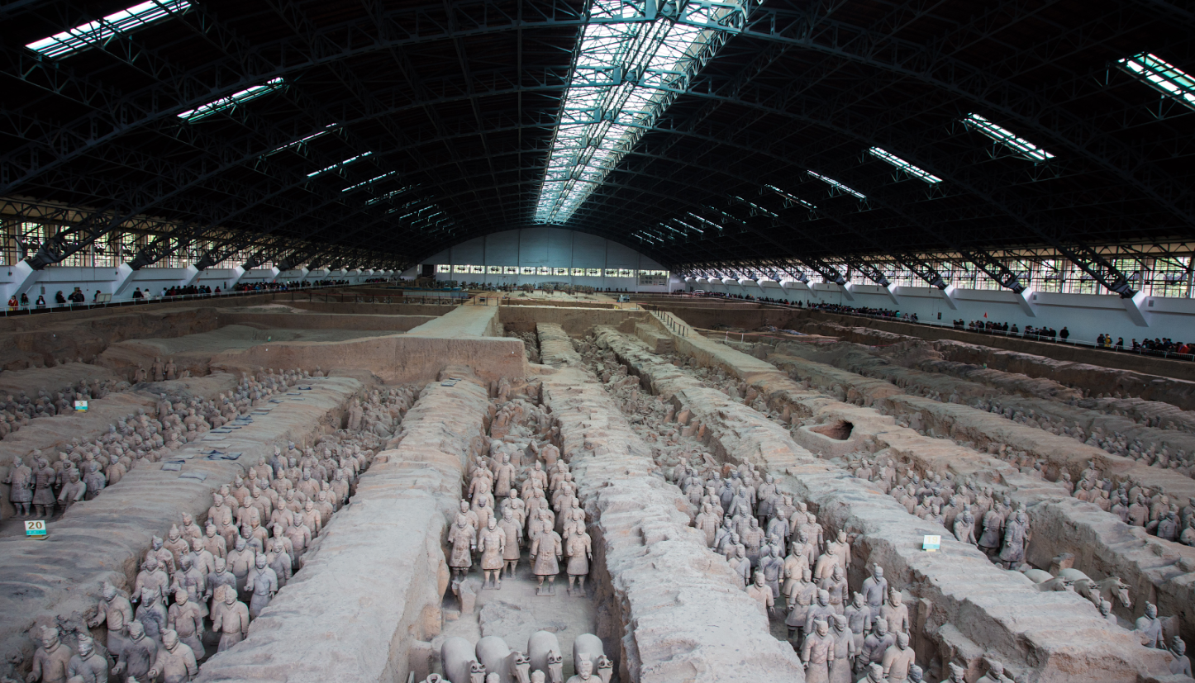
Source: https://upload.wikimedia.org/wikipedia/commons/4/49/Terracotta_Army%2C_View_of_Pit_1.jpg
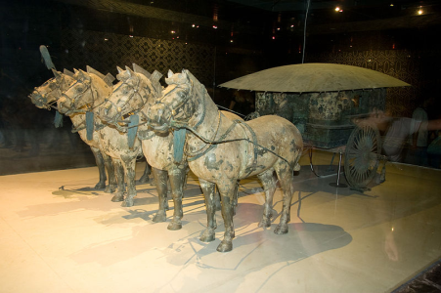  Detail  Source: https://commons.wikimedia.org/wiki/File:Terracotta_Army_31.jpg | 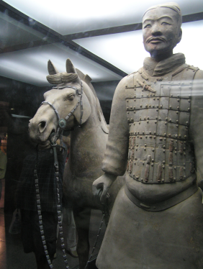  Detail  Source: https://upload.wikimedia.org/wikipedia/commons/7/7c/Soldier_Horse.JPG | 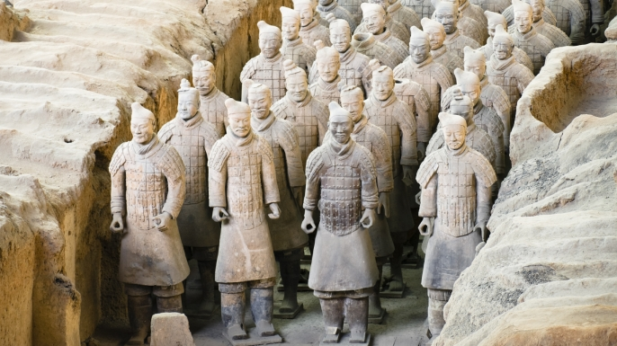  Detail  Source: http://www.history.com/shows/ancient-discoveries/articles/the-terra-cotta-army
Analyzing Artifacts
Directions: Using the artifact images and context above, respond to the questions and prompts below.
Description | 1a. Describe the terracotta soldiers and the mausoleum structure.
Function & Form | 1b. Who found the terracotta army in 1974?  1c. When was the terracotta army built? ____________________  1d. Where is the terracotta army located? ___________________  1e. Who built the terracotta army? _______________________  1f. For whom was the terracotta army built? _________________  1g. What purpose might the terracotta army have served?
Interpretation | 1h. What does the terracotta army tell you about Shi Huangdi?  1i. What did Shi Huangdi do to ensure that no one knew the location of his tomb?  1j. What does this tell you about Shi Huangdi?
Further Research | 1k. What other questions do you have about Shi Huangdi and the terracotta army?

What can we learn about Shi Huangdi from artifacts?
Artifact 2: The Great Wall of China
Context: Though the beginning of the Great Wall of China can be traced to the third century BCE, many of the fortifications included in the wall date from hundreds of years earlier, when China was divided into a number of individual kingdoms during the so-called Warring States Period. Around 220 BCE, Qin Shi Huangdi, the first emperor of a unified China, ordered that earlier fortifications between states be removed and a number of existing walls along the northern border be joined into a single system that would extend for more than 10,000 li (a li is about one-third of a mile) and protect China against attacks from the north. When Emperor Qin Shi Huangdi ordered construction of the Great Wall around 221 BCE, the labor force that built the wall was made up largely of soldiers and convicts. It is said that as many as 400,000 people died during the wall's construction; many of these workers were buried within the wall itself. Construction continued up to the Ming dynasty (1368–1644), when the Great Wall became the world's largest military structure. Today, the Great Wall is generally recognized as one of the most impressive architectural feats in history.
Source: “Great Wall of China”, http://www.history.com/topics/great-wall-of-china
“The Great Wall”, http://whc.unesco.org/en/list/438
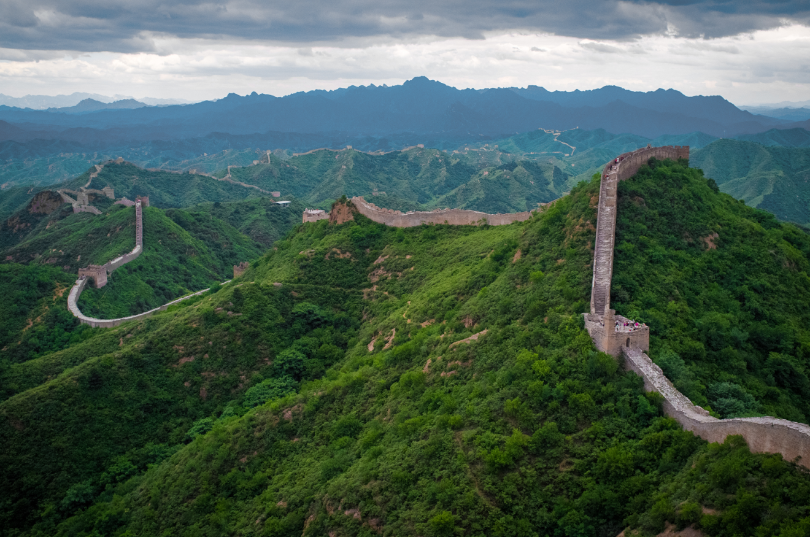
Source: https://en.wikipedia.org/wiki/Great_Wall_of_China#/media/File:The_Great_Wall_of_China_at_Jinshanling-edit.jpg
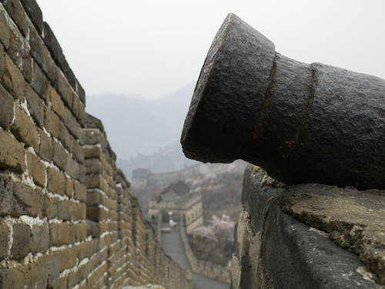  Detail  Source: http://whc.unesco.org/pg.cfm?cid=31&l=en&id_site=438&gallery=1&&maxrows=27 | 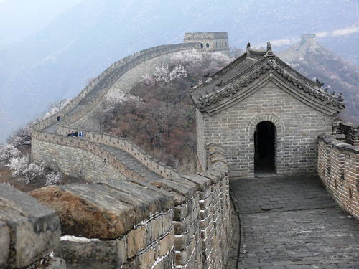  Detail  Source: http://whc.unesco.org/pg.cfm?cid=31&l=en&id_site=438&gallery=1&&maxrows=27 | 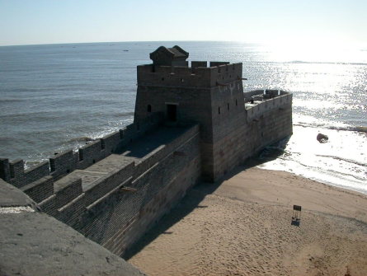  Detail  Source: http://smithsonianmag.tumblr.com/post/27580593620/smithsonian-magazine-great-wall-of-china

Analyzing Artifacts
Directions: Using the artifact images and context above, respond to the questions below.
Description | 2a. Describe the Great Wall of China.
Function & Form | 2b. When was the Great Wall of China first built? _________________  2c. Where is the Great Wall of China located? ___________________  2d. Who built the Great Wall of China?  2e. What purpose might the Great Wall of China have served?
Interpretation | 2f. What does the Great Wall of China tell you about Shi Huangdi?  2g. What does the Great Wall of China tell you about Chinese society 2,200 years ago?
Further Research | 2h. What other questions do you have about Shi Huangdi and the Great Wall of China?

Further Research on the Great Wall of China
Watch the History Channel clip, “Deconstructing History: Great Wall of China” and respond to the questions below. (0:00-1:15)
2i. Why did Chinese kingdoms begin building walls in the 8th century BC?

2j. Why did Shi Huangdi order the construction of the Great Wall of China?

2k. What did the treatment of the laborers building the Great Wall of China reveal about Shi Huangdi?

2l. Describe one way the Great Wall of China was used by the military.

Thesis Tracker 1:
Directions: Based on the evidence you have examined so far, circle “Yes” or “No” below.

Claim: Did Shi Huangdi improve China? YES NO

Directions: Fill in the table below with the reasons and evidence that support your claim.
Reasons
Supporting Evidence

Supporting Question 1:
How did Shi Huangdi unify China politically?
Objective: Describe how Shi Huangdi unified China politically.

Directions: Read the excerpts below and respond to the questions.
China in 260 BCE
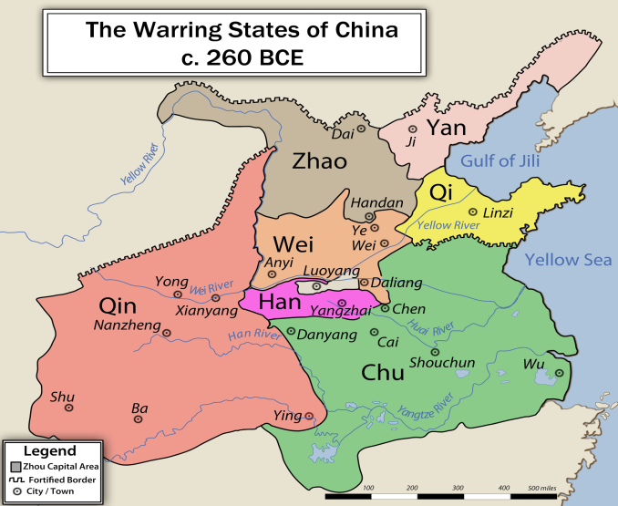  NOTE: The 250 years between 475 and 221 BCE is called the Warring States period because China was divided into seven states. These states had frequent wars until 221 BCE when Shi Huangdi conquered them all.  Source: Created by Philg88 and licensed under the Creative Commons Attribution-Share Alike 3.0.http://upload.wikimedia.org/wikipedia/commons/c/ca/EN-WarringStatesAll260BCE.jpg.http://www.c3teachers.org/inquiries/china/ http://www.c3teachers.org/inquiries/china/ | 1. Describe the political situation in China in 260 BCE before Shi Huangdi came to power.
China in 220 BCE
Note: Ch’in = Qin  Source: http://archive.artsmia.org/art-of-asia/history/images/maps/china-ching-large.gif http://www.c3teachers.org/inquiries/china/ | 2. Comparing the map to the left with the map above, what impact did Shi Huangdi have on China’s political situation in 260 BCE?
Legalism
Legalism was a school of Chinese philosophy that grew popular during the turbulent Warring States era (475–221 BCE) through the influence of the philosophers Shang Yang, Li Si, and Han Feizi. Legalism influenced the government of the Qin Dynasty (221–207 BCE). The Legalists believed that human beings are inherently selfish and short-sighted. Thus there can be no social harmony by choice. Instead, social harmony is achieved, through strict laws, a strong central control and absolute obedience to authority. The Legalists advocated for a government that handed out strict punishments and rewards for specific behaviors. They stressed the direction of all human activity toward the goal of increasing the power of the ruler and the state.  Adapted from:: http://www.britannica.com/topic/Legalism | 3. Describe Legalism.  4. Shi Huangdi supported the philosophy of legalism. How would this philosophy help him to politically unify China?
Memorial on Annexation of Feudal States, Li Si (Legalist counselor for Shi Huangdi)
Through military victories, the state of Qin has, in the time of the last six kings, brought the feudal lords [leaders in China who rivaled Shi Huangdi’s power] into submission. Now, with the might of Qin and the virtues of Your Highness [Shi Huangdi], at one stroke, like sweeping off the dust from a kitchen stove, the feudal lords can be annihilated [completely destroyed], imperial [relating to an empire] rule can be established, and unification of the world can be brought about. This is the one moment in ten thousand ages. If Your Highness allows it to slip away and does not press the advantage in haste, the feudal lords will revive their strength and organize themselves into an anti-Qin alliance. Then no one, even though he possesses the virtues of the Yellow Emperor, would be able to annex their territories.  Source: “Memorial on Annexation of Feudal States,” by Li Si (recorded by Sima Qian), in Sources of Chinese Tradition: From Earliest Times to 1600, compiled by William Theodore de Bary, Irene Bloom, and Joseph Adler. © 1999 Columbia University Press. Reprinted with permission of the publisher. http://www.c3teachers.org/inquiries/china/ | 5. According to Li Si, how did Shi Huangdi bring the “feudal lords into submission?”  6. What did Li Si recommend that Shi Huangdi do? Why did he make this recommendation?
Thesis Tracker 2:

Directions: Based on the evidence you have examined so far, circle “Yes” or “No” below.

Claim: Did Shi Huangdi improve China? YES NO

Directions: Fill in the table below with the reasons and evidence that support your claim.
Reasons
Supporting Evidence

Supporting Question 2:
How did Shi Huangdi’s reforms standardize society?
Objective: Describe how Shi Huangdi’s laws and reforms unified China through standardization.

Directions: Examine the images below and respond to the questions.

Context: When Shi Huangdi ascended as ruler of the Qin tribe in 246 B.C., China had been at war for 200 years. Seven major states were battling each other for dominance in the land, which was then a patchwork of feudal villages with no central bureaucracy [government]. After a series of victories, the Qin absorbed its last rival in 221 B.C., unifying China under one leader. As head of the new empire of China, Shi Huangdi didn't hesitate to establish a new law of the land. The Emperor quickly abolished the old feudal system, standardized the Chinese writing and currency systems, built a vast network of roads and canals to link the country and divided China into states with one centralized government.
Source: Heather Whips, “How One Chinese Emperor Changed the World.” http://www.livescience.com/2363-chinese-emperor-changed-world.html

Image 1: Unification of currency. Bronze banliang coin. China, Qin dynasty, Third century BCE. The Chinese inscription on this coin reads banliang, with ban to the right of the hole and liang to the left. Banliang means “half-ounce”—the weight of the coin.
Source: © The Trustees of the British Museum / Art Resource, NY. http://www.c3teachers.org/inquiries/china/
1. How might using the same currency throughout China have improved the empire?

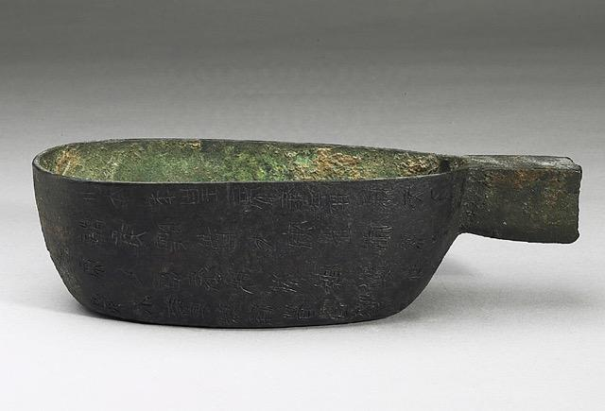 | Image 2: Unification of weights and measurements. Officials throughout China would have used this same weight to measure goods.  Source: Courtesy National Palace Museum/Taipei City, Taiwan. http://www.c3teachers.org/inquiries/china/  2. How might using the same weights and measurements throughout China have improved the empire?

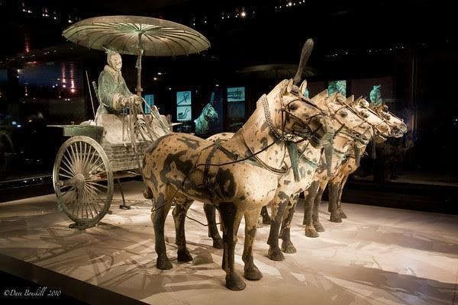 | Image 3: Vehicles of the same track. The Qin dynasty expanded the number of roads in the empire and standardized how the roads were built.  © theplanetD. http://theplanetd.com/. http://www.c3teachers.org/inquiries/china/  3. How might having the same road system throughout China have improved the empire?

Image 4: Major water conservancy project, the Lingqu Canal. The Qin dynasty built more canals in China to more easily move goods and people.
Source: Photographed by Farm and licensed under the Creative Commons Attribution-Share Alike 3.0. © theplanetD
.https://commons.wikimedia.org/wiki/File:Lingqu_Canal.jpg. http://www.c3teachers.org/inquiries/china/
4. How might building canals have improved the empire?

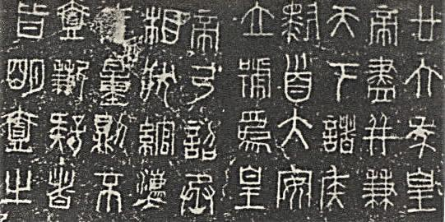 | Image 5: Books with the same characters.  The Qin dynasty standardized the letters used to write in the empire.  Source: Public domain. Available at Wikimedia Commons: https://commons.wikimedia.org/wiki/File:XiaozhuanQinquan.jpg\  http://www.c3teachers.org/inquiries/china/.  5. How did using the same writing system throughout China have improved the empire?

Thesis Tracker 3:

Directions: Based on the evidence you have examined so far, circle “Yes” or “No” below.

Claim: Did Shi Huangdi improve China? YES NO

Directions: Fill in the table below with the reasons and evidence that support your claim.

Reasons
Supporting Evidence

Supporting Question 3:
To what extent did Shi Huangdi’s treatment of opponents diminish his success?
Objective: Evaluate how Shi Huangdi’s treatment of opposition impacted his success.

The Records of the Grand Historian, Sima Qian
Context: The Records of the Grand Historian is a comprehensive history of ancient China that covers a 2500-year period from the age of the legendary Yellow Emperor to the reign of Emperor Wu of the Han Dynasty in the 2nd century B.C.E. The Records of the Grand Historian was finished in 109 B.C.E in China by the Han dynasty official Sima Qian.
Among the most infamous acts of the Emperor Shi Huangdi that were recorded in the The Records of the Grand Historian were the “burning of books,” ordered in 213 BCE, and the “execution of scholars,” ordered in 212. The following excerpt tells the story of the 213 book burning edict. In the excerpt, Li Si speaks in response to a scholar who has challenged Shi Huangdi. Li Si was a strong supporter of Legalism and served as the Grand Counselor to Emperor Shi Huangdi.

Pre-Reading Questions
1a. Who wrote this document? When was it written? Where was it written?
Who wrote or recorded this document?
Who is the speaker in this document?
(Hint: The person who recorded this document is not the same as the speaker. )

What is the perspective of the speaker?
(Hint: What ideas or philosophies does the speaker believe in?)

Based on the speaker’s perspective, what predictions can you make about what you might read in this document below?

When was this document written or recorded?
Where was it written or recorded?

The Records of the Grand Historian, Sima Qian
1  2  3  4  5  6  7  8  9  10  11  12  13  14  15  16  17  18  19  20  21  22  23  24  25  26  27  28  29  30  31  32  33  34  35  36  37  38 | Chunyu Yueh, a scholar of Chi said “I have yet to hear of anything able to endure that was not based on ancient precedents.”  The emperor ordered his ministers to debate this question.  The prime minister Li Si said, “...Now Your Majesty [Shi Huangdi] has built up this great empire to endure [survive] for generations without end. [...] In times gone by different barons fought among themselves and gathered wandering scholars. Today, however, the empire is at peace, all laws and order come from one single source, the common people support themselves by farming and handicrafts, while students study the laws and prohibitions.  “Now these scholars learn only from the old, not from the new, and use their learning to oppose our rule and confuse the black-headed people [common people]. As prime minister I must speak out on pain of death. In former times when the world, torn by chaos and disorder, could not be united, different states arose and argued from the past to condemn the present, using empty rhetoric to cover up and confuse the real issues, and employing their learning to oppose what was established by authority. Now Your Majesty has conquered the whole world, distinguished between black and white, see unified standards. Yet these opinionated scholars get together to slander the laws and judge each new decree according to their own school of thought, opposing it secretly in their hearts while discussing it openly in the streets. They brag to the sovereign [ruler] to win fame, put forward strange arguments to gain distinction [importance], and incite the mob to spread rumors. If this is not prohibited [banned], the sovereign's prestige will suffer and factions will be formed among his subjects. Far better put a stop to it!”  “I humbly propose that all historical records but those of Qin be burned. If anyone who is not a court scholar dares to keep the ancient songs, historical records or writings of the hundred schools, these should be confiscated and burned by the provincial governor and army commander. Those who in conversation dare to quote the old songs and records should be publicly executed [Chinese tradition claims that 460 rebellious Confucian scholars were buried alive in a common grave and many others were stoned to death]; those who use old precedents to oppose the new order should have their families wiped out; and officers who know of such cases but fail to report them should be punished in the same way.”  “If thirty days after the issuing of this order the owners of these books have still not have them destroyed, they should have their face tattooed and be condemned to hard labor at the Great Wall. The only books which need not be destroyed are those dealing with medicine, divination, and agriculture. Those who want to study the law can learn it from the officers. The emperor sanctioned this proposal.”  Source: From Andrea/Overfield. The Human Record, 8E. © 2016 Wadsworth, a part of Cengage Learning, Inc. Reproduced by permission. www.cengage.com/permissions.  http://www.c3teachers.org/inquiries/china
1. In lines 6-10, Li Si describes the great achievements of Shi Huangdi. According to Li Si, what are two achievements that Shi Huangdi was able reach that the leaders before him were unable to reach?

2. What does the phrase “opinionated scholar” (li. 18) mean?

3. According to lines 18-23, what are these “opinionated scholars” doing and saying in response to the reforms made by Shi Huangdi? How does Li Si feel about their actions?

4. What does Li Si suggest that Shi Huangdi do in response to these “opinionated scholars?”

5. Reread lines 25-32.
- What is the consequence for those who “dare to quote the old songs and records?”

- What is the consequence for those who “use old precedents [examples] to oppose the new order?”

- What is the consequence for officers who “know of such cases but fail to report them?”

6. Which books were allowed in the Qin dynasty? Why?

7. How did Li Si’s policy increase the power of Emperor Shi Huangdi?

8. What does this document reveal about how the Qin dynasty treated its opponents?

9. To what extent might Shi Huangdi’s treatment of opponents diminish his success?

Qin Shi Huangdi, 259–210 BCE, the first Qin emperor, 221–210 BCE, Scene of Burning Books and Executing Scholar
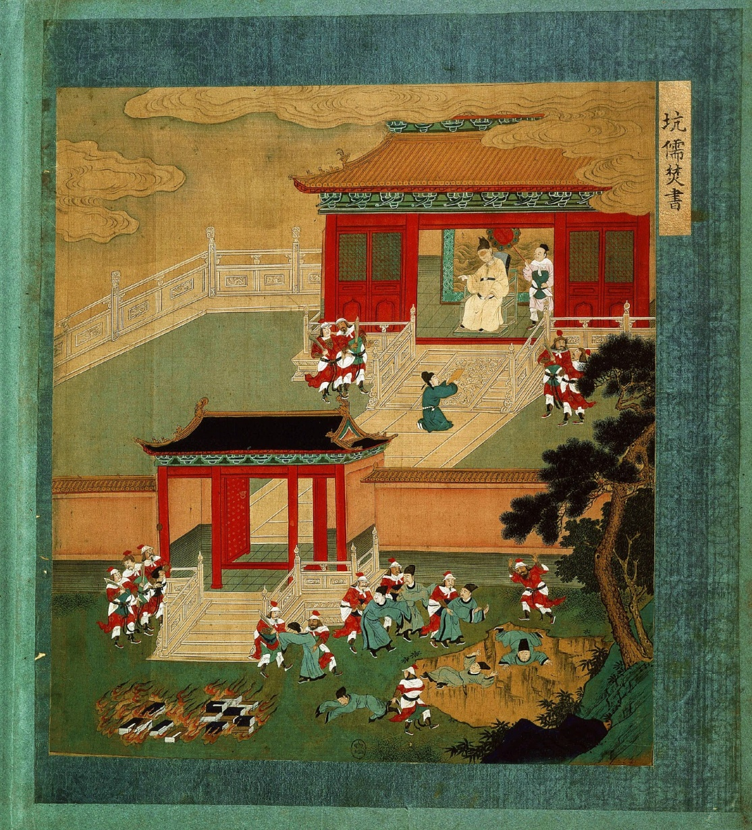  Source: Qin Shihuangdi, 259–210 BCE, the first Qin emperor, 221–210 BCE, scene of burning books and executing scholars, by Hung Wu, from Lives of the Emperors, watercolor on silk. Bibliothèque Nationale Paris. Photo: The Art Archive at Art Resource, New York. Used with permission  http://www.c3teachers.org/inquiries/china | 1. List the objects or people you see in the painting.
 | 2. Describe the action in the painting
 | 3. Explain the message that the painting conveys.

4. What does this image reveal about how Shi Huangdi treated his opposition?

5. Were Shi Huangdi’s practices justified? Explain.

Thesis Tracker 4:

Directions: Based on the evidence you have examined so far, circle “Yes” or “No” below.

Claim: Did Shi Huangdi improve China? YES NO

Directions: Fill in the table below with the reasons and evidence that support your claim.

Reasons
Supporting Evidence
Summative Assessment:
Did Shi Huangdi Improve China?

DIRECTIONS: Using the knowledge and resources from the packet, write an argument that addresses the questions above. Be sure to use specific claims and evidence.

