What were the Silk Roads?
How might the Silk Roads have affected the civilizations connected by them?
- Describe the location of the Silk Roads.
- Predict how the Silk Roads might have affected the civilizations connected by it.
Where were the Silk Roads?

Directions: Watch the TED-Ed Video on The Silk Road (https://goo.gl/jRuA6d), read the definition, and examine the map below, then answer questions that follow.

Definition of the Silk Roads
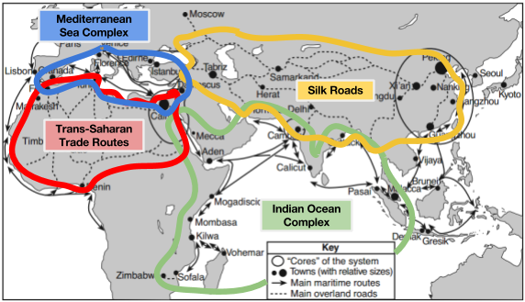 | 1. Which continent were the Silk Roads primarily on?  2. Which continents were connected through the Silk Roads?  3. Who helped isolated civilizations trade with one another in ancient times (1:00- 1:30)?  4. According to this video, what goods were traded between Rome and China?  5. Which religions, ideas, and technologies were spread through the Silk Roads?
The “Silk Road” is the name often given for the vast network of land and maritime trade routes between the Mediterranean Sea and East Asia. The Silk Road covered more than 4,600 miles and was in use from about the 2nd century BCE to the 15th and 16th centuries CE. However, the name ‘Silk Road’ is relatively recent. It was coined by the German scholar, Ferdinand von Richthofen, in 1877. He derived the term from Rome’s historical connection to the trade route and their love of silk.
What was the Indian Ocean Complex?
How might the Indian Ocean Complex have affected the civilizations connected by it?
- Describe the location of the Indian Ocean Complex.
- Predict how the Indian Ocean Complex might have affected the civilizations connected by it.
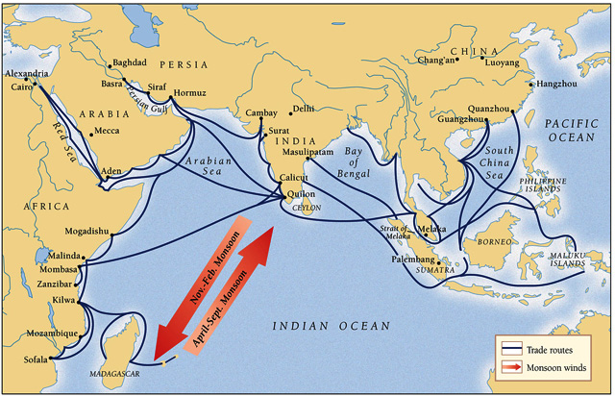
Where was the Indian Ocean Complex?

Directions: Watch the Crash Course Video on Indian Ocean Complex (https://goo.gl/AiqWMu; start: 0:57-3:41), read the definition, and examine the map below, then answer questions that follow. (Turn on closed captions to follow along.)

Definition of the Indian Ocean Complex
The Indian Ocean, connecting the Middle East and Africa to East Asia by way of the Indian subcontinent, has been home to shippers and traders for millennia. However, maritime technology was not truly developed until around 800 CE, at which point the Indian Ocean became the central hub of some of the greatest international trade networks the world has ever seen. .. For roughly 700 years, trade goods from across the entire supercontinent of Afro-Eurasia passed through the Indian Ocean. Products from the Persians and powerful Turkish Caliphates of the Middle East were exchanged for items in the kingdoms of Africa, which were sold to empires of India and China.
Source: http://study.com/academy/lesson/indian-ocean-trade-route-network-history.html

1. How was the Indian Ocean Complex similar to and different from the Silk Road?

2. Describe what happened in the Indian Ocean Complex during the following years (1:47-2:05):
- 1000-1200 CE-
- 1200-1300 CE (Pax Mongolica)-
  - Why did this happen?
- 1300-1400s (14th/15th Centuries)-
3. What are monsoons and how did they impact trade in the Indian Ocean Complex?

