Should We Call It the
“Silk Road”?
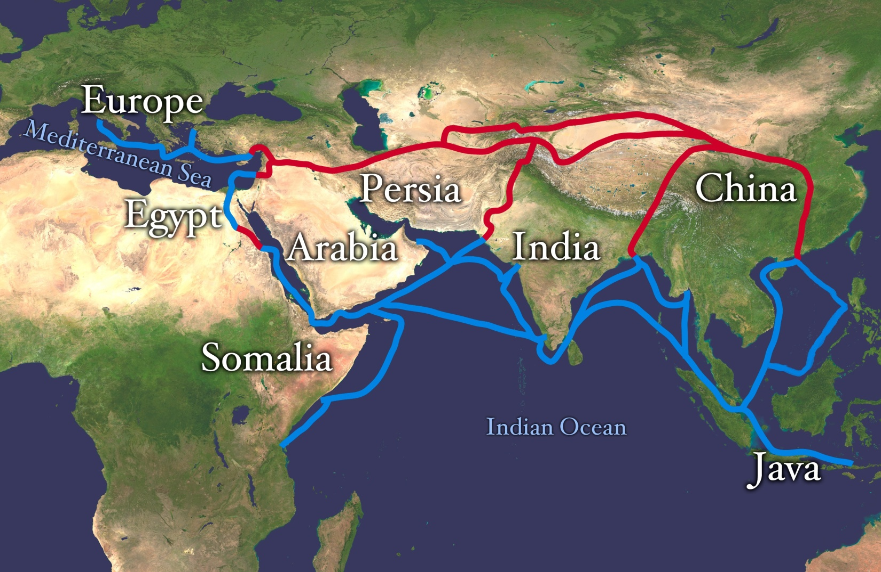 Public domain. NASA Visible Earth via Wikimedia Commons. https://commons.wikimedia.org/wiki/File:Silk_route.jpg

Supporting Questions
- What was the “Silk Road”?
- Why was silk so important?
- What, besides silk and other goods, was shared on the Silk Road?
- What else could this trade network be called?

DIRECTIONS: After completing all of the activities for each of the Supporting Questions, construct an argument that answers the compelling question: Should we call it the “Silk Road”?
Supporting Question #1:
What was the Silk Road?
DIRECTIONS: After watching the video (https://goo.gl/jRuA6d) , answer the questions below.

- What was the Silk Road?
- Why was the Silk Road important to history?

Supporting Question #2:
Why was silk so important?

DIRECTIONS: Use sources 1 and 2 to complete the chart.

How did silk impact…
Chinese societies? | Western societies?

SOURCE 1
Featured Source | Source A: Suleiman, description of Suleiman’s 851 C.E. travel through India and China, translated into English by Jerry H. Bentley, Voyage du marchand arabe Sulayman en Inde et en Chine (excerpts), 1922

NOTE: Suleiman, an Arab merchant, describes his travels through India and China. The excerpts below are his description of the Chinese use of silk.
Young and old Chinese all wear silk clothes in both winter and summer, but silk of the best quality is reserved for the kings….During the winter, the men wear two, three, four, five pairs of pants, and even more, according to their means. This practice has the goal of protecting the lower body from the high humidity of the land, which they fear. During the summer, they wear a single shirt of silk or some similar material.

Bentley, J. H., & Ziegler, H. F. (2006). Traditions & Encounters: A Global Perspective on the Past. Boston: McGraw-Hill.

SOURCE 2
Featured Source | Source B: Richard Kurin, description of the role, value, and uses of silk, “Silk Road: Connecting People and Cultures” (excerpts), Smithsonian Institute, 2002.

Since the concept of "Seidenstrassen" or "Silk Roads" was first invented by the German geologist and explorer Baron Ferdinand von Richthofen in 1877, the "Silk Road" has been used as a metaphor of European and Asian cultural interchange. While largely commercial, the Silk Road provided the vehicle for all sorts of creative exchange between tremendously diverse peoples and cultures.

Given the Silk Road's symbolic meaning of sharing and exchange, it is somewhat paradoxical that the desire to control its namesake commodity, silk, was so strong. The ancient Chinese guarded the secret of silk production for centuries. The Ottoman Turks and the Persians fought a war over it. The English and French competed to restrict its markets. But despite such attempts, silk moved across the planet with remarkable ease and was a vehicle of cultural creativity wherever it went. The degree of borrowing and choosing of techniques and patterns, [and] the invention and discovery of uses and styles is incredible. Every culture that touched silk added to its adornment of humanity.

And silk turns up everywhere — aboard medieval Viking ships sailing out of Constantinople and as kerchiefs from India (bandannas, from bandhana) around the necks of cowboys in the American West. The terms used for silk reveal its history and influences. Damask silk, referring to the style of Damascus, Syria, is actually Chinese in origin. Silk chinoiserie is not Chinese but a European imitation of Chinese style. Martha Washington wore a dress of Virginia silk to her husband's inauguration, and Native Americans learned silk embroidery to decorate traditional apparel. In the 19th century Paterson, New Jersey, of all places, declared itself "Silk City."

What is so special about silk? How did it go around the globe, and connect diverse civilizations for millennia? And what is the current significance of the Silk Road?

Chinese Silk Cultivation
Silk cultivation and production is such an extraordinary process that it is easy to see why its invention was legendary and its discovery eluded many who sought its secrets….

Silk has been long thought to be a special type of cloth; it keeps one cool in the summer and warm in the winter. It is extremely absorbent, meaning it uses color dyes much more efficiently than cotton, wool, or linen. It shimmers. It drapes upon the body particularly well. Silk is strong enough to be used for surgical sutures — indeed, by weight it is stronger than steel and more flexible than nylon. It is also fire and rot resistant. All these natural characteristics make silk ideal as a form of adornment for people of importance, for kimonos in Japan and wedding saris in India, for religious rituals, for burial shrouds in China and to lay on the graves of Sufis in much of the Muslim world.

Early in Chinese history, silk was used to clothe the emperor, but eventually it was adopted widely throughout Chinese society. Silk proved to be valuable for fishing lines, for the making of paper, for musical instrument strings. Under the Han dynasty (206 B.C.E.-220 C.E.), silk became a great trade item, used for royal gifts and tribute. It also became a generalized medium of exchange, like gold or money. Chinese farmers paid their taxes in silk. Civil servants received their salary in silk.

Silk on the Road
…The growth of silk as a trade item both stimulated and characterized other types of exchanges during the era. Curative herbs, ideas of astronomy, and even religion also moved along the Silk Road network. Arabs traveled to India and China, Chinese to Central Asia, India, and Iran. Buddhism itself was carried along these roads from India through Central Asia to Tibet, China, and Japan. Islam was carried by Sufi teachers, and by armies, moving across the continent from Western Asia into Iran, Central Asia, China and India. Martial arts, sacred arts like calligraphy, tile making, and painting also traversed these roads. The Tang capital city of Chang'an, present-day Xi'an, became a cosmopolitan city — the largest on earth at the time, peopled with traders from all along the Silk Road, as well as monks, missionaries, and emissaries from across the continent.

The Mongol Silk Road and Marco Polo
Though some new silk styles such as silk tapestry made their way eastward from Iran to Uyghur Central Asia to China, the transcontinental exchange of the Silk Road diminished in the later Middle Ages and through the period of the Christian Crusades in the Holy Land from 1096 to the mid-1200s. Yet Crusaders, returning home with Byzantine silks, tapestries, and other spoils, rekindled European interest in trade with Asia. Moorish influence in Spain also had an enormous impact. It was through Arab scholars that Europeans gained access to Indian and Chinese advances in medicine, chemistry, and mathematics, and also to ancient Greek and Roman civilizations that had survived in Arabic translations and commentaries. This flow of knowledge eventually helped to fuel the Renaissance.

With the Mongol descendants of Genghis (Chinghis) Khan in control of Asia from the Black Sea to the Pacific, a third Silk Road flourished in the 13th and 14th centuries. The emissary of King Louis IX of France, Willem van Rubruck, visited the court of the Mongol ruler in 1253, and, seeing the wealth of silks, realized that Cathay, or China, was the legendary Seres of Roman times. The Venetian Marco Polo followed.

Setting out with his uncles in 1271, Polo traveled across Asia by land and sea over a period of 24 years. The tales of his travels, narrated while a prisoner in a Genoa jail cell, spurred broad European interest in the Silk Road region. He told of the Mongols, who under Genghis and then Kublai Khan had taken over China and expanded their dominion across Asia into Central Asia, India, Iran, and Asia Minor. Polo related fantastic tales of the lands he had visited, the great sites he had seen, and the vast treasures of Asia. The 13th and 14th centuries were characterized by considerable political, commercial, and religious competition between kingdoms, markets, and religious groups across Eurasia….

During this "third" Silk Road, silk, while still a highly valued Chinese export, was no longer the primary commodity. Europeans wanted pearls and gems, spices, precious metals, medicines, ceramics, carpets, other fabrics, and lacquerware. All kingdoms needed horses, weapons, and armaments. Besides, silk production already was known in the Arab world and had spread to southern Europe. Silk weavers and traders — Arabs, "Saracens," Jews, and Greeks from Sicily and the eastern Mediterranean — relocated to new commercial centers in northern Italy. Italian silk-making eventually became a stellar Renaissance art in Venice, Florence, Genoa, and Lucca in the 14th and 15th centuries. New stylistic techniques were added, like alto-e-basso for velvets and brocades, while old motifs, like the stylized Central Asian pomegranate, took on new life.

Commercial trade and competition was of great importance by the 15th century with the growth of European cities, guilds, and royal states. With the decline of Mongol power, control over trade routes was vital. The motivation behind Portuguese explorations of a sea route to India was to secure safer and cheaper passage of trade goods than by land caravans, which were subject to either exorbitant protection fees or raiding by enemies. Indeed, it was the search for this sea route to the East that led Columbus westward to the "New World." When Vasco da Gama found the sea route to India and other Europeans subsequently opened direct shipping links with China, contact with Central Asia decreased dramatically….

Silk became both a component and a symbol of this cultural diffusion. It was seen as a valuable index of civilization with regard to religious ritual, kingship, artistic production, and commercial activity. Silk stood for the higher things in life. It was a valuable, traded commodity, as well as a historical medium of exchange. Silk both epitomized and played a major role in the early development of what we now characterize as a global economic and cultural system. Europeans of the 19th century saw this new globalism not just as an interesting historical occurrence, but also as something that resonated with the growing distribution of silk use and manufacturing of the time….
© Smithsonian Institute. Used with permission. http://www.festival.si.edu/past_festivals/silk_road/program_richard_kurin.aspx.

Supporting Question #3:
What, besides silk, was shared on the Silk Road?

DIRECTIONS: Read sources 1 and 2 and then make a list of cultural and technological knowledge shared along the Silk Road.

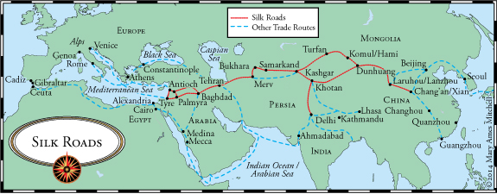

CULTURAL EXCHANGES | TECHNOLOGICAL EXCHANGES
SOURCE 1
Featured Source | Source B: American Museum of Natural History, exhibition description, “Traveling the Silk Road” (excerpts), 2009

Xi’an

A Cosmopolitan Capital
The Silk Road begins in the massive Xi'an, capital of China's Tang Empire. It was the largest city in the world around 750 CE. This metropolis is home to nearly a million people, and another million live just outside the imposing walls. Imperial buildings, temples and markets line the streets, and the city buzzes with activity. Foreign merchants, ambassadors, scholars, and musicians flock to this urban center, stocking the markets with exotic goods and filling the streets with sights and sounds from distant lands.

The Secret of Silk
The secret of silk, carefully guarded for centuries, brought wealth and prestige to Chinese empires. Legend has it that almost 5,000 years ago, a Chinese empress named Xi Ling was drinking tea in her garden when a small cocoon dropped from the branches of a mulberry tree into her cup. As she fished it out, the cocoon unwound into a single shimmering silk strand. Mesmerized by the thread, the empress gathered more cocoons, plunged them in hot water, unraveled the strands and wove the world's first silk cloth.

The Sound of Music
From a solitary flutist in the desert to grand orchestras in the palaces of Xi'an, musicians played all along the ancient Silk Road. Drumbeats rhythmically pounding in the distance, airy notes from a flute drifting by on the breeze, gentle tones from a bow drawn against strings, all punctuated by the sharp clash of cymbals--these made up the soundtrack of Xi'an during the Tang dynasty. Indeed, music was a constant feature of life in Xi'an, enhancing rituals, telling stories, and bringing communities closer together through festivity and celebration.

Turfan
After months spent baking under the blazing sun, the caravan has reached Turfan. At last, here is a lush oasis refuge from the harsh Taklimakan Desert of Central Asia. Ingenious irrigation systems bring cool water from nearby mountains, offering you and your thirsty camels a refreshing drink. More important, the water allows farmers here to grow an incredible array of fruits and vegetables. What's not eaten by residents or hungry travelers will be traded along the Silk Road, reaching kitchens thousands of miles away.

Market Place

Luxury Goods
Fashionable hats, elegant coats and dazzling jewelry might seem out of place at gritty Silky Road markets like this one. But in fact, the raw materials for such luxury goods--as much about style as practicality--were widely traded across Asia along the Silk Road. Merchants brought expensive skins, feathers and gems from afar to marketplaces where eager buyers awaited.

Foreign Flavors
Walk into your local supermarket and you may well find French wines and Japanese pears. Surprisingly, visitors to markets along the ancient Silk Road--long before overnight shipping and refrigeration--could also choose from an array of foreign delicacies. As travelers moved along trade routes, they introduced their own ingredients and recipes to foreign lands. Over time, such exotic edibles became familiar features on local menus.

Samarkand

City of Merchants
As the caravan approaches the fabled city of Samarkand, the gates swing open. Are you seeking the finest silk brocade? A sable coat, a packet of fragrant musk or a smooth roll of cream-colored paper? Whatever you desire, chances are a Sogdian merchant from Samarkand can deliver it. These shrewd traders have built up a fortune buying and selling in distant countries. The Sogdians are ambitious go-betweens, controlling a network of commerce that extends to India, China and Persia--and the heart of their trading empire is here, deep in Central Asia.

Paper
Samarkand was famous throughout the Islamic world for its especially fine paper…. Paper is made from plant material or cloth that is mashed to a pulp and then formed into a sheet.

Baghdad

The Scholarly City
The journey along the Silk Road has taken you thousands of miles from the imperial city of Xi'an, China. At last, here is its western rival: Baghdad, capital of the Islamic world. Founded in 762, this elegant metropolis is known as the City of Peace. Its gleaming palaces and fragrant gardens look down on Iraq's Tigris River; foreign goods arrive daily by ship as well as by camel caravan. An illustrious family of Islamic rulers holds court here. Under their patronage, Baghdad has blossomed into a remarkable center of learning--a meeting place for scholars, scientists and philosophers, and a storehouse for knowledge from many lands.

House of Wisdom

The Golden Age
Great minds from many lands gathered at a Baghdad library called the House of Wisdom, one of many centers of learning in an era known as the Islamic Golden Age.

Whenever you look at a map, gaze at the stars or take down a phone number, think of Baghdad. Long ago, brilliant scholars in this booming city studied geography, astronomy and mathematics--and made advances that are still relevant today.

Star Finder
Islamic astronomers used a tool called an astrolabe as a guide to the sky. By measuring the position of the sun and stars, they could precisely tell the time of the day or night, or predict the moment when the sun would rise in the morning.

To develop the astrolabe, Islamic scholars took a Greek idea, refined it and added many new features to make it more versatile. According to one early astrolabe expert, this all-purpose astronomical instrument had 1,000 uses in all!

New Numbers
At the House of Wisdom, in Baghdad, scholars pored over Indian books on mathematics. These works used a set of ten symbols to represent numbers--not letters of the alphabet, as in Baghdad and Rome. In the early 800s, mathematician Muhammad ibn Musa al-Khwarizmi wrote a book on how to do math using the Indian system. Three centuries later, it was translated into Latin. Eventually, people all over Europe followed Al-Khwarizmi's example--and switched to the "Arabic" numerals we use today.

Master of Medicine
One of the greatest minds in early medicine was Muhammad ibn Zakariya al-Razi (A.D. 865-925). It is said that al-Razi chose the most sanitary location for a Baghdad hospital by hanging meat in different neighborhoods to see where it took longest to rot. A firm believer in logic and close observation, al-Razi wrote some 200 books, from a pamphlet on toothaches to a medical handbook that was used in Europe for hundreds of years.

Glorious Glass
Glass blown in Baghdad and other Islamic cities traveled over the trade routes toward China, where it was treated as the rarest of jewels. Glass catches the light. It can flash crystal clear or sparkle with color. When molten, it can be shaped as no other material can: with a simple puff of air. The art of glassblowing developed in the Middle East around 100 B.C. Centuries later, it reached new heights of craftsmanship under Islam. Glass blown in Baghdad and other Islamic cities traveled over the trade routes toward China, where it was treated as the rarest of jewels.

Sea Routes
Trading by Sea
While caravan merchants of the Silk Road risked their worldly assets transporting goods over mountains and deserts, other traders placed their bets on the sea. To reach China, ships sailing from Baghdad had to travel some 6,000 miles (9,600 kilometers). The voyage took about six months--yet this was considerably faster than overland travel, which could take as long as a year. Despite the peril of pirate attacks and shattering storms, sea trade expanded and eventually overshadowed the caravan trade.

Across the Seas
In 851, an Arab traveler gave an account of the sea voyage from the Persian Gulf to Guangzhou, the Chinese port formerly known as Canton.

A Magnificent Exchange
Islamic merchants who traveled by sea contributed to the flow of ideas as they traded glass and other goods for Chinese decorated ceramics. In Arab and Persian households, clay pots with colorful glazes and fine white porcelain from Chinese kilns were especially prized. Over time, potters in both China and the Middle East developed new styles and techniques in response to the overseas trade.
© American Museum of Natural History. Used with permission.

SOURCE 2
Featured Source | Source B: John Major, description of impact, “Silk Road: Spreading Ideas and Innovations” (excerpt), Asia Society, 2015
NOTE: Teachers and students can view this article by visiting this link: https://goo.gl/1s78GO

Supporting Question #4:
What else could this trade route be called?
DIRECTIONS: Read sources 1 and 2. Propose a different name for the Silk Road and cite your reasons why.

SOURCE 1
Featured Source | Source A: Warwick Ball, historian’s essay on the Silk Road, “Following the Mythical Road”(excerpts), Geographical (Campion Interactive Publishing), 1998
In 1877 a German geographer of Central Asia, the Baron von Richtofen (an uncle of the First World War flying ace of the same name), coined a new term to describe the ancient caravan routes of innermost Asia: "die Seidenstrasse," or the Silk Road. News soon began to trickle back to Europe of fabulous treasures buried in the sands that had long blown over these caravan routes deep in Chinese Turkestan: silks, manuscripts, precious objects in a perfect state of preservation, cave paintings as fresh as the day they were painted, ordinary houses and elaborate temples.
By the turn of the century the archaeologists started arriving. The first objects brought back to Europe caused a sensation. Unimaginable art treasures that combined elements of Greek, Persian, Indian and Chinese civilisations perfectly preserved in the dry sands sent scholars hurrying to rewrite their books. An entirely lost ancient Indo-European language was discovered which some linguists claimed was related to Celtic. An entire lost civilisation was revealed, where Christian monks rubbed shoulders with Zoroastrian priests, Buddhist mystics and Taoist sages in perfect amicability. The first tentative archaeological probes soon became a stampede, so that by the early years of this century British, French, German, Russian, Japanese and Americans were competing with each other to bring these treasures back to museums at home.
The Silk Road has become one of the most romantic and evocative of images known to geography, with its great caravan cities from Damascus to Loyang; long lines of camels and remote caravanserais; impenetrable mountain barriers and endless deserts. These images were echoed in the poetry of Flecker and Coleridge and a vast array of travel writing from Marco Polo to Colin Thubron. This writing has conjured up the picture of a great international and multinational highway where Romans, Chinese, Indians and Tartars freely met and intermingled. The Silk Road has become one of the best known "facts" of Asian geography.
Such images could not be further from the truth. For such is the power of the Silk Road today that few realise the whole thing is a modern fabrication. The first "fact" one must learn about the Silk Road is that there was no such thing. The Baron von Richtofen was the first person to use the name, yet the one person now associated with the Silk Road more than anybody else, Marco Polo, would never have heard of it.
Edward Gibbon, writing of Roman trade with the East over 200 years ago, makes no reference to any purported "Silk Road" or route nor even any reference to China. Eastern trade was seen solely in terms of Arabia and India, China is not mentioned, and silk only referred to in reference to India and the spice trade.
Arguably the greatest "Silk Road" explorer, the British archaeologist Sir Aurel Stein -- who excavated the ancient sand-buried ruins of Chinese Turkestan and publicised them to astonished audiences -- never once used the term….
Hence when we turn to India, there is copious evidence for sea trade with the West.… Items imported from India were mainly luxury goods, as only their high retail value in western markets could justify the high cost of transporting them across such vast distances. They included silk, pearls, precious woods, ivory, precious stones, and occasionally exotic animals such as tigers and leopards. Above all it was spices, such as cinnamon, balsam, cassia, cardamom and pepper. Spices were always the main import from the East, and especially pepper. Silk was never a major commodity, despite the high profile given to it in modern accounts.
In searching for evidence for the Silk Road and other trade routes one senses that perhaps we have inherited a little of our Victorian forebears' obsession with routes, dominated as it is by concerns with wheeled transport. In actual fact, established routes -- lines drawn with such confidence across maps -- were largely non-existent in ancient times. Outside the Roman and Persian Empires there were never roads or even routes in an organised sense. Such routes as did exist went simply from city to city or, at best (and more rarely), from country to country. There were never any transcontinental routes. Any ancient route, therefore, was at best simply a broad channel of communications across a region. It consisted of a series of short irregular hops, rarely following any fixed or time-worn pathway….
The arrival of silk in the West was more a result of a series of accidents rather than organised trade. When it did come, it was via India and the sea routes -- and certainly not overland. Both ancient Rome and China had only the haziest notions of each other's existence and, more importantly, even less interest.
The greatest value of the Silk Road to geography is as a lesson -- and a very important one at that -- in how quickly and how thoroughly a myth can become enshrined as unquestioned fact.
Used with permission. © Syon Geographical, Ltd.
SOURCE 2
Featured Source | Source B: Alfred Andrea, historian’s essay on the Silk Road, “The Silk Road in World History: A Review Essay” (excerpts), Asian Review of World Histories, 2014
THE SILK ROAD AS A HISTORIOGRAPHICAL CONSTRUCT
Silk Road? Silk Roads? Silk Routes? Which is it and why? Today, most Anglophone scholars who write books and articles that are focused exclusively on these trans-Eurasian caravan routes that crisscrossed Eurasia’s heartland in Late Antiquity and following prefer the evocative and admittedly misleading singular “Silk Road.” Yet many (but certainly not all) world historians, whose historiographical vision impels them to view the past on a grand scale, choose to use the more correct plural form. Likewise, some contemporary world historians, who see the sea lanes of the Indian Ocean, the Red Sea, the Mediterranean, and similar avenues of maritime transportation as integral parts of the network of long-distance interchange in Late Antiquity and following, favor the term “Silk Routes,” which lacks connotations of singularity and terrestriality. French historians almost universally favor the singular and romantic la route de soie (the Silk Route). German scholars likewise largely prefer the traditional and singular die Seidenstrasse (the Silk Road). It is significant, and tells us quite a bit about how old historical labels remain in vogue long after their accuracy has been questioned, that although historians now agree that silk was only one of many valuable items transported and traded along the Silk Road and also that, in the final analysis, the most historically important “commodities” carried along these routes were ideas and culture and not goods, we still preface Road, Roads, or Routes with “Silk.”
…We have to ask ourselves, are the terms “Silk Road,” “Silk Roads,” and “Silk Routes” valid today, given the expansion of our knowledge and perspectives over the past 137 years since Baron Ferdinand von Richthofen gave life to these terms and concept? This writer’s answer is a resounding “Yes!” There is no good reason to abandon these evocative, albeit inexact, terms. History without romance is sterile. Moreover, it is clear that the current institutionalization of Silk Road studies and its expanse on a global scale due to digital technology ensure that we are now in an era of profound advancement in our understanding of the Silk Road. The Silk Road lives on.
Courtesy of A. J. Andrea.
NEW NAME:
  - Reason #1-
  - Reason #2-
  - Reason #3-

Should we call it the “Silk Road”?
DIRECTIONS: Using the knowledge you gained from answering the supporting questions, construct an argument that answers the questions above. Be sure to use specific evidence and cite your sources.

