Name: Date:
Global 9R/Period: The Atlantic Slave Trade

DIRECTIONS: Use the TedEd video found at https://www.youtube.com/watch?v=3NXC4Q_4JVg to complete the following questions. There is no text as part of this video so it may be helpful to turn on the captions by clicking on the “cc” at the bottom right hand corner.

The Atlantic Slave Trade

- According to the video, what is slavery?
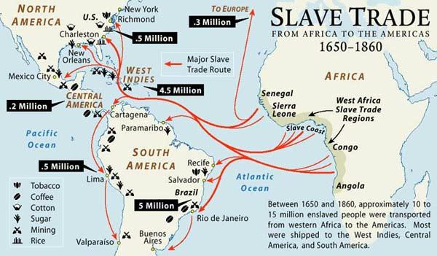
- When did the Atlantic Slave Trade begin? How far did it span? How many Africans were impacted?
- What crops were being grown in the Americas and what did they require?
- What happened to the enslaved natives?
- What did white captains offer for slaves?
- How did the Atlantic Slave Trade benefit African tribes?
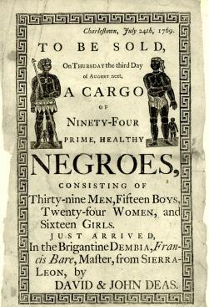
- Describe what happened to captured Africans before they were brought to the ships.
- How were Africans treated on the ships to the Americas?
- How did the Atlantic Slave Trade affect Africa’s future?
- How did Christians justify slavery despite it going against Christian ideals?

