Document 1

Terrace Farming
Several societies including the Chinese and the Inca used terrace farming to create farmland where there is little. The technique involves cutting land away from a hillside to create flat surfaces that look like large steps. Plants can then be grown on the newly flattened sections.
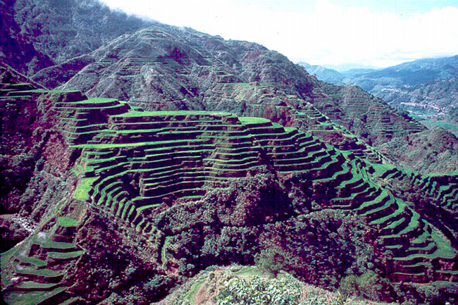  Rice terraces  Source: Rice terraces.png by McCouch S published under the Creative Commons Attribution 2.5 Generic license. | 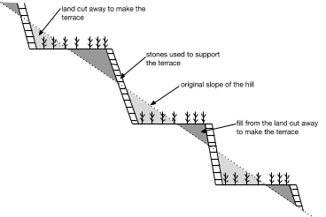  Terrace farming technique
Document 2
Rooftop Gardening
Rooftop gardening is a technique for building a garden on top of a building. Some rooftop gardens are small and for personal use, while others are on the scale of small farms. In addition to providing food, the gardens help cool down the building, provide habitats for wildlife, and provide recreational activities for people.

There have been examples of rooftop gardens throughout history dating back to Mesopotamia, Rome, and the middle ages in Egypt, but have become more popular in the 20th and 21st centuries because of the lack of green space and food production in cities.
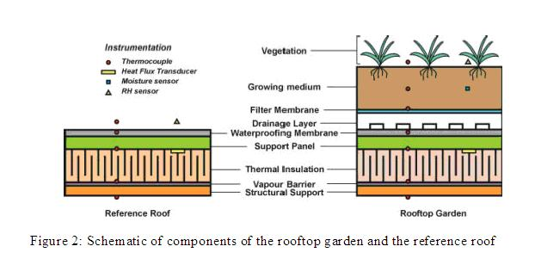  Components of a rooftop garden  Source: Components of a roof garden vs reference roof by Karen Liu published under the Creative Commons CC0 1.0 Universal Public Domain Dedication and modified by New Visions for Public Schools. | 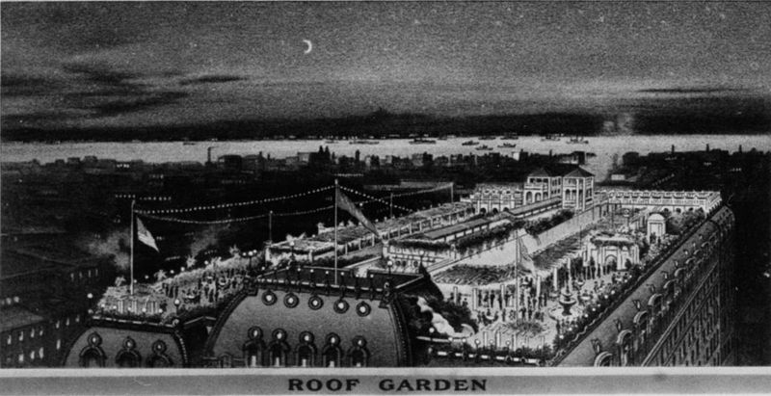  Rooftop Garden on the Astor Hotel in New York City from 1904.  Source: HotelAsterRooftopGarden.jpg by the New York Historical Society this work is in the public domain and has been modified by New Visions for Public Schools.
Document 3

Vertical Farming
Vertical farming is a technique for growing food that attempts to save as much space, energy, and water as possible by stacking crops vertically, usually in climate controlled facilities. Vertical farms have been created and proposed in skyscrapers and warehouses in and near cities because the buildings are already there and the food produced in them would already be close to most of the people who would consume, it thus saving the time and fuel it would take to ship food.
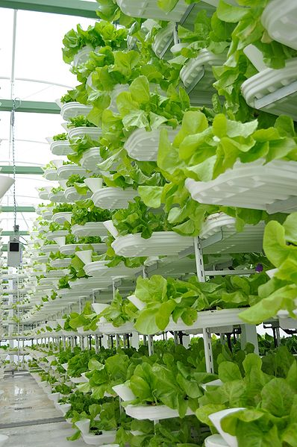  An example of the VertiCrop System, used in some vertical farms.  Source: VertiCrop System by Eigenes Werk published under the CC BY-SA 3.0 license. | 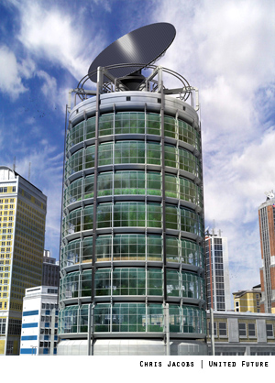  A vertical farm design.  Source: United Future by Chris Jacobs published under the Creative Commons Attribution-ShareAlike 3.0 License.

