How did the “discovery” of the New World by Europeans impact the indigenous people?
Historical Context:
Columbus’s “discovery” sparked interest in the “New World” in Spain and other European countries. Soon, the Spanish, British, Dutch, Portuguese, and French sent expeditions to explore the new world in hopes of finding Gold, Glory, and indigenous people to convert to Christianity (God).

European Exploration 15th-17th Centuries
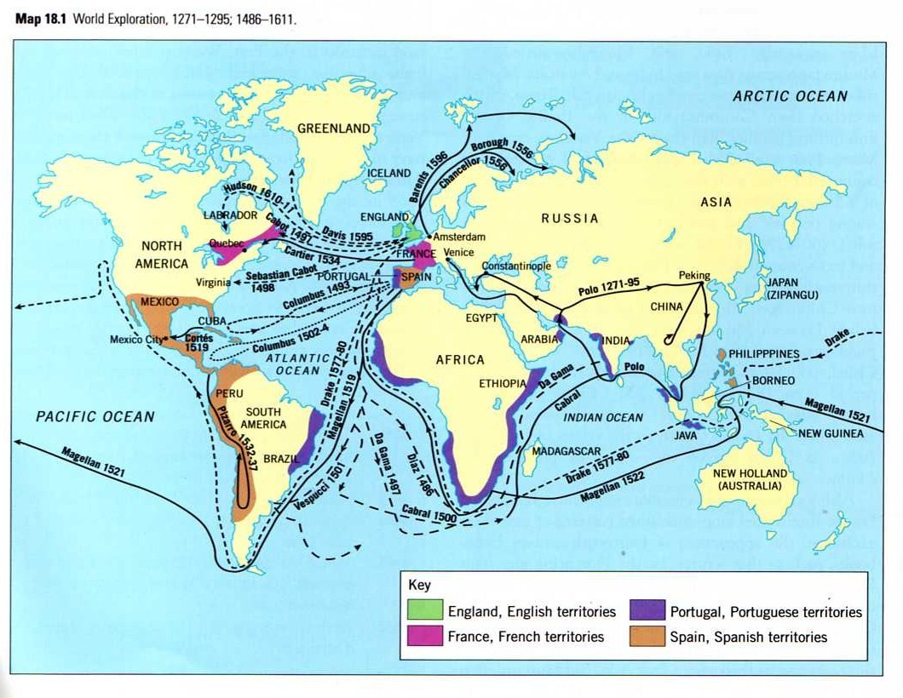

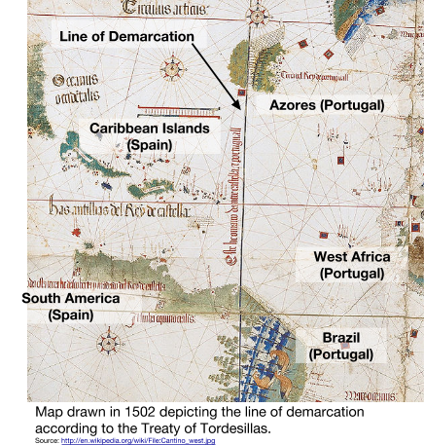
Treaty of Tordesillas, 1494
In the late 1400s and early 1500s, Portugal and Spain, both of which were ruled by Catholic monarchs, were the first countries to explore new trade routes and discover new lands. Even before Columbus landed in the Caribbean, the two countries argued over who had ownership over territory that their sailors found and mapped independently.

In 1494, they approached the one organization that had authority over both rulers to settle their disputes. The Spanish and Portuguese monarchs left the question of ownership over new lands to Pope Alexander VI. The Pope simply drew a line of demarcation [separation] between the Azores, islands off the coast of Europe already discovered by the Portuguese, and the islands discovered by Columbus. The Pope proposed that all lands discovered to the east of the line would belong to the Portuguese, and that all lands discovered to the west of the line would belong to the Spanish. In the Treaty of Tordesillas, the Spanish and Portuguese agreed to the Pope’s compromise.

Because of the Treaty of Tordesillas, the Spanish spent most of their effort exploring and conquering the western hemisphere, while the Portuguese devoted their time and power to Africa and the Indian Ocean. Unfortunately for the Portuguese, who did not yet know what was west of the line of demarcation, most of South America with the exception of the eastern tip which later became Brazil, was controlled by the Spanish.

1. What were the effects of the Treaty of Tordesillas?

Why were the Spanish able to conquer the Aztecs and Inca?
Objective: Explain why the Spanish were able to conquer the Aztecs and Inca despite being outnumbered.

Historical Context:
In search of wealth, glory, and indigenous people to convert to Christianity, companies of Spanish conquistadors (conquerors) ventured into the American continent.

The two most well known expeditions, were those that led to the conquest of powerful empires that already existed in the Americas: the Aztecs and Inca. The first, led by a conquistador named Hernando Cortes, defeated the Aztecs (1518-1520). The second was led by Francisco Pizarro in 1532 during which he and his fellow conquistadors conquered the Inca.
Directions: Read the descriptions of the conquests of the Aztecs and Inca below, and then answer the questions that follow. As you read, note the similarities and differences between the two stories.
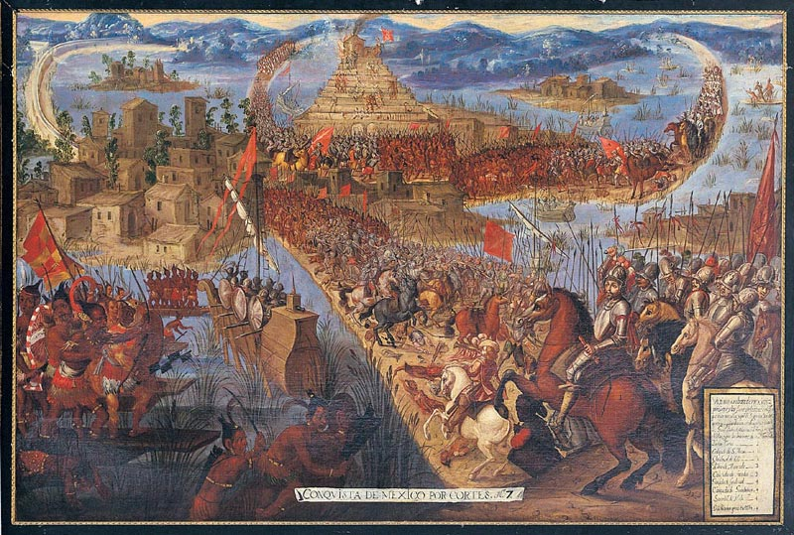  "The Conquest of Tenochtitlán," Unknown artists, Mexico; second half of 17th century; oil on canvas.  Source: http://en.wikipedia.org/wiki/File:The_Conquest_of_Tenochtitlan.jpg |  | 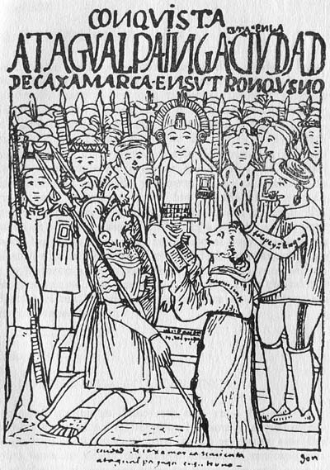  The meeting between Francisco Pizarro and the Inca emperor Atahualpa. Drawn by Felipe Guáman Poma de Ayala an Inca man who fought for indigenous rights and wrote the book El Primer Nueva Corónica y Buen Gobierno.  Source: http://commons.wikimedia.org/wiki/File:Atawallpa_Pizarro_tinkuy.jpg
Conquest of the Aztecs |  | Conquest of the Inca
In 1519, Hernan Cortes, a conquistador, landed on the coast of Mexico to lead an expedition in hopes of riches. There were previous reports of a great empire and gold in the area. On his way to the Aztec capital city of Tenochtitlan, Cortes fought and defeated other Mexican tribes, who then became the Spaniards’ allies. Many of the tribes that Cortes came in contact with were ruled by the Aztecs and resented the power they had over them. Those tribes saw working with the Spanish as an opportunity to defeat the Aztecs and to gain power for themselves.  On November 8, 1519, Cortes, his men, and his native Mexican allies were welcomed into Tenochtitlan by the Aztec ruler Moctezuma. Cortes took Moctezuma captive and held him prisoner in one of the Aztec palaces. Cortes demanded gold and other valuables as ransom. Following a massacre of the Aztec people by Cortes’ men, many natives were turned against the Spaniards. The Aztecs prevented the Spanish from getting any supplies, and finding no use for him, the Spanish killed Moctezuma.  Cortes and his men went on to convince the tribes surrounding the Aztecs to fight for him by making false promises. Because of the harsh rule of the Aztecs and the false promises, the Spanish gained the support of many of the tribes.  During this time, the Aztecs repaired their city from the damage the Spanish caused, but they also suffered from a smallpox epidemic brought to the city by the Spanish that killed many in the capital.  Cortes returned to Tenochtitlan to conquer it with new supplies from the Spanish, and an expanded group of warriors from allied tribes. Cortes started his assault by blocking all food and water from getting into the city in an attempt to starve the inhabitants. Then, he sent troops on boats to invade Tenochtitlan through its waterways.  It took eighty days for the Spanish to defeat the Aztecs. Two-hundred and forty thousand Aztecs are estimated to have died, and only 900 of Cortes’s troops survived. Though they did not benefit from the victory in the long run, the Spanish success was largely due to the efforts of Cortes’ Indian allies who might have numbered as many as 200,000.  Source: Adapted and modified from “Battle of Tenochtitlan,” New World Encyclopedia. http://www.newworldencyclopedia.org/entry/Battle_of_Tenochtitlan#cite_note-atlas-3 |  | In 1532, after reports of gold, silver, and emeralds in Ecuador, Francisco Pizarro, Hernando de Soto, and 180 other Spanish conquistadors mounted an expedition into South America hoping to find wealth and glory.  At one point in their journey, De Soto was sent to explore new lands and returned to Pizarro with men that were sent by the Inca emperor Atahualpa to invite Pizarro and his men to meet with him.  At the time, the Inca empire was divided and engaged in a civil war. Pizarro formed alliances with tribes who opposed the Inca. In addition, the entire Inca empire was suffering from an epidemic of smallpox which decimated the population.  After two months of marching, Pizarro and his troops came to one of the Inca king’s retreats near Cajamarca to meet with him. De Soto met with the king but Atahualpa told the Spaniard to leave the Inca empire saying he would “be no man’s tributary.” In response, Pizarro organized his troops, attacked Atahualpa's army and captured him in what became known as the Battle of Cajamarca. Thousands of Inca died in the battle, but none of the Spanish soldiers did. Pizarro executed Atahualpa’s 12-man honor guard and held the king for ransom. Though the Inca filled one room with gold and two with silver, Pizarro executed Atahualpa on August 29, 1533.  A year later, Pizarro invaded Cuzco, the capital of the Inca empire, with indigenous troops and with it sealed the conquest of the Inca.  Adapted from “Francisco Pizarro,” New World Encyclopedia. http://www.newworldencyclopedia.org/entry/Francisco_Pizarro#Conquest_of_Peru_.281532.29
1. How were the conquests of the Aztecs and Inca similar?
2. What was different about the conquests of the Aztecs and Inca?
3. Why do you think the Spanish were able to defeat the Aztecs and Inca?

Slavery and Gold: Encomienda
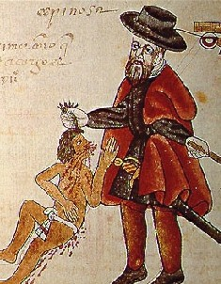  Source: http://es.wikipedia.org/wiki/Encomienda#/media/File:Kingsborough.jpg Códice Kingsborough: un encomendero abusa de un indio. Copia del italiano Agostino Aglio 1825-1826, para Lord Kingsborough | The encomienda system was created by the Spanish to control and regulate [...] Indian labor and behavior during the colonization of the Americas. Under the encomienda system, conquistadors and other leaders (encomenderos) received grants of a number of Indians, from whom they could exact “tribute” in the form of gold or labor. The encomenderos were supposed to protect and Christianize the Indians granted to them, but they most often used the system to effectively enslave the Indians and take their lands.  Source: http://www.gilderlehrman.org/history-by-era/imperial-rivalries/timeline-terms/encomienda-system-established
Define the encomienda system.

Hierarchy: Peninsulares, Creoles, Mestizos, Africans & Indigenous
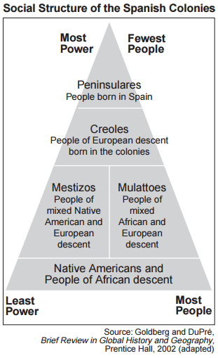 | … Growing sugar cane became a large business. At first, Native Americans were forced to work on sugar plantations, large estates run by an owner or overseer. They were treated cruelly, and many died. The Spanish then brought slaves from Africa to do the work.  A new social structure developed. People born in Spain made up the highest social class. Those of European descent born in the colonies were next. People of mixed European and Indian or African descent were in the middle. Native Americans and people of African descent were in the lowest classes.…  Source: Guide to the Essentials of World History, Prentice Hall from the NYS Global History and Geography Regents Exam, June 2013.
Why did the social structure of the Americas change?

What determined a person’s rank?

Explain what the Columbian Exchange was,
and predict what effects it might have had on the Eastern and Western hemispheres.

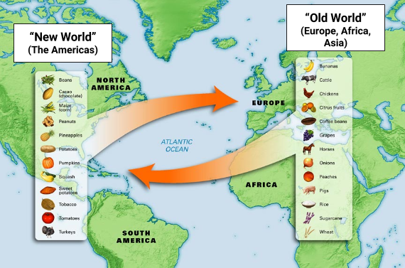  Source: http://blogs.uoregon.edu/mesoinstitute/about/curriculum-unit-development/spanish-conquest/columbian-exchange/ | Favorite Foods! Ingredients in your favorite foods Old World or New World?
4) If you lived in the New World and did not have access to Old World plants and animals, which of your favorite foods would you still be able to eat?

What effect did the Columbian Exchange have on the native people?

When Christopher Columbus returned to Spain from the Americas in 1493, he brought with him plants and animals he found in the Americas. In late 1493, he returned to the Americas and brought with him a collection of European animals and plants. Through Columbus’ voyages, he initiated a global exchange that drastically affected the world. The animal, plant, and bacterial life of these two worlds began to mix and this mix had a variety of effects on people and the environment. This exchange of plants, animals, humans, bacteria, and technology between the Old World [Europe, Asia and Africa] and the New World [the Americas] is known as the Columbian Exchange. The Columbian Exchange created a connection between the Eastern and Western hemispheres that brought the two sections of the world together like never before. |  | In your own words, what was the Columbian exchange?

Based on the charts, how did the Columbian Exchange impact the native people?
