Tang and Song Golden Ages of China
Objective: Identify the achievements and innovations of the Tang and Song dynasties in China.
China: An Introduction to the Tang Dynasty (618–906) and Song Dynasty (960–1279)
The Tang (618–906) and Song (960–1279) Dynasties of China was one of the most technologically advanced civilizations in the world. Like other golden ages in history, the Tang and Song Dynasties unified China, created a strong central government (one government that controlled all of China), and ruled over a time of peace.. The Tang expanded China’s territory by taking over Korea and Vietnam, as well as portions of northeast, central, and southeast Asia.  The peace during the Tang and Song dynasties allowed for trade throughout the empire and abroad through the Silk Roads. Chinese cities during the Tang and Song dynasties became international cultural centers where religious, academic, and artistic cultural diffusion occurred. Scholars and merchants from as far as Persia and India came to Tang China to participate in its golden age.  While the government was strong, it was not oppressive (harsh or cruel). Some became very rich, but the Tang rulers redistributed land to give the less fortunate an opportunity to grow in wealth. In addition this was a time when education and achievement were rewarded and women attained (gained) a higher status in the government and more freedom than they had in previous dynasties.  Modified and adapted from New Visions 2018 |  | 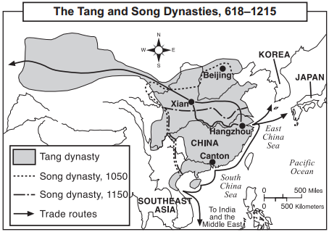  Source: Goldberg and DuPré, Brief Review in Global History and Geography, Prentice Hall (adapted) from the NYS Global History and Geography Regents Exam, June 2005.
Questions:
1. Based on the reading passage to the left, why was Tang China a “cultural center?”

2. Based on the passage and your knowledge of golden ages, why was China during the Tang dynasty a likely place for golden age to occur?

NTD on China, Discovering China: The Song Dynasty
Directions:
- Preview the questions listed in the right-hand column.
- Watch the video (https://goo.gl/GQtD3E) one time through, without stopping and try to answer the questions.
- Read the excerpts from the transcript of the video below and answer those questions that you could not by watching the film.
Time | Excerpts from Discovering China: The Song Dynasty |  | Questions
1:17 | ...the Southern Song period was one of prosperity with flourishing art and culture as well as technological advancements. During the Song, the government started to grant farmers ownership of land which led to a huge increase in rice production. The economy started to change from a purely agricultural economy to a commercial one with peasants selling their surpluses to buy a wide range of goods such as tea, coal, oil, and wine. With the growth in the economy, so grew the population, hitting 100 million by the year 1100. |  | 1. What evidence from this section suggests that the Song dynasty was prosperous?
1:50 | Three of China's four great inventions originate from the Song Dynasty namely, printing, the magnetic compass, and gunpowder. The Song government used its printing techniques for currency production and in the 12th century, became the first government in the world to print paper money. The Song was also the first Chinese dynasty to establish a permanent standing navy to safeguard foreign trade and guard against invasions from the north. The ships used the newly invented compass to navigate and used gunpowder in their weaponry. Gunpowder was first employed in bombs delivered from ships via catapult. The Song used these tactics to successfully defend their territory against a Jurchen invasion on the Yangtze River in the year 1161 AD. A Song force of only three thousand men on 120 ships defeated a Jurchen force of seventy thousand on over six hundred ships… |  | 2. Describe how each of the following innovations affected the Song Dynasty.  2a. Printing  2b. gunpowder  2c. the compass
3:25 | Southern Song scholars gave a lot of attention to how Confucian principles could be applied to society rather than to politics. They proposed ways to build a better society focusing on families communities. The most famous of the Song Dynasty scholars was a man named Zhu Xi who would go on to leave a legacy lasting seven hundred years. |  | 3. What philosophy was important to Song society?
3:57 | ...Song painters also mimicked the mood of the time their artworks. Northern Song painters like Fan Quan painted huge grand landscape scenes. Whereas after the loss of the North, paintings became more intimate, focusing on family or village scenes within the natural environment. Scenes would often be in one corner with a large empty expanse occupying much of the painting.  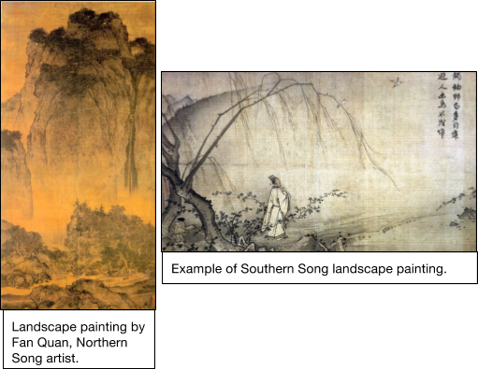 |  | 4. Based on this excerpt from the video, describe Song Dynasty painting.

Poetry and the Civil Service Exam in the Tang (618-906) and Song (960-1279) Dynasties
The Tang (618-906) and Song (960-1279) dynasties were the golden ages of Chinese classical literature, especially poetry. Poets of these periods, including Li Bo, Du Fu, and Su Shi, are well known throughout East Asia and are still thought of as greatly respected models for later generations of poets.  So why was there a flourishing (growing) of literature during the Tang and Song dynasties? The answer to this question lies primarily in the fact that civil service exams put into place during the Tang and Song demanded significant literary skills. Poetry was considered the most refined (high-quality) means of expression, and was believed to be relevant to many professional areas, including diplomacy (people-skills), communication, reasoning (thinking), and philosophy. Civil service exams were used to identify capable people for government service and were the most important avenue for people from different social backgrounds to achieve political ambitions and gain prestige. Although the practice of the exams originated in the sixth century, it was not widely established (used) until the Tang and significantly expanded during the Song. During the Tang, exam candidates were tested on poetry composition (writing). This meant that if a person in the Tang wanted to achieve his social ambition or simply live a better life, he needed to be able to write poems. Even though by the middle of the Song, the exam requirement for poetry was replaced by essays, essays demanded no less literary (writing) skill. During the Song, along with the increase in the national literacy rate (the people’s ability to read and write), the government increased exam enrollment among people of all classes. This development in turn prompted (caused) more people to acquire literary skills. Besides the great significance (importance) and widespread pursuit of the civil service exams, the invention and development of printing in the Tang and Song made the circulation (distribution) of poems easier than before, and facilitated (made possible) the study of poetry. All this contributed to the flourishing of poetry during the Tang and Song dynasties.  Source (modified): Asian Art Museum’s Education and Public Programs, “The Flourishing of Poetry in the Tang (618-906) and Song (960-1279) Dynasties.” http://education.asianart.org/explore-resources/background-information/flourishing-poetry-tang-618-906-and-song-960-1279-dynasties | - Based on the passage above, what were “civil service exams?” What were they used for?  - Based on the passage, what tasks did students need to complete on the civil service exams during the Tang and Song dynasties?  - After reading the entire article, answer the question that the author poses in the second paragraph of this passage. “So why was there a flourishing of literature during the Tang and Song dynasties?”
Chinese Innovation and Culture Spreads East to Korea and Japan
Objective: Explain how Japan’s location near Korea and China impacted its history.

Korean and Japanese cultures have been greatly influenced by Chinese culture because of their geographic location close to China. Korea acted as a “cultural bridge” between China and Japan. The Japanese and Koreans were in contact with one another early on in the history of their civilizations. They traded and warred against one another. In the process, Koreans introduced Chinese writing and culture, and Buddhism to the Japanese. This exchange sparked Japanese interest in China.
In the 600s, a Japanese ruler named Prince Shotoku of the Yamato clan sent nobles to China to study with government officials, scholars, and monks during the Tang Dynasty. Over the next 200 years, more Japanese students, monks, traders, and officials visited the Tang court. The Japanese absorbed Chinese technological innovations, agricultural techniques, philosophies, arts, and architecture, but they did not become Chinese. Instead, the Japanese practiced selective borrowing, by accepting some Chinese practices into their culture and modifying them to meet their needs, but choosing not to adopt other practices like the Chinese civil service system.
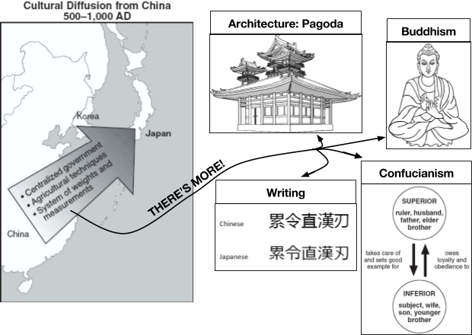 | Question:  - Based on the reading, try to define the following:  - Cultural Bridge:  - Selective Borrowing:  - Based on the reading above and graphic to the left, what was the impact of Japan’s location near Korea and China on its history?

