Tang and Song Golden Ages of China
Objective: Identify the achievements and innovations of the Tang and Song dynasties in China.
China: An Introduction to the Tang Dynasty (618–906) and Song Dynasty (960–1279)
Scholars often refer to the Tang (618–906) and Song (960–1279) dynasties as the "medieval" period of China [because Western Europe was in its Middle Ages, a time often referred to as “medieval”]. The civilizations of the Tang and Song dynasties of China were among the most advanced civilizations in the world at the time. Discoveries in the realms of science, art, philosophy, and technology—combined with a curiosity about the world around them—provided the men and women of this period with a worldview and level of sophistication that in many ways were unrivaled until much later times, even in China itself.  When the rulers of the Tang dynasty (618–906) unified China in the early seventh century, the energies and wealth of the nation proved strong enough not only to ensure internal peace for the first time in centuries, but also to expand the Chinese realm to include large portions of neighboring lands such as Korea, Vietnam, northeast, central, and southeast Asia. The Tang became a great empire, the most powerful and influential of its time any place in the world. Flourishing trade and communication transformed China into the cultural center of an international age. Tang cities such as the capital of Chang’an (modern Xi’an), the eastern terminus [end] of the great Silk Road, were global hubs of banking and trade as well as of religious, scholarly, and artistic life. Their inhabitants, from all parts of China and as far away as India and Persia, were sophisticated…. Government was powerful, but not oppressive; education was encouraged, with the accomplished and learned well rewarded. Great wealth was accumulated by a few, but the Tang rulers saw that lands were redistributed, and all had some measure of opportunity for material advancement. This was also a time when many women attained higher status at court, and a greater degree of freedom in society.  Source: Asian Art Museum’s Education and Public Programs, “China: An Introduction to the Tang Dynasty (618-906).”  http://education.asianart.org/explore-resources/background-information/introduction-tang-dynasty-618%E2%80%93906 |  | 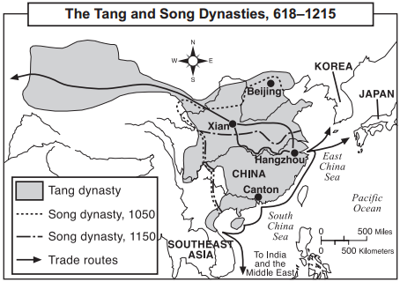  Source: Goldberg and DuPré, Brief Review in Global History and Geography, Prentice Hall (adapted) from the NYS Global History and Geography Regents Exam, June 2005.
Questions:
1. Based on the reading passage to the left, why was Tang China a “cultural center of an international age?”

2. Based on the passage and your knowledge of golden ages, why was China during the Tang dynasty a likely place for golden age to occur?

NTD on China, Discovering China: The Song Dynasty
Directions:
- Preview the questions listed in the right-hand column.
- Watch the video (https://goo.gl/GQtD3E) and answer the questions.
Time | Questions
1:17 | 1. What evidence from this section suggests that the Song dynasty was prosperous?
1:50 | 2. Describe how each of the following innovations affected the Song Dynasty.  2a. Printing  2b. gunpowder  2c. the compass
3:25 | 3. What philosophy was important to Song society?
3:57 | ...Song painters also mimicked the mood of the time their artworks. Northern Song painters like Fan Quan painted huge grand landscape scenes. Whereas after the loss of the North, paintings became more intimate, focusing on family or village scenes within the natural environment. Scenes would often be in one corner with a large empty expanse occupying much of the painting.  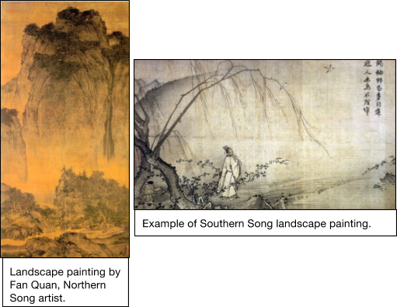  4. Based on this excerpt from the video, describe Song Dynasty painting.

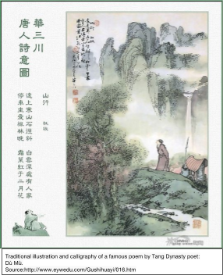
The Flourishing of Poetry in the Tang (618-906)

and Song (960-1279) Dynasties
The Tang (618-906) and Song (960-1279) dynasties were the golden ages of Chinese classical literature in general, and poetry in particular. Poets of these periods, including Li Bo, Du Fu, and Su Shi, are well known throughout East Asia and are still regarded as revered models for later generations of poets.
So why was there a flourishing of literature during the Tang and Song dynasties? The answer to this question lies primarily in the fact that civil service exams instituted during the Tang and Song demanded significant literary skills. Poetry was considered the most refined and elevated means of expression, and was believed to be relevant to many professional arenas, including diplomacy, communication, reasoning, and philosophy. Civil service exams were used to identify capable people for government service and were the most important avenue for people from different social backgrounds to achieve political ambitions and gain prestige. Although the practice of the exams originated in the sixth century, it was not widely established until the Tang and significantly expanded during the Song. During the Tang, exam candidates were tested on poetry composition. This meant that if a person in the Tang wanted to achieve his social ambition or simply live a better life, he needed to be able to write poems. Even though by the middle of the Song, the exam requirement for poetry was replaced by essays, essays demanded no less literary skill. During the Song, along with the increase in the national literacy rate, the government increased exam enrollment among people of all classes. This development in turn prompted more people to acquire literary skills. Besides the great significance and widespread pursuit of the civil service exams, the invention and development of printing in the Tang and Song made the circulation of poems easier than before, and facilitated the study of poetry. All this contributed to the flourishing of poetry during the Tang and Song dynasties.

Source: Asian Art Museum’s Education and Public Programs, “The Flourishing of Poetry in the Tang (618-906) and Song (960-1279) Dynasties.” http://education.asianart.org/explore-resources/background-information/flourishing-poetry-tang-618-906-and-song-960-1279-dynasties
1. Based on the passage above, what were “civil service exams?” What were they used for?
____________________________________________________________________________________________________________________________________________________________
2. Based on the passage, what tasks did students need to complete on the civil service exams during the Tang and Song dynasties?
____________________________________________________________________________________________________________________________________________________________
3. Answer the question that the author poses in the second paragraph of this passage. “So why was there a flourishing of literature during the Tang and Song dynasties?” ____________________________________________________________________________________________________________________________________________________________
Chinese Innovation and Culture Spreads East to Korea and Japan
Objective: Explain how Japan’s location near Korea and China impacted its history.

Korean and Japanese cultures have been greatly influenced by Chinese culture because of their geographic location close to China. Korea acted as a “cultural bridge” between China and Japan. The Japanese and Koreans were in contact with one another early on in the history of their civilizations. They traded and warred against one another. In the process, Koreans introduced Chinese writing and culture, and Buddhism to the Japanese. This exchange sparked Japanese interest in China.
In the 600s, a Japanese ruler named Prince Shotoku of the Yamato clan sent nobles to China to study with government officials, scholars, and monks during the Tang Dynasty. Over the next 200 years, more Japanese students, monks, traders, and officials visited the Tang court. The Japanese absorbed Chinese technological innovations, agricultural techniques, philosophies, arts, and architecture, but they did not become Chinese. Instead, the Japanese practiced selective borrowing, by accepting some Chinese practices into their culture and modifying them to meet their needs, but choosing not to adopt other practices like the Chinese civil service system.
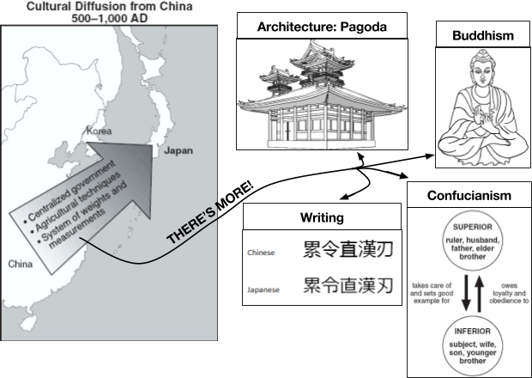 | Question:  1. Based on the reading above and graphic to the left, what was the impact of Japan’s location near Korea and China on its history?

