***THE BATTLE OF TOURS***



**DIRECTIONS:** Watch the video (https://goo.gl/SAUJKk) and read the passage below. Using the document and the video clip, answer the question(s).

**“The Hammer” Stop Muslim Expansion**

At the Battle of Tours near Poitiers, France, Frankish leader Charles Martel, a Christian, defeats a large army of Spanish Moors, halting the Muslim advance into Western Europe. Abd-ar-Rahman, the Muslim governor of Cordoba, was killed in the fighting, and the Moors retreated from Gaul, never to return in such force.

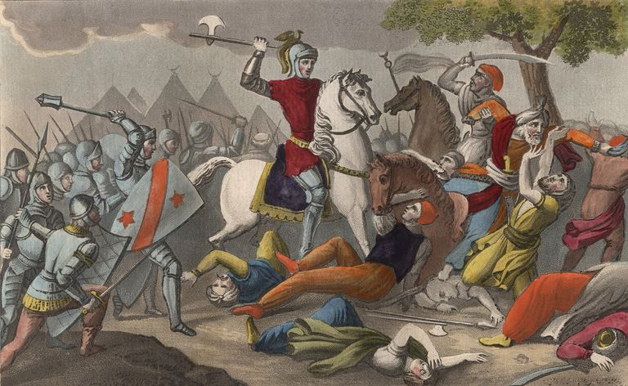Charles was the illegitimate son of Pepin, the powerful mayor of the palace of Austrasia and effective ruler of the Frankish kingdom. After Pepin died in 714 (with no surviving legitimate sons), Charles beat out Pepin’s three grandsons in a power struggle and became mayor of the Franks. He expanded the Frankish territory under his control and in 732 repulsed an onslaught by the Muslims.

Victory at Tours ensured the ruling dynasty of Martel’s family, the Carolingians. His son Pepin became the first Carolingian king of the Franks, and his grandson Charlemagne carved out a vast empire that stretched across Europe. The Christian victory also ensured the end of Muslim expansion into Europe under the Islamic Caliphates that had dominated the Middle East and Africa and solidified Christian dominance of the European continent.

1. **Describe the impact the Battle of Tours had on Europe.**





**DIRECTIONS:** Watch the video (https://goo.gl/Ue95Bp) and read the passage below. Using the document and the video clip, answer the question(s).

**The Fall of Rome Opens a Position for the Catholic Church’s Favorite King Candidate**

Corruption, invaders, and a failing economy due to war left Rome desolate and weak by 500 AD. About this time, the ferocious tribe called Franks conquered Gaul, or modern France, with a different type of warfare. Their troops of heavily armored knights defeated their opponents from horseback. Through the marriage of their leader Clovis to a Christian woman Clotilda, the Franks were converted to Christianity.

Almost 200 years later, an even stronger leader arose from the Franks. ***Charlemagne***, also known as Charles the Great, ruled his ever expanding empire from 768 to 814. In those times, he battled and conquered many neighboring kingdoms, and absorbed parts of modern Germany, Italy, and northern Spain under his rule. Most of his kingdom had once belonged to the Roman Empire. For this reason, the then current Pope Leo III crowned Charlemagne Emperor of the Romans as a symbolic show of Rome’s power returning.

Charlemagne’s use of rewards for knights service to accomplish his conquests laid the foundation for feudalism in Europe. ***Feudalism*** is a economical and political system in which a king grants lands to a noble or knight in exchange for service, and serfs or peasants work the land for the nobles. In return, the serfs were protected from the dangers of frequent invaders.

In addition to being a fierce leader and conqueror, Charlemagne was a deep thinker and scholar. He built many universities and hired scholars to teach at his capital city of Aachen in modern western Germany. These efforts in education lasted well beyond the middle ages and proliferated the cause of the renaissance.

1. ***Charlemagne was a very accomplished leader.* Write at least two pieces of evidence that supports this claim. Be sure to use quotes in your examples.**
2. **Infer the meaning of *proliferated* from the following sentence: “These efforts lasted well beyond the middle ages and *proliferated* the cause of the renaissance.”**

**DIRECTIONS:** Watch the video (https://goo.gl/RTCHpk) and read the passage below. Using the document and the video clip, answer the question(s).

**Invaders From the North**

Even and Charlemagne began to conquer all the European tribes, Europe faced attacks from **Magyars** (a clan from the Ural Mountain region) to the East and **Muslims** from the Southeast (which eventually lead to the Crusades). Perhaps the earliest and most feared invaders came from the northern country of Scandinavia. As early as the eighth century, **Vikings** started to raid villages along the coasts of Finland and Sweden. For centuries, they sailed their shallow ships around the coasts and deep inland via river ways, pillaging villages, cities, and monasteries. Those they didn’t kill were often captured to sell as slaves. Later in the middle ages, the Norsemen settled in Ireland and England, using them as home bases between attacks on the rest of Europe.



The Vikings attacks and the Europeans need to defend themselves set the stage for Feudalism to prosper. Frank leader **Charlemagne** lead a strong war campaign in which he rewarded faithful knights, and many leaders who reigned after him followed his example. Lords and barons built walls and castles, and manned them with trained warriors to defend against Vikings and other invaders.

1. **List three (3) invaders of Europe and from where they came.**
2. **Why do you think Vikings were so greatly feared by Europeans?**
3. **How did Vikings influence the creation of a Feudalist European Society?**