How were Classical Civilization interconnected?
Describe how classical civilizations were connected.

Trade in the Classical World
Vocabulary Preview
Directions: Write your own definition for the following vocabulary words.
Vocabulary Word | Definition
Trade
Trade Route
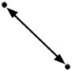
Trade Network
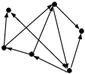
Cultural Diffusion
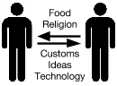

Major World Trade Routes in the 15th Century

The map below shows trade routes and trade networks that existed at the end of the Classical Era and continued to exist through the 15th century. The maps that follow this one focus in on some of the trade networks that are highlighted below.

Directions: Examine each of the following maps that show trade routes and networks that developed during the Classical Era and complete the synthesis at the end of this packet. Full color maps can be found on my website.
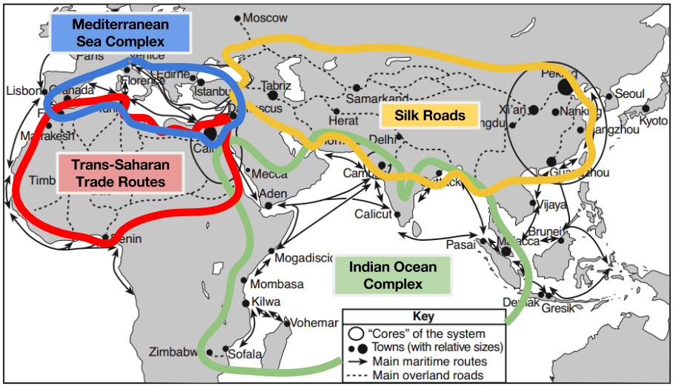
Source: Philippe Beaujard in “The Indian Ocean in Eurasian and African World-Systems before the Sixteenth Century,” Journal of World History (adapted) from the NYS Global History and Geography Regents

Think Like a Geographer  Remember, when analyzing a map:  1: Examine the DOGSTAIL: Date, Orientation, Grid, Scale, Title, Author, Index, Legend/Key, Sources  2 .Determine what each symbol on the map represents  3. Contextualize: Identify where the region on the map is in the world and what is around it | Indian Ocean Complex  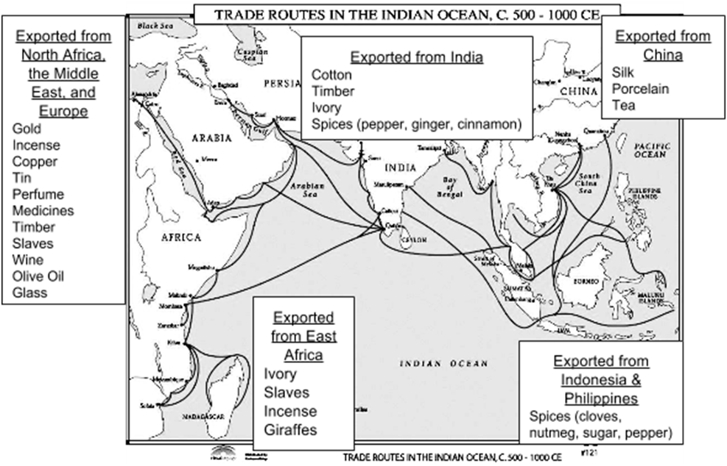
See |  | Think | Wonder
I see (identify 3 details)... |  | Trade Routes the Region is Connected To  ⎕ Mediterranean Sea Complex ⎕ Trans-Saharan Trade Routes ⎕ Silk Roads ⎕ Indian Ocean Complex  Other Regions the Region is Connected To Through Trade  ⎕ South America ⎕ Western Europe ⎕ Central America ⎕ West Africa ⎕ South Asia ⎕ East Asia ⎕ Middle East | I wonder...

Think Like a Geographer  Remember, when analyzing a map:  1: Examine the DOGSTAIL: Date, Orientation, Grid, Scale, Title, Author, Index, Legend/Key, Sources  2 .Determine what each symbol on the map represents  3. Contextualize: Identify where the region on the map is in the world and what is around it | Silk Road  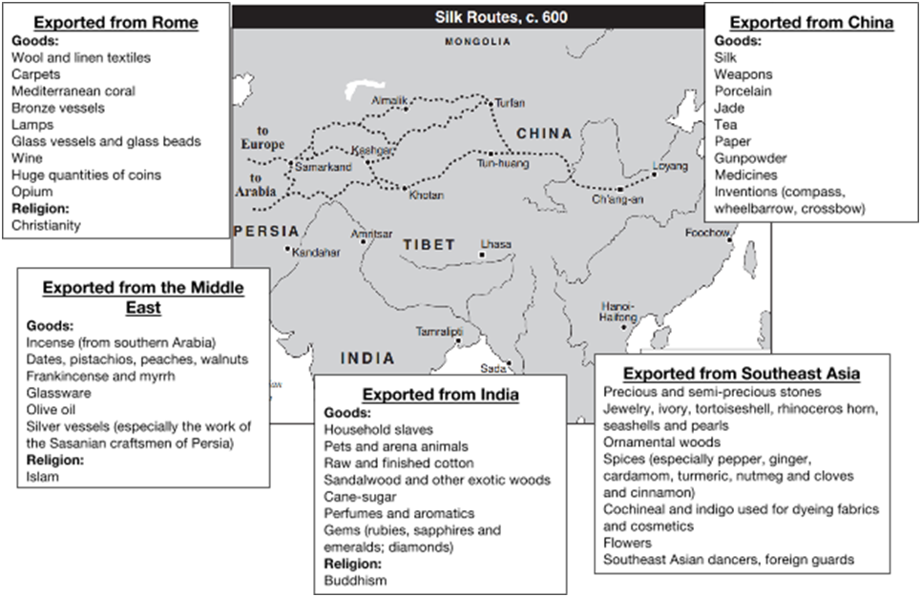
See |  | Think | Wonder
I see (identify 3 details)... |  | Trade Routes the Region is Connected To  ⎕ Mediterranean Sea Complex ⎕ Trans-Saharan Trade Routes ⎕ Silk Roads ⎕ Indian Ocean Complex  Other Regions the Region is Connected To Through Trade  ⎕ South America ⎕ Western Europe ⎕ Central America ⎕ West Africa ⎕ South Asia ⎕ East Asia ⎕ Middle East | I wonder...
Think Like a Geographer  Remember, when analyzing a map:  1: Examine the DOGSTAIL: Date, Orientation, Grid, Scale, Title, Author, Index, Legend/Key, Sources  2 .Determine what each symbol on the map represents  3. Contextualize: Identify where the region on the map is in the world and what is around it | Mediterranean Sea Complex  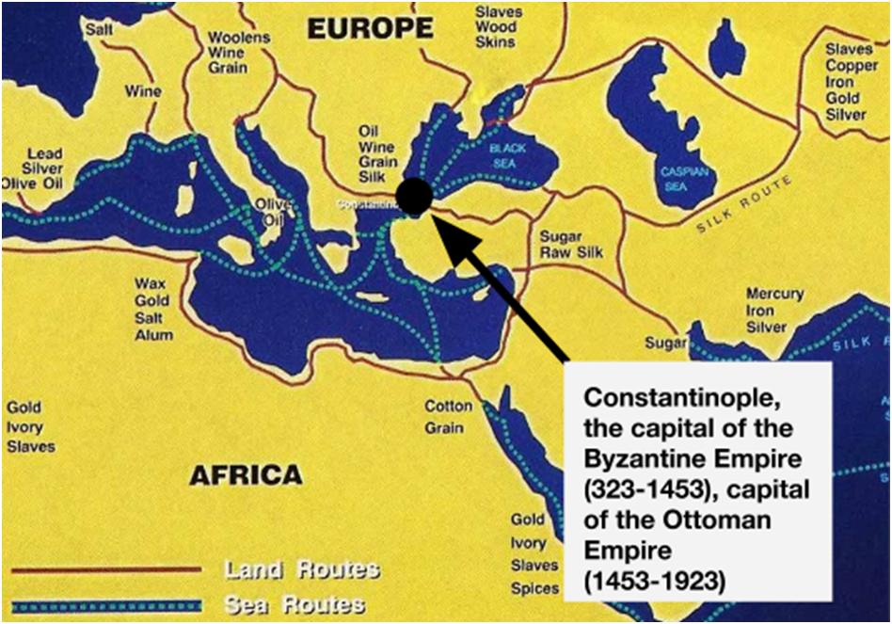
See |  | Think | Wonder
I see (identify 3 details)... |  | Trade Routes the Region is Connected To  ⎕ Mediterranean Sea Complex ⎕ Trans-Saharan Trade Routes ⎕ Silk Roads ⎕ Indian Ocean Complex  Other Regions the Region is Connected To Through Trade  ⎕ South America ⎕ Western Europe ⎕ Central America ⎕ West Africa ⎕ South Asia ⎕ East Asia ⎕ Middle East | I wonder...
Synthesis
Directions: For each of the examples below, use the maps you’ve examined to:
- Determine if the good described could have been traded between the regions specified by the end of the Classical Era. Circle Yes or No.
- Explain whether or not the good could have been traded between the regions specified before the Age of Exploration.
  - If it could have been traded between those regions, then explain how by identifying which regions the good could have travelled through, which bodies of water it could have crossed, and which trade networks it would have been traded through.
  - If the item could NOT have been traded between the regions identified, then explain why.

Description of good | Could the good have been traded between the regions specified? | Explain how or why not
Silk from East Asia was traded in the Middle East | YES NO
Gold from West Africa was traded in East Asia. | YES NO
Pepper from South Asia was traded in Western Europe. | YES NO

