West African
Trading Kingdoms
(Ch 15)

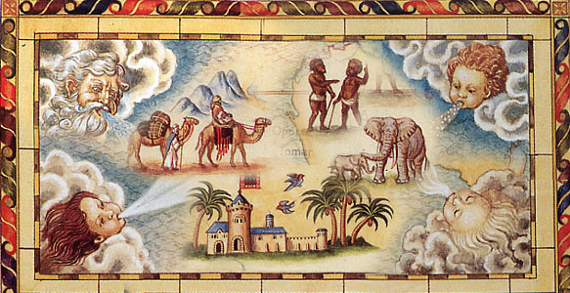

Name:
Date:
Period:

Where is the Trans-Saharan trade route located?
Objective: Identify location of the Trans Sahara trade route.

Trans - Saharan

Trans means... | The Sahara is…

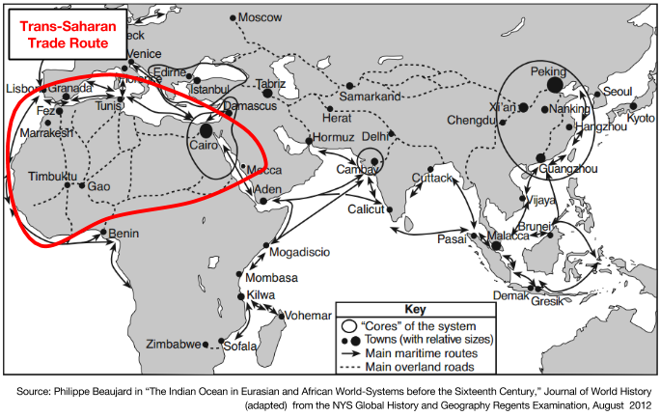 | Synthesis Sentence: The Trans-Saharan trade route is an exchange of commodities and ideas between the following three regions:  - __________________  - __________________  - __________________

Which commodities were traded along the Trans-Saharan trade route? Why were these commodities so important?
Objective: Identify and explain importance of two key commodities on the Trans Sahara trade route.

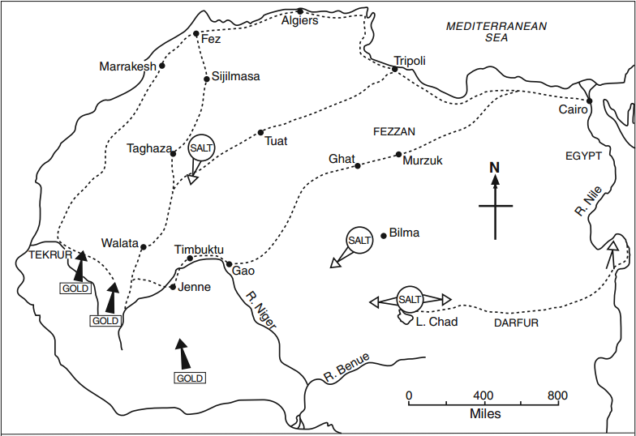 | A commodity is a  __________________________ .  According to the map above, which two commodities were traded along the Trans-Sahara trade route?  1  2

If you could choose between a pile of salt and a pile of gold, which would you choose? Why?

BUT, both commodities were equally important on the Trans-Saharan trade route.
Make a prediction: How might these commodities be important to different societies?

Salt | - Geographic Source: _________________________________  - In West Africa, it was difficult to find salt, but it was useful for two reasons:  - 1.  - 2. | 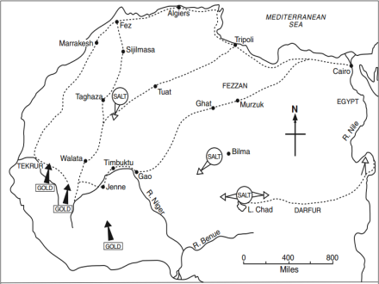
Gold  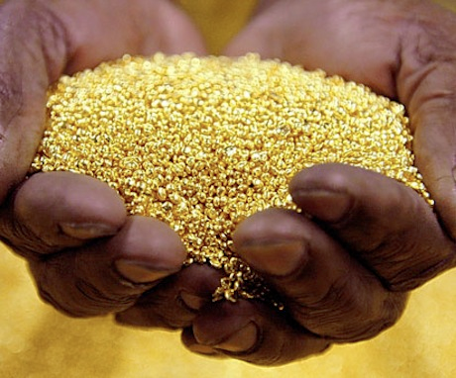 | - Geographic Source: _________________________________  - In North Africa, there were no gold mines, but gold was useful for two reasons:  - 1.  - 2. | 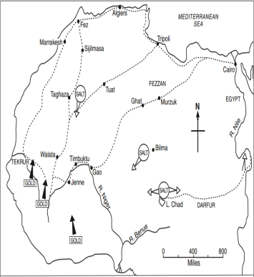

How do we know what we know about early African kingdoms and city-states?
Objective: Describe how historians learn about the history of Africa using oral history and written sources.

Directions: Read the documents and respond to the questions.

Document 1:  Until the late colonial period, it was widely believed among Western historians that Africa, south of the Sahara, had no “civilization” and thus no history. Others insisted that even if there were events of a historical nature, such a history was unknown and unknowable, since African societies, for the most part, were non-literate and as such left no records that historians could study.  [...]  Using an array of sources, these scholars were successful in showing that Africa not only had a history but that its history and the writing of it date back to ancient Antiquity. Ancient and classical writers wrote about Africa, even though their writings were unsystematic. They were followed by Islamic and Arabic writers, who left first- or second-hand accounts of African states and societies that have continued to prove valuable for scholars of African history. The next phase of African historiography was dominated by European traders, travelers, as well as missionaries and other adventurers [...]  Source:http://www.oxfordbibliographies.com/view/document/obo-9780199846733/obo-9780199846733-0011.xml | Why did some historians believe that Africa had no history?  What three sources have contemporary scholars and historians used to learn about the history of Africa?
Document 2a  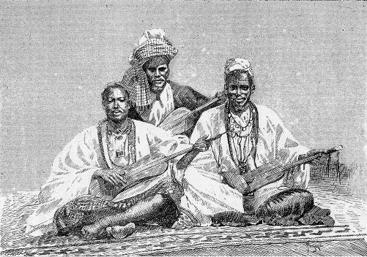  Source: Griots de Sambala, roi de Médine (illustration de Côte occidentale d'Afrique du Colonel Frey) - Fig.81 p.128 - [Cote : Réserve A 200 386] / http://commons.wikimedia.org/wiki/File:GriotsSambala.jpg  Document 2b  Context: Early and medieval African societies preserved their histories through written and oral literature. In West Africa, griots, a highly honored professional storyteller recited ancient stories that would be passed on from generation to generation. The griot is often viewed as a leader in their society because they preserve the history. One of the more well-known griot stories is the Epic of Sundiata. It tells the story of the hero Sundiata Keita (died 1255), the founder of the Mali Empire.  The West African epic of [Sundiata], the Mande king, has been transmitted orally by professional bards called griots (or jali in the Mande languages) since at least the fourteenth century. [Sundiata] Keita was a historical king of the Mandean Empire during the thirteenth century, but there are few written accounts of his life. Nearly all of what is known about him comes from variations of this famous oral tale, which over the centuries spread from Mali and Guinea to regions of Senegal, Gambia, and Burkina Faso.  The tale tells of a boy born to King Makhang and one of his wives, a deformed woman named Sogolon who is believed to have magical powers. [Sundiata] grows up bent and crippled like his mother, but he also apparently possesses her gift, for one day, angered by an insult to her, he uproots a baobab tree and grows instantly straight and tall (in some versions of the story he grows straight simply by leaning against his mother's shoulder). Even as a boy he possesses many virtues, including humility, strength, courage, and above all filial piety.[Sundiata] goes on to become a great king, surrounding himself with strong warriors and wise counsel. He defeats the Susa king Sumanguru through the use of wit and magic [...] [Sundiata] unites the territories surrounding his kingdom into the strongest and richest state of Africa.  The traditional role of the griots is an essential element in the tale of [Sundiata]. It was the duty of these storytellers to be the official memory of their kings, and thus of their people, connecting members of the community to one another as well as to their collective past. Griots were (and still are) trained in their art from childhood, acquiring the stories and legends of their ancestors, studying the tradition of oral poetry, and learning to accompany their stories on musical instruments, such as a twenty-one-string harp, a xylophone, or a small lute.  Source: http://bcs.bedfordstmartins.com/worldlit/content.asp?b=3&c=litlinks&r=Africa&i=sunjata | Document 2a:  The image to your left depicts griots. From this image, what can you infer about what role griots may have played in West African society?  Document 2b:  According to this excerpt, what is a griot?  What can we learn about Sundiata from the Epic of Sundiata?  What can we learn about West African history from the Epic of Sundiata?  What can we learn about the importance to history and storytelling in West African culture from the Epic of Sundiata?

How did Islam influence the growth of trade networks and power relations in the Songhai Empire and in East African city-states? How did these empires and states consolidate power?
Objective: Analyze the influence of Islam on the growth of trade networks and power relations in the Songhai Empire and in East African city-states. Describe the achievements of the Songhai Empire in consolidating their power?

Directions: Read the documents and respond to the questions.

Document 1  The Mali Empire, which originated in the eighth century, gradually became the most powerful kingdom in the Sahel (the area south of the Sahara Desert), and the leader of the trans-Saharan gold and slave trade. Islam was first introduced to the Sahel region in the eleventh century and quickly spread throughout the region. Though traditional African religious remained popular among the populace, many of the leaders of the Mali Empire and subsequent states followed and supported Islam [...]. The cities of Timbuktu and Djenné were the economic centers of the Mali Empire and attracted traders, scholars, and artisans from across the Islamic world.  In the fifteenth century, unchecked growth and political infighting prevented the Mali from addressing the spread of secession among their vassal states. The Tuareg, a Berber-speaking group, began encroaching on Malian territory, culminating in the capture of Timbuktu in 1430. The Mali were driven from their colonial territories and retreated to the upper Niger River, while the Sahel fractured into hundreds of warring states.  Sonni ʿAli (d. 1492), who became Songhai emperor in 1464, led the military [...] With the city secured, the Songhai began a program of military expansion and eventually controlled the Niger Delta and the gold trade [...] By the 1480s, the Tuareg and Mossi had been [...] integrated into the Songhai state.  Sonni ʿAli instituted an administrative structure based on regional military leadership. The administration angered the Islamic community by granting equal status to native tribal religions and reducing the power and influence of Islamic sects [...]  Sonni ʿAli died in 1492 after leading a military expedition [...] His son and successor was unable to consolidate support among the Islamic community and was overthrown in 1493 by Mohammed I Askia (d. 1538).  The Songhai was the largest empire in African history, dominating thousands of tribes and controlling a region comparable in size to the United States. The central regions, including the major cities of Gao, Timbuktu, and Djenné, were predominantly Muslim. Timbuktu was one of the world’s foremost centers of Islamic scholarship and attracted students and religious adherents from across Africa and parts of Europe. More than 90 percent of Songhai subjects were non-Muslims, however, and the government adopted a policy of religious freedom, though Islam remained the dominant religion in the government.  Source: "Songhai Empire." Gale Encyclopedia of World History: Governments. Vol. 1. Detroit: Gale, 2008. World History in Context. Web. 6 Apr. 2015.(http://tinyurl.com/songhaitext) | Under which empire did Islam spread through West Africa?  Explain how the Songhai empire became the strongest empire in African history?  What policy did the Songhai empire adopt to govern their diverse empire of mostly non-Muslims? How did this policy allow the Songhai empire to maintain and consolidate power?
Document 2 | Based on this image, identify 3 achievements of the Songhai empire.  Based on this image, what caused the decline of the Songhai Empire?
Where did Ibn Battuta and Mansa Musa travel? What were the effects of their travels?
Objective: Describe the effects of Ibn Battuta and Mansa Musa’s travels around the Trans-Saharan trade route.

MANSA MUSA
Musa I was the tenth Mansa, or emperor, of the Manden Kurufaba, or Mali Empire, located in Western Africa. Musa reigned from 1312-1327 CE. Mansa Musa built his wealth from gold and salt mines, both of which were extremely valuable. The Mali Empire was strategically situated on trade routes throughout Africa.. Musa I was also a devout Muslim. In 1324 he made his hajj, or pilgrimage, to Mecca. This pilgrimage is one of the Five Pillars of Islam. Mansa Musa returned from his hajj with the architect Ishaq El Teudjin, who built several buildings, including the Djinguereber Mosque, which became one of three mosques of the University of Timbuktu. Mansa Musa also ordered the creation of several libraries and supported education in the Qur’an. Under Mansa Musa’s reign the Malian empire reached its greatest size. His cultural legacy is seen in Mali to this day.

Document 1: Al-Umari Al-Umari was an Arab historian from Damascus, Syria. He visited the city of Cairo in Egypt several years after Mansa Musa passed through there on his pilgrimage in 1324 CE. He then wrote this account of Mansa Musa’s visit, as told to him by the people of Cairo.

From the beginning of my coming to stay in Egypt I heard talk of the arrival of this sultan Musa on his Pilgrimage and found the people of Cairo eager to tell what they had seen of the Africans’ extravagant spending. I asked the emir Abu and he told me of the opulence, manly virtues, and piety of his sultan. Abu said, “When I went out to meet him, Musa did me extreme honor and treated me with the greatest courtesy. He addressed me, however, only through an interpreter despite his perfect ability to speak in the Arabic tongue. Then he sent to the royal treasury many loads of unworked native gold and other valuables. I tried to persuade him to go up to the Citadel to meet the sultan of Cairo, but he refused persistently saying: ‘I came for the Pilgrimage and nothing else. I do not wish to mix anything else with my Pilgrimage.’” Mansa Musa flooded Cairo with his gifts. He left no emir or holder of a royal office without the gift of a load of gold. The people of Cairo made incalculable profits out of him and his caravan in buying and selling and giving and taking. They traded away gold until they depressed its value in Egypt and caused its price to fall. This has been the state of affairs for about twelve years until this day by reason of the large amount of gold which they brought into Egypt and spent there.

Source: Al-Umari, Pathways of Vision in the Realms of the Metropolises, 1337-1338.

Vocabulary
sultan: king  opulence: great wealth, especially shown by extravagant living | emir: a high ranking title  piety: religious devotion incalculable: huge depressed: lowered

Document 2: The Catalan Atlas is a medieval map from Spain drawn in 1375 by a mapmaker named Abraham Cresques. Cresques had never visited West Africa but relied on the accounts of travelers and traders to make his map.

“This Black lord is called Musa Mali, Lord of the Black people of Mali. So abundant is the gold which is found in his country that he is the richest and most noble king in all the land.”
—Catalan Atlas inscription Source: Abraham Cresques, 1375.

IBN BATTUTA
In 1325, a young explorer named Ibn Battuta left his home in Morocco to make a ritual pilgrimage, called a haj, to the holy Muslim cities of Mecca and Medina. Battuta continued to travel and explore for the next three decades. When he returned home in 1355, Battuta described his travels to the scholar Ibn Juzayy, who wrote them down in The Rihla, which means “the journey.” Although some historians have questioned its accuracy, Ibn Battuta’s Rihla has remained a resource for historians to learn about the Muslim world in the 1320s.

Document 3:
While the vast majority of written historical sources on the Mali Empire were compiled by non-Africans who rarely set foot in Africa and never ventured south of the Sahara, an important exception is the eyewitness account by the Arab traveler Ibn Battuta. Its wealth of detail and observation makes his memoirs, Rihla, an unprecedented portrait of life in fourteenth-century Mali. Ibn Battuta was born in Tangier, Morocco, in 1304. Although he studied law, he began his celebrated travels as a young man in 1326 with the pilgrimage to Mecca. In the course of his lifetime he journeyed more than 70,000 miles to China, Southeast Asia, India, East Africa, the Niger, and the Byzantine Empire. Ibn Battuta considered himself a citizen of the Dar al-Islam, the entire “abode,” or world, of Islamic civilization. It was through this lens that Ibn Battuta viewed Mali in 1352–1353.
[…] Ibn Battuta was shocked by the lack of adherence to orthodox Islamic custom and practice. He wrote of partially clothed women, subjects who prostrated themselves before the mansa (king), and royal poets who danced in feathers and masks, all of which were spectacles outlawed by the orthodox Islam Ibn Battuta knew. From Ibn Battuta’s account we learn that although Mali officially belonged to the Islamic world and thereby had expanded the trading opportunities available to the empire and its ruling elite, it was clear that Islam was to be found only in the veneer of Mali’s material life; the underlying substance of Mali’s culture was a belief in Mande superiority.

Source: Bridging World History, 5 The Annenberg Foundation copyright © 2004

Vocabulary
Memoirs- collection of memories that an individual writes about moments or events that took place in their life.  Unprecedented- never done or known before  Adherence- to follow or uphold  Prostrated-to lay flat on the ground to show humility | Spectacles-behave foolishly or badly in public  Veneer-a superficially valuable or pleasing  appearance  Mande-traditional west African tribe

Document 4:

The legacy of Ibn Battuta’s Travels

[…]Unlike the impact of the Travels of Marco Polo on the European world, the account of Battuta’s travels had only modest impact on the Muslim world before the 19th century. While copies circulated earlier, it was French and English scholars who eventually brought The Travels of Ibn Battuta [Rihla] the international attention it deserved.
How does Ibn Battuta’s account compare with that of Marco Polo’s? Each traveler lived by his wits — they had that in common. Each took joy in discovering new experiences, and each exercised amazing perseverance and fortitude to complete extensive travels and return to their home country.
Yet there were many differences. Ibn Battuta was an educated, cosmopolitan, gregarious, upper-class man who traveled within a familiar Muslim culture, meeting like-minded people wherever he went. Polo was a merchant, not formally educated, who traveled to strange, unfamiliar cultures, where he learned new ways of dressing, speaking, and behaving. Ibn Battuta told more about himself, the people he met, and the importance of the positions he held. Marco Polo, on the other hand, focused on reporting accurate information about what he had observed. How fortunate we are to have accounts from two contrasting intercontinental travelers from more than 600 years ago.
Source: https://www.khanacademy.org/partner-content/big-history-project/expansion-interconnection/exploration-interconnection/a/ibn-battuta

Vocabulary
Modest-minimal  Fortitude-mental and emotional strength when facing a difficult situation | Cosmopolitan- belonging to the world rather than a specific town or nation  Gregarious- sociable; enjoying the company of others

Topic | Source | Describe the effects of Mansa Musa’s/Ibn Battuta’s travels around the Trans-Saharan Trade Route.
Mansa Musa | #1
 | #2
Ibn Battuta | #3
 | #4

How did monsoons impact trade routes in the Indian Ocean complex?
Objective: Explain how monsoons affected trade in the Indian Ocean complex.

What are monsoons?  Watch an excerpt from this Crash Course video and answer the questions below. If you need to, you can follow along with the video transcript here. | 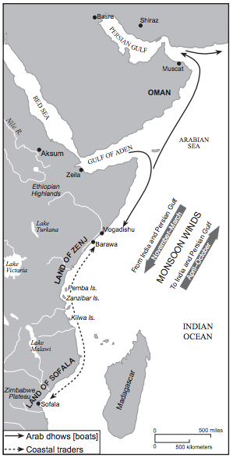  Source: Peter N. Stearns et al., World Civilizations: The Global Experience, Pearson (adapted) from the NYS Global History and Geography Regents Examination, June 2008.
- What are monsoons?
____________________________________________________________________________________________________________________________________________________________________________________________________________

- How did monsoons help sailors trade in the Indian Ocean complex?
________________________________________________________________________________________________________________________________________________________________________________________________________________________________________________________________________________

- Why were “predictable winds” important to trade in the Indian Ocean complex? ________________________________________________________________________________________________________________________________________________________________________________________________________________________________________________________________________________

