Trans-Saharan Trade

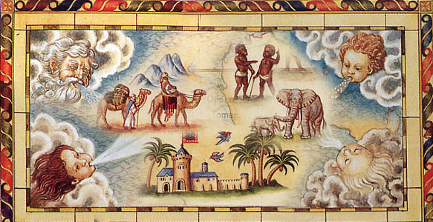

Name:
Date:
Period:

- What/where were the Trans-Saharan Trade Network?
- How did the Trans-Saharan Trade Network affect the civilizations connected to them?
- Why were the West African Empires prosperous?
- How did Mansa Musa and Ibn Battuta impact the Islamic World?

Where is the Sahara Desert?
Directions: Examine the map to the left and answer the questions that follow.

1. What is a desert?

2. In what part of Africa is the Sahara Desert located?

3. Describe the relative location of the Sahara Desert to two geographic features or regions.

4. Based on your prior knowledge of deserts, what do you think life is like in the Sahara desert?

___________________________________________________________________________________________________
Watch Life in the Sahara, 1953 [https://youtu.be/S4dLGXPZYEw] (00:00-1:42) and list three characteristics of the Sahara Desert. Complete the chart below.
Size: It is larger than… | Weather and Rainfall: | Other Geographic Features:

Where were the Trans-Saharan Trade Routes located?

Directions: Examine the map below and answer the questions that follow.
From the New York State Education Department. August 2012 Global History Exam. Internet. Available here; accessed July 10, 2017.
CONNECT IT TO WHAT YOU KNOW:
- What other major trade route have we learned about?
- Where is it?
- What empire brought it to its height?
- What kinds of things were traded on this route?

What was traded on the Trans-Saharan trade routes?  Directions: Examine the map below and answer the questions that follow.  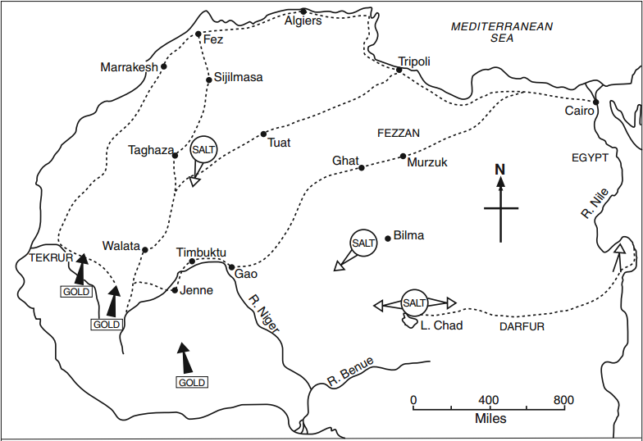  Crescent Moon by Federico Panzano is published on the Noun Project under the CC BY 3.0 US license.From the New York State Education Department. August 2012 Global History Exam and modified by New Visions. Internet. Available here; accessed July 10, 2017. | 1. According to the map to the left, which two commodities were traded along the Trans-Sahara trade routes?  1.  2.  2. Which religion spread along the Trans Saharan trade routes?

Why was salt so valuable in the Trans-Saharan Trade?
Directions: Watch the video Mankind- Salt (https://youtu.be/I59GSIgxk_8) and then fill out the information below.
Geographic Source: _________________________________

Salt was useful...
1. because/but/so (circle one)...

Why were West African Empires prosperous?
Directions: Read the text below and examine the map, then respond to the question that follows.
The West African Trading Empires of Ghana (800-1050 CE), Mali (1235-1464 CE), and Songhai (1464-1591 CE) were powerful and wealthy states that controlled the gold and salt trade in West Africa. Their cities were located at the intersections of trade routes.

The Kingdom of Mali, sometimes called the Mali Empire, experienced one of the golden ages of West Africa. Islam came to West Africa through trade and the rulers of Mali, who were called Mansas were Muslim. The capital city of Mali, Timbuktu, was a prosperous center of trade and learning. Islamic scholars came to Timbuktu to study at the Sankoré University which was a fully staffed university that could house 25,000 students and had one of the largest libraries in the world.
The Mali Capital of Timbuktu

The excerpt below was written by a Swedish explorer in the early 1900s, but his observations were as true when Mali ruled the area as they were hundreds of years later.

The remarkable features of Timbuktu are, then, its situation and its trade. We have only to take a look at the map to perceive that this town stands like a spider in its web. The web is composed of all the routes which start from the coast and converge on Timbuktu...

Caravans from the northern coast bring cloth, arms, powder, paper, tools, hardware, sugar, tea, coffee, tobacco, and a quantity of other articles to Timbuktu. But when they begin their journey through the Sahara, only half the camels are laden [loaded]. The other half are loaded with blocks of salt on the way, for salt is in great demand at Timbuktu…On the return journey northwards the [camels] are laden with wares from the Sudan, rice, manioc, honey, nuts, monkey breadfruit, dried fish, ivory, ostrich feathers, india-rubber, leather, and many other things…The largest caravans contain five hundred or a thousand [camels] and five hundred men at most. The goods they can transport may be worth twenty-eight thousand pounds [money] or more.
Source: Hedin, Sven. From Pole to Pole. London: Macmillan and Co. Ltd., 1914. Page 297. Adapted from the Global History Measures of Student Learning NYC Performance Assessment 2013-2014.
1. Why were Ghana, Mali, and Songhai wealthy and prosperous empires?
Identify two pieces of evidence that support your claim.

What were the effects of Mansa Musa’s rule and hajj?
Directions: Watch the TED-Ed video Mansa Musa, one of the wealthiest people who ever lived (https://youtu.be/O3YJMaL55TM) and follow the transcript below, then watch this National Geographic Video (https://youtu.be/M6yGK7UnX2c) , examine the map and image below and respond to the questions that follow.

Source: http:fga.freac.fsu.edu/ (adapted) from the NYS Global History and Geography Regents Examination, January 2010. | Image is in the public domain.  This image of Mansa Musa, from a map called the Catalan Atlas, was created by a European mapmaker in 1375. It demonstrates that the king of Mali and his wealth were known in Europe soon after his Hajj.
Transcript of the TED-Ed Video “Mansa Musa, one of the wealthiest people who ever lived”
If someone asked you who the richest people in history were, who would you name? Perhaps a billionaire banker or corporate mogul, like Bill Gates or John D. Rockefeller. How about African King Musa Keita I? Ruling the Mali Empire in the 14th century CE, Mansa Musa, or the King of Kings, amassed a fortune that possibly made him one of the wealthiest people who ever lived. But his vast wealth was only one piece of his rich legacy.

When Mansa Musa came to power in 1312, much of Europe was racked by famine and civil wars. But many African kingdoms and the Islamic world were flourishing, and Mansa Musa played a great role in bringing the fruits of this flourishing to his own realm. By strategically annexing the city of Timbuktu, and reestablishing power over the city of Gao, he gained control over important trade routes between the Mediterranean and the West African Coast, continuing a period of expansion, which dramatically increased Mali's size. The territory of the Mali Empire was rich in natural resources, such as gold and salt.
The world first witnessed the extent of Mansa Musa's wealth in 1324 when he took his pilgrimage to Mecca. Not one to travel on a budget, he brought a caravan stretching as far as the eye could see. Accounts of this journey are mostly based on an oral testimony and differing written records, so it's difficult to determine the exact details. But what most agree on is the extravagant scale of the excursion. Chroniclers describe an entourage of tens of thousands of soldiers, civilians, and slaves, 500 heralds bearing gold staffs and dressed in fine silks, and many camels and horses bearing an abundance of gold bars. Stopping in cities such as Cairo, Mansa Musa is said to have spent massive quantities of gold, giving to the poor, buying souvenirs, and even having mosques built along the way. In fact, his spending may have destabilized the regional economy, causing mass inflation.
This journey reportedly took over a year, and by the time Mansa Musa returned, tales of his amazing wealth had spread to the ports of the Mediterranean. Mali and its king were elevated to near legendary status, cemented by their inclusion on the 1375 Catalan Atlas. One of the most important world maps of Medieval Europe, it depicted the King holding a scepter and a gleaming gold nugget. Mansa Musa had literally put his empire and himself on the map. But material riches weren't the king's only concern.
As a devout Muslim, he took a particular interest in Timbuktu, already a center of religion and learning prior to its annexation. Upon returning from his pilgrimage, he had the great Djinguereber Mosque built there with the help of an Andalusian architect. He also established a major university, further elevating the city's reputation, and attracting scholars and students from all over the Islamic world.
Under Mansa Musa, the Empire became urbanized, with schools and mosques in hundreds of densely populated towns. The king's rich legacy persisted for generations and to this day, there are mausoleums, libraries and mosques that stand as a testament to this golden age of Mali's history.

1. What actions did Mansa Musa take to make Mali more powerful and wealthy? | 3. Identify two effects of Mansa Musa’s hajj.
2. Why did Mansa Musa travel to Mecca? | 4. What actions did Mansa Musa take to nurture the growth of Islam in Mali?
Who was Ibn Battuta?
Watch excerpts from the video “The Man Who Walked Across the World” [https://youtu.be/L8xU2ukQKiY ](Start- 1:57, 5:22-8:32, 10:14-13:49) and read the text below, then respond to the prompts that follow.

Ibn Battuta (1304-1369) was a scholar of Islamic law and a traveler who left his home of Tangiers, in modern-day Morocco, on a pilgrimage to Mecca, and continued traveling for almost thirty years. Battuta traveled mostly in lands where Islam was the predominate religion and where people spoke Arabic because of the spread of the religion.

By the 1300s, Muslims could be found throughout North Africa, the Middle East, Eastern Europe, Central Asia, and even in China. Islam spread to the far-flung areas of Asia by merchants from the Middle East who traded for spices and other goods in Asia and spread their religion through cultural diffusion. Battuta was able to travel throughout the Muslim world because of his experience as a traveler and knowledge of Islamic law were sought after by followers of the religion who had not been able to study in centers of Islamic scholarship like Baghdad.

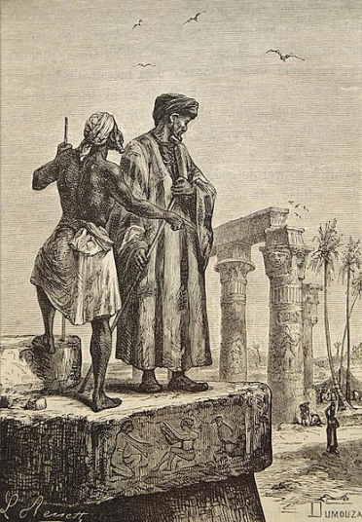
When he returned home to Tangiers, Ibn Battuta was instructed by the Sultan of Morocco to record his stories. Twenty years after they took place, he dictated his tales to a writer named Ibn Jazayy who wrote them into a travel guide called the Rihla. Some scholars believe that some of Ibn Battuta’s accounts were made up or based on what he heard from other travelers and that Ibn Jazayy filled in some of the gaps in Ibn Battuta’s recollections with descriptions from the writings of other travelers.
1. Where was Ibn Battuta from? | 2. Why do we know about Ibn Battuta’s travels?
3. Why was Islam important to Ibn Battuta’s travels? | 4. Why did Ibn Battuta start his journey?
5. (video, 7:35- 8:32) Is the photograph that the host of this video finds in the hotel in Tangier a reliable source of evidence for information about Ibn Battuta? Why or Why not?

What does Ibn Battuta’s account of his travels reveal about the Islamic world in the 1300s?
The following are excerpts from Ibn Battuta’s accounts of his travels (1325-1354) from the Rihla.  I left Tangier, my birthplace, on Thursday, 2nd Rajab 725 [June 14, 1325], with the intention of making the Pilgrimage to the Holy House [at Mecca] and the Tomb of the Prophet [at Medina].  Tripoli  Sometime later I joined a pilgrim caravan...Then we set out for Tripoli, accompanied for several stages by a hundred or more horsemen as well as a detachment of archers, out of respect for whom the Arab robbers kept their distance. . . . There is an uninterrupted chain of bazaars from Alexandria to Cairo, and from Cairo to Assuan [Aswan] in Upper Egypt.  Cairo  I arrived at length at Cairo, mother of all cities and seat of Pharaoh the tyrant. It is said that in Cairo there are twelve thousand water-carriers who transport water on camels, and thirty thousand hirers of mules and donkeys, and that on the Nile there are thirty-six thousand boats belonging to the sultan and his subjects which sail upstream to Upper Egypt and downstream to Alexandria and Damietta, laden with goods and profitable merchandise of all kinds. . . .The madrasas [Islamic colleges] of Cairo cannot be counted. . . .  Damascus  I entered Damascus on Thursday 9th Ramadan 726 [9th August, 1326], and lodged at the Malikite college. Damascus surpasses all other cities in beauty, and no description can do justice to its charms. The Cathedral Mosque, known as the Umayyad Mosque, is the most magnificent mosque in the world.  Mecca  I got rid of my tailored clothes, bathed, and putting on the pilgrim’s garment, I prayed and dedicated myself to the pilgrimage. The inhabitants of Mecca have many excellent and noble activities and qualities. They are good to the humble and weak, and kind to strangers. When any of them makes a feast, he begins by giving food to the religious devotees who are poor and without resources.  The customs of the Ahmadi dervishes [Dervishes, mostly found in modern day Turkey, practice a sect of Islam called Sufism.]  I reached the establishment at noon the next day and found it to be an enormous monastery containing thousands of darwishes [dervishes]. After the mid-afternoon prayer drums and kettledrums were beaten and the darwishes began to dance. After this they prayed the sunset prayer and brought in the meal, consisting of rice-bread, fish, milk and dates...A number of loads of wood had been brought in and kindled into a flame, and they went into the fire dancing; some of them rolled in it and others ate it in their mouths until they had extinguished it entirely. This is the peculiar custom of the Ahmadi darwishes....  Source: “Ibn Battuta: Travels in Asia and Africa 1325-1354 in “Internet History Sourcebooks,” Fordham University. http://www.fordham.edu/halsall/source/1354-ibnbattuta.asp found through the Stanford History Education Group https://sheg.stanford.edu/ibn-battuta | Based on what you see in the document, what can you infer about the Islamic world in the 1300s?  What questions do you have about Ibn Battuta’s travels and the Islamic world in the 1300s?

