Unit 1: Paleolithic and Neolithic Ages

Enduring Understanding(s):

- DEVELOPMENT OF CIVILIZATION: The development of agriculture enabled the rise of the first civilizations, located primarily along river valleys; these complex societies were influenced by geographic conditions and shared a number of defining political, social, and economic characteristics.

- 9.1a The Paleolithic Era was characterized by non-sedentary hunting and gathering lifestyles, whereas the Neolithic Era was characterized by a turn to agriculture, herding, and semi-sedentary lifestyles.

- 9.1b Complex societies and civilizations adapted to and modified their environment to meet the needs of their population.

Essential Questions

- 9.1a: How did the Neolithic Revolution change history?
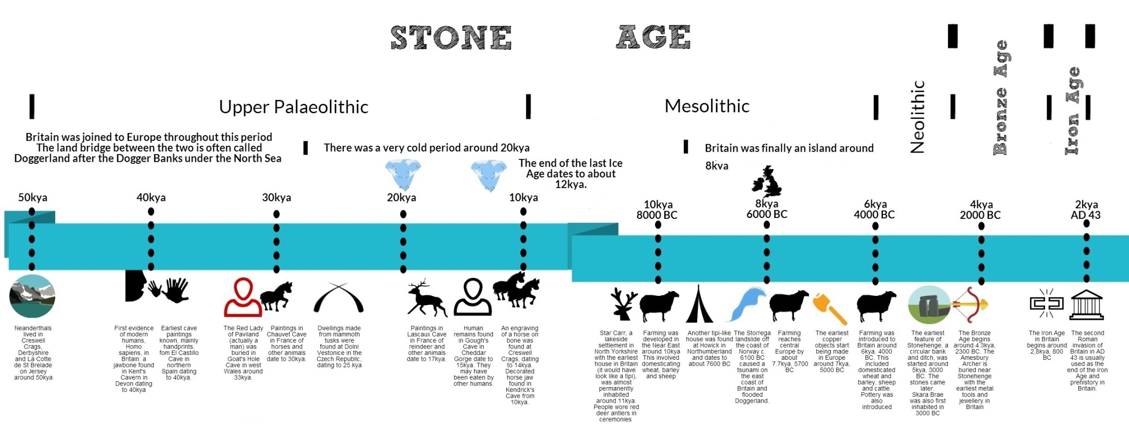

Important Vocabulary
Word/Phrase | Definition
nomadic | living like a nomad; moving from place to place staying in one place temporarily
hunting and gathering | the act of getting one’s food by hunting for it and collecting wild fruit, vegetables, and nuts
domesticate | to tame; to change a wild plant or animal so it can be grown or raised by humans
settlements | places where people start a new place to live where others have not before
revolution | a very great change from things in the past
Paleolithic | having to do with the Paleolithic Period, or Old Stone Age, the time period from 2 million B.C.E. to about 10,000 B.C.E., characterized by the use of stone tools
sedentary | living in a fixed location; not nomadic
agriculture | farming
crops | plants grown on a farm
hunter-gatherer | one who gets their food by hunting for it and collecting wild fruit, vegetables, and nuts; most humans in the Paleolithic Period were hunter-gatherers
nomad | a person who lives a nomadic lifestyle, moving from one place to another following food sources
river valley | the area of land nearby and parallel to a river
fertile | able to produce farm cops or other plant life
Neolithic | having to do with the Neolithic period or New Stone Age, the time period from about 8,000 B.C.E to about 3,500 B.C.E characterized by the beginnings of farming
civilization | an advanced state of development of a society as judged by such things as having a system of government and laws, using a written language, and keeping written records
reliable | capable of being trusted
adapt | to change

