The Yin and Yang is an important symbol in my philosophy. The Yin and Yang must be in balance so harmony can exist. The Yin is cool, dark, female and submissive while the Yang is warm, light, male and aggressive.

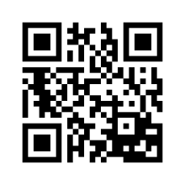  Hinduism | 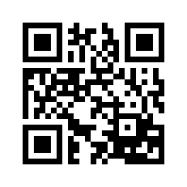  Buddhism | 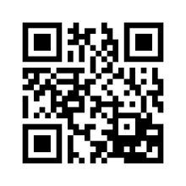  Confucianism | 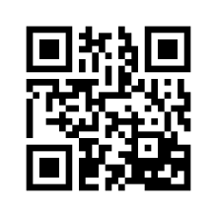  Daoism

My followers believe in karma, that is how a person lives determines what form the person will take in the next life.

Hinduism | Buddhism | Confucianism | Daoism

I was created from a combination of beliefs from the Indus River Valley and Aryans.

Hinduism | Buddhism | Confucianism | Daoism

A key part of my philosophy is the Dao, or “the way.” It is an eternal force that permeates everything in nature.

Hinduism | Buddhism | Confucianism | Daoism

My founder, Siddhartha Gautama, was born in luxury and raised as a prince. When he realized there was suffering in the world he wanted to know why. Why he discovered the answer, he began sharing it.

Hinduism | Buddhism | Confucianism | Daoism

My founder was born to a poor family. He taught that people should live by the principles of good conduct and moral judgment. He also believed that the government had a duty to set an example of right conduct.

Hinduism | Buddhism | Confucianism | Daoism

My followers are polytheistic and believe in many gods.

Hinduism | Buddhism | Confucianism | Daoism

An important text for my followers is the Dao De Jing.

Hinduism | Buddhism | Confucianism | Daoism

My important leaders are Brahmins or priests.

Hinduism | Buddhism | Confucianism | Daoism

My followers know the Four Noble Truths: 1) All people suffer and know sorrow; 2) Desires cause suffering; 3) End suffering by ending desires; 4) Eliminate desire by following the Eightfold Path.

Hinduism | Buddhism | Confucianism | Daoism

I became the basis of Chinese society until the 1900s.

Hinduism | Buddhism | Confucianism | Daoism

My founder became known as the “enlightened one.”

Hinduism | Buddhism | Confucianism | Daoism

My important leader is my founder, Laozi.

Hinduism | Buddhism | Confucianism | Daoism

My followers believe that nirvana is the freedom from the pain and suffering of reincarnation. Nirvana can be achieved regardless of your caste.

Hinduism | Buddhism | Confucianism | Daoism

The Vedas and Upanishads are important religious texts for my followers

Hinduism | Buddhism | Confucianism | Daoism

My followers believe in reincarnation, the rebirth of the soul until a person reaches spiritual perfection.

Hinduism | Buddhism | Confucianism | Daoism

The Analects, a collection of sayings and ideas, is an important text for my followers.

Hinduism | Buddhism | Confucianism | Daoism

Dharma is the correct actions for one’s social class. By following the correct actions, you may move up a social class when you are reincarnated.

Hinduism | Buddhism | Confucianism | Daoism

I focus on the harmony between individuals and nature.

Hinduism | Buddhism | Confucianism | Daoism

Want to know how to end suffering? My followers practice the Eightfold Path to reach enlightenment.

Hinduism | Buddhism | Confucianism | Daoism

My followers believe that moksha is the release from the pain and suffering of rebirth. It can only occur for Brahmins.

Hinduism | Buddhism | Confucianism | Daoism

My founder, Laozi, rejected the idea that people must fill specific roles in society. He believed people should renounce worldly ambitions and turn to nature and the Dao.

Hinduism | Buddhism | Confucianism | Daoism

The caste system is interconnected with my beliefs.

Hinduism | Buddhism | Confucianism | Daoism

My founder believed in the Five Relationships: 1) Ruler and subject; 2) Father and son; 3) Older brother and younger brother; 4) Husband and wife; 5) Friend and friend

Hinduism | Buddhism | Confucianism | Daoism

This belief system rejects the caste system.

Hinduism | Buddhism | Confucianism | Daoism

