How did industrialization affect British workers?

Effects of the Industrial Revolution on Work in Great Britain
As a result of the innovations in technology and technique of the Agricultural Revolution in Great Britain, farmers in the mid-1700s could produce more crops in less time and with fewer workers. People who lived in rural areas and relied on the farms for their money and food had to find new places for employment. Around the same time, the first factories were built in cities and towns nearby. People flocked to these new industrial centers for employment and resettled there.

Watch this Timelines.tv video on “Factories and Machines” then answer the questions below.
1. What effects of the Industrial Revolution are still a part of modern life? | 2. What is an entrepreneur? What was his/her role in industrial England?
3. What were the positive effects of factory work? | 4. What were the negative effects of factory work?
Document Set 1

Document 1a  At Work in a Woolen Factory  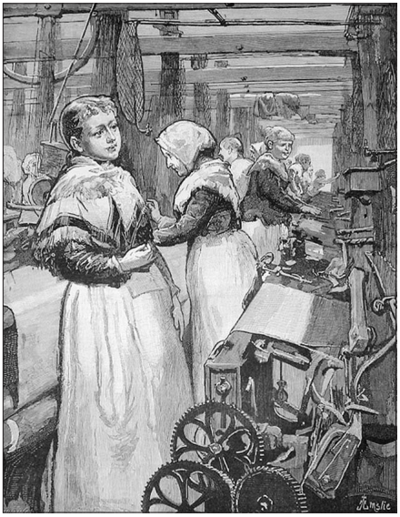  The Illustrated London News, August 25, 1883  Source: NYS Global History and Geography Regents Exam, June 2006. |  | Document 2a  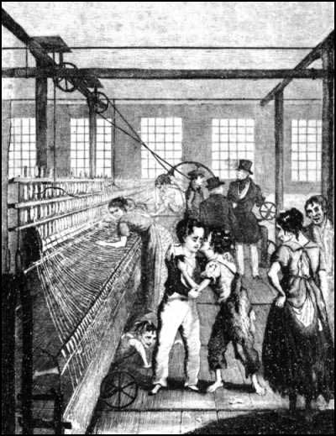  Illustration from Frances Trollope’s Michael Armstrong: Factory Boy (1840), a novel about a child laborer.  Source: https://commons.wikimedia.org/wiki/File:Scene_from_Factory_Boy.jpg

Document Set 2

The Sadler Committee (1832)
In 1832 Michael Sadler secured a parliamentary investigation of conditions in the textile factories and he sat as chairman on the committee. The evidence printed here is taken from the large body published in the committee's report. The questions are frequently leading; this reflects Sadler's knowledge of the sort of information that the committee were to hear and his purpose of bringing it out.
Source: http://history.hanover.edu/courses/excerpts/111sad.html
Document 2a  This is an excerpt from William Cooper’s testimony before the Sadler Committee in 1832. | \ | Document 2b  This is an excerpt from the testimony of Joseph Hebergam to the Sadler Committee.
Sadler: When did you first begin to work in mills?  Cooper: When I was ten years of age.  Sadler: What were your usual hours of working?  Cooper: We began at five in the morning and stopped at nine in the night.  Sadler: What time did you have for meals?  Cooper: We had just one period of forty minutes in the sixteen hours. That was at noon.  Sadler: What means were taken to keep you awake and attentive?  Cooper: At times we were frequently strapped.  Sadler: When your hours were so long, did you have any time to attend a day school? Cooper: We had no time to go to day school. |  | Sadler: Do you know of any other children who died at the R Mill?  Hebergam: There were about a dozen died during the two years and a half that I was there. At the L Mill where I worked last, a boy was caught in a machine and had both his thigh bones broke and from his knee to his hip . . . . His sister, who ran to pull him off, had both her arms broke and her head bruised. The boy died. I do not know if the girl is dead, but she was not expected to live.  Sadler: Did the accident occur because the shaft was not covered?  Hebergam: Yes.

Document 3
Occupational Distribution in the 1851 Census of Great Britain
Occupational Category | Males (thousands) | Females (thousands) | Percent Female
Public Administration | 64 | 3 | 4.5
Armed Forces | 63 | 0 | 0
Professions | 162 | 103 | 38.9
Domestic Services | 193 | 1135 | 85.5
Commercial | 91 | 0 | 0
Transportation & Communications | 433 | 13 | 2.9
Agriculture | 1788 | 229 | 11.4
Mining | 383 | 11 | 2.8
Metal Manufactures | 536 | 36 | 6.3
Building and Construction | 496 | 1 | .2
Wood and Furniture | 152 | 8 | 5
Bricks, Cement, Pottery, Glass | 75 | 15 | 16.7
Chemicals | 42 | 4 | 8.7
Paper and Printing | 62 | 16 | 20.5
Textiles | 661 | 635 | 49
Clothing | 418 | 491 | 54
Food, Drink, Lodging | 348 | 53 | 13.2
Other | 445 | 75 | 14.4
Total Occupied | 6545 | 2832 | 30.2
Total Unoccupied | 1060 | 5294 | 83.3
Source: B.R. Mitchell, Abstract of British Historical Statistics, Cambridge: Cambridge University Press, 1962, p. 60. Retreived from http://eh.net/?s=women+workers+and+the+industrial+revolution

Document Set 4
Document 4a
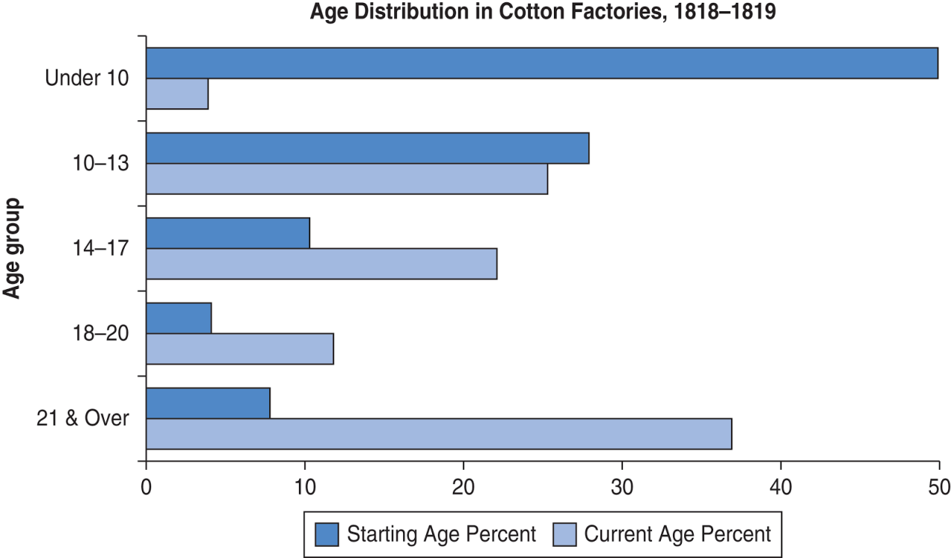
Source: Created for the New York State K–12 Social Studies Toolkit by Agate Publishing, Inc., 2015. Based on data from Wade Thatcher, Child Labor During the English Industrial Revolution. http://wathatcher.iweb.bsu.edu/childlabor/. British Parliamentary Papers (BPP) (1818) Minutes of Evidence on the Health and Morals of Apprentices and others employed in Cotton Mills and Factories. Sessional Papers, House of Lords, vol. 96, appendix. BPP (1919) Minute of Evidence on the State and Condition of the Children employed in Cotton Factories, Sessional Papers, House of Lords, vol. 110, appendix.
Document 4b
Child Employment in the United Kingdom in 1851
Mining |  |  | Textiles and Dyeing
Males under 15 | 37,300 |  | Males under 15 | 93,800
Females under 15 | 1,400 |  | Females under 15 | 147,700
Males 15-20 | 50,100 |  | Males 15-20 | 92,600
Females over 15 | 5,400 |  | Females over 15 | 780,900
Total under 15 as % of workforce | 13% |  | Total under 15 as % of workforce | 15%
Source: Booth, C. “On the Occupations of the People of the United Kingdom, 1801-81.” Journal of the Royal Statistical Society (J.S.S.) XLIX (1886): 314-436. Data retreived from: https://eh.net/encyclopedia/child-labor-during-the-british-industrial-revolution/

Primary Source Graffiti Graphic Organizer
Research Question: How did industrialization affect British workers?
Document | Sourcing Information  (What type of document is it? Who wrote it? When was it written? What do you know about the author?) | Evidence to Answer Research Question
1a
1b
2a
2b
Document | Sourcing Information  (What type of document is it? Who wrote it? When was it written? What do you know about the author?) | Evidence to Answer Research Question
3
4a
4b

