Name: Date:
Global 10R/Period: WWII Notes

World War II

The Road to War

- Post: WWI:

- The Ineffectiveness of the League of Nations

- The “Stab-In-The-Back” Theory

- 1929:
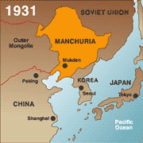
Aggressors Invade
- Japan Invades Manchuria, 1931

- 1931-
- The Japanese Invasion of China, 1937

- Italy Attacks Ethiopia, 1935

  - League did nothing
- Germany Invades the Rhineland March 7, 1936
- GB urges appeasement
  - Appeasement-
TURNING POINT TOWARD WAR

- Shifted power in Germany’s favor

Rome-Berlin Axis, 1936
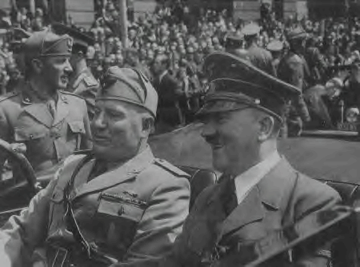
Rome-Berlin-Tokyo Axis
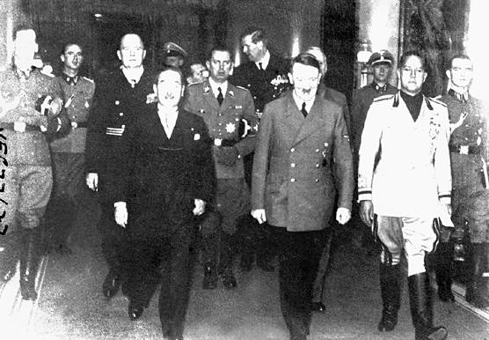
Now called the
- The Spanish Civil War 1936 – 1939

The National Front | The Popular Front

The Austrian Anschluss, 1938
Anschluss-

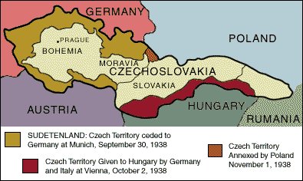
    - 1938-Ger. annexed Aust.
- The “Problem” of the Sudetenland
- 1938-
- Czechs ask for help
- The Munich Conference
- Sept 29, 1938-
  - Neville Chamberlain (GB Prime Min)felt he could preserve peace through appeasement
AGGREEMENT
- Hitler-

- Who was right?

- The Nazi-Soviet Non-Aggression Pact, 1939
- GB & France asked USSR to help
- While negotiating w/GB & France, Stalin also bargained w/ Hitler
  - August 23rd 1939- Non-Aggression Pact

        - USSR -
The War Begins
- Poland Attacked: Sept. 1, 1939
- Blitzkrieg / “Lightning War”

  - Take enemy by surprise
- Miracle at Dunkirk
- May 1940-
- May 26-June 4-
- France Surrenders

- Now Britain Is All Alone!
- Winston Churchill-
- Battle of Britain: The “Blitz”
- Summer 1940-
- RAF aided by:

  - Enigma-
- Ger. began night bombings

- Operation Barbarossa: June 22, 1941
- USSR retreated
- Sept 8-
- “General Winter to the Rescue”
- Oct 1941-
  - Reached capital by Dec.
- Dug in until March

- Battle of Stalingrad: Winter of 1942-1943
- August 23rd, 1942-
- November 19th, 1942-
  - Leaves Germans trapped
- February 2nd, 1943-

US Involvement and the Pacific Campaign
- US Policies Before Entering the War
- Started out neutralWhy?
- “Cash and Carry” & Lend-Lease Act
- Japan’s Planned Attack

  - “A dagger pointed at [Japan’s] throat”
- Pearl Harbor - Dec. 7, 1941
- President Roosevelt Signs the US Declaration of War
- Allies Strike Back
  - Lt. Col. Jimmy Doolittle-First U. S. Raids on Tokyo, 1942
- Battle of Midway Island: June 4-6, 1942
- Destroyed 332 Japanese planes, 4 aircraft carriers & one support ship

- Allied Counter-Offensive: “Island-Hopping”

- Seize the weaker islands that were closer to Japan
- Gen. MacArthur “Returns” to the Philippines [1944]
- US Marines on Mt. Surbachi, Iwo Jima [Feb. 19, 1945]
Meanwhile, Back in Europe…
- Gen. Eisenhower Gives the Orders for D-Day [“Operation Overlord”]
- D-Day (June 6, 1944)

- GB, Am, French & Canadian troops landed on 60 mile stretch of beach at Normandy
- D Day: Normandy Landing
- By Sept-
- The Battle of the Bulge
- Dec. 16, 1944 -
- The beginning of the end for der Furher!
- Mussolini Assassinated:
- Hitler Commits Suicide:
- V-E Day :
The Horrors of the Holocaust Exposed
- The Holocaust Begins
- Nuremburg Laws-deprived Jews of German citizenship; outlaws intermarriage; ltd jobs
- Kristallnacht/ “Night of Broken Glass”
  - Nov 9 1938-
- Ghettos-
- The “Final Solution”
  - Genocide against Roma (gypsies), Poles, Russians, homosexuals, the insane, disabled, the incurable ill & especially Jews

  - Used:
    - Concentration camps-
    - Extermination camps-
      - Ex. Auschwitz
The Lone Axis Power
- Hiroshima – August 6, 1945

- 48,000 buildings destroyed
- 100,000s died of radiation poisoning & cancer later
- Nagasaki – August 9, 1945

- 60,000 injured
- 100,000s died of radiation poisoning & cancer later
- V-J Day :

