Who was Zheng He?
What impact did his travels have on China and other regions?

Directions: Watch this PBS video on Zheng He (https://goo.gl/GZNt5J) then answer the questions that follow.
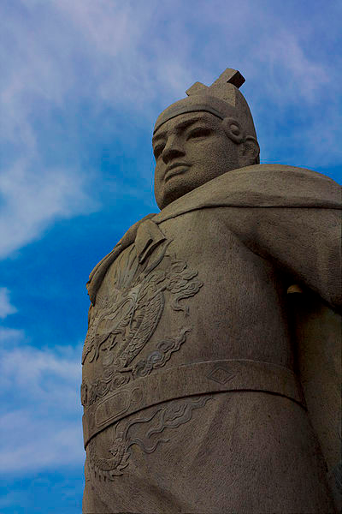
- How long was Zheng He travelling before his European counter parts?

- Describe Zheng He personal background. (Where is he from? Who were his parents? Etc)

- Why did the new Ming emperor instruct Zheng He to build his fleet?

- Where did Zheng He go on his first voyage?

- Where did Zheng He go in 1413?

- Describe the effects of the voyages of Zheng He.

- Explain why the voyages of Ming ended.

- Describe the long-lasting results of the Ming voyages under Zheng He.

The Voyages of Zheng He
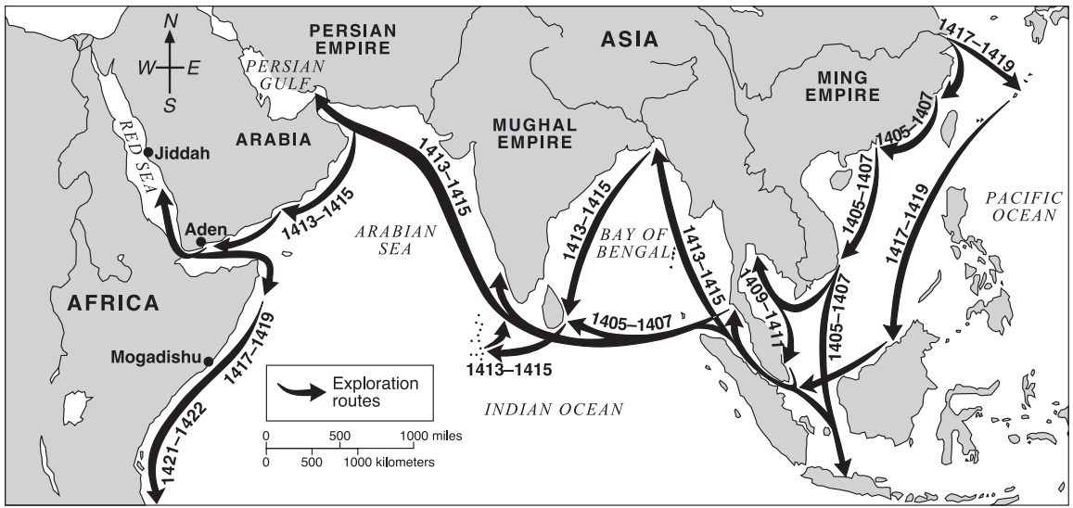
Source: Elisabeth Ellis and Anthony esler, World History: Connection to Today, Prentice Hall (adapted) from the NYS Global History and Geography Regents Examination, June 2004

