Who was Zheng He?
What impact did his travels have on China and other regions?
Directions: Watch this excerpt from a History Channel Video on Zheng He (https://goo.gl/CD7qNo) , read along with the transcript, and examine the images below then questions that follow about Zheng He and his voyages.
The Voyages of Zheng He  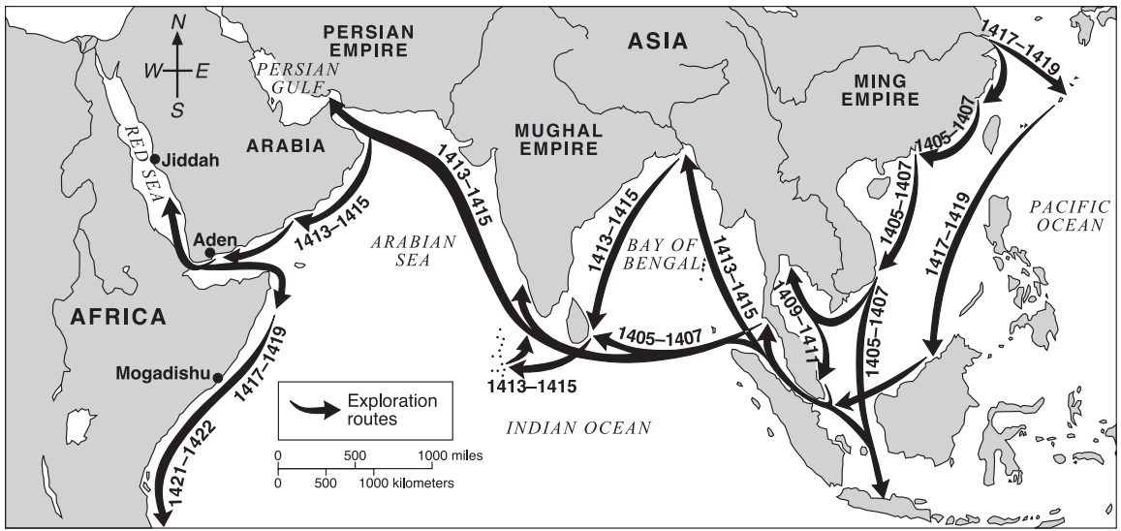  Source: Elisabeth Ellis and Anthony esler, World History: Connection to Today, Prentice Hall (adapted) from the NYS Global History and Geography Regents Examination, June 2004 | 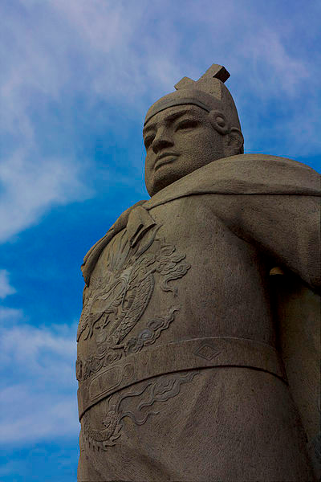Modern day statue of of admiral Zheng He, located in Malaysia.  Source: https://commons.wikimedia.org/wiki/File:Zhen_he.jpg

Video Transcript  It was a fleet unlike any that had ever put to sea. [There were] giant nine-masted junks escorted by dozens of supply ships, patrol boats, and transports for cavalry horses. The crew totaled more than 27,000 sailors and soldiers. This was the famed armada of the powerful Ming dynasty, a herald to the world that after a century of Mongol domination China was returned to its rightful rulers.  0:29  At its helm was unlikely admiral, a commoner from the outlying Hunan province who rose to become one of the most powerful figures in the Ming Dynasty. His name was Zheng He.  Zheng He soon rose through the ranks to become the chief lieutenant to the Emperor himself. Together they sketched out a bold plan for conquest of the seas. Zheng He was named to lead an extraordinary fleet of ships. It was an engineering challenge unlike anything a Chinese dynasty had ever attempted. Historian Edward L. Dreyer, “He was somebody who definitely wanted to create a personal stamp on the world.”  1:17  He ordered 337 ocean-going ships. An additional 188 flat bottom transports were converted for ocean travel. Historian, Arthur Waldron: “Just to get the building materials together and get the craftsman, get the designers and all the rest and then say put together a fleet of 300 ships is remarkable. I mean, the British fleet at the time of Napoleon had a really an upper limit of about a hundred ships on the line man-of-war.”  1:46  An army of 30,000 carpenters, sailmakers, and sail-rights worked and lived at the shipyards working day and night on Zheng He’s magnificent fleet. At the center of the enormous shipyard, seven 1500 ft dry docks were separated from the Yangtze River by twenty five foot high dams. Once the ships were complete the dams were opened, flooding the dry docks.  2:15  The flagship of the fleet was a spectacular nine-masted vessel measuring 440 feet nearly 1.5 times the length of a football field, making it the largest wooden ship ever built. Designed for stability, it had a flat bottom filled with heavy ballast stones and an innovative exterior rudder post that could be raised to reduce the ship's draft in shallow waters. Watertight bulwark compartments inspired by the partitioned shape of bamboo stalks stored drinking water and supplies and kept the ship afloat if the hull was breached. The second deck had living quarters for the crew. The kitchen, mess hall, and operations were on the third, while the fourth deck was used as a high fighting platform. Fully rigged, the flagships had nine staggered masts and twelve square sails of red silk soaring skyward.  3:16  Other ships were armed with as many as twenty-four bronze cannons capable of firing up to nine hundred feet. Their bows and sterns had reinforced high profiles for ramming smaller boats. Some ships carried horses for transporting troops, others were fresh water tankers packed with provisions for up to 28,000 men. Historian Edward L. Dreyer, “We're talking about a really really big fleet. It had as many soldiers and sailors on it as the Spanish Armada in 1588. It had about twice as many ships.”  3:54  In 1405, the unit commander, Zheng He, set sail for the world. Historian Edward L. Dreyer, “Zheng He was not an explorer. What Zheng He how was doing was what we would call in modern terminology power projection.”  4:06  During his 28-year naval career, Admiral Zheng He visited thirty-seven countries, traveled around the tip of Africa into the Atlantic Ocean and commanded a single fleet whose numbers surpassed the fleets of all of Europe combined.  4:25  Zheng He’s voyages established China as a superpower on the world's oceans. But in 1433, China's Age of Exploration came to a crashing halt. Zheng He suddenly died during a stopover in India and the fleet was recalled to China. A new emperor was on the throne. In one stunning command he would change the course of Chinese history.  4:54  Despite China's total domination as a naval power. Zheng He’s magnificent fleet was to be burned to the ground. It would be one of the great turning points in Chinese history. China was poised to seize control of the seas and colonize the world years before the Portuguese, Spanish, Dutch, and British.  5:21  Under the new emperor, all ocean-going vessels were destroyed. Even records of Zheng He's expeditions were torched. China's Age of Exploration was over. The open door slammed shut. The ships were gone and the promise of international power and conquest was dead. The reason for the Emperor's decision remains a mystery to this day.  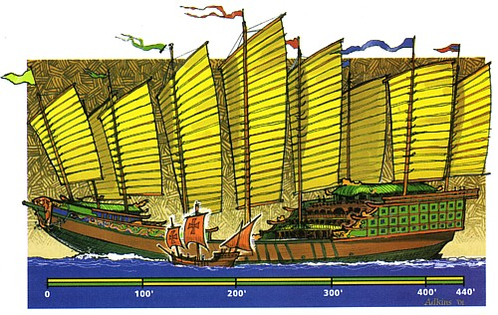 | 1. Based on the map above, where did Zheng He’s voyage begin?
 | 2. Based on the map above, identify three regions visited by Zheng He and his fleet.
 | 3. Who was Zheng He?
 | 4. What was so impressive about Zheng He’s fleet?
 | 5. One of the historians in the video describes the purpose of Zheng He’s voyage as “power projection.” What does that mean?
 | 6. What ended China’s “Age of Exploration?”

